THE BIOCHEMICAL & PHYSIOLOGICAL IMPLICATION OF GOUT
SANKAR P. MITRA Ph.D*
Former Assistant Professor, Department of Surgery, Division of Urology, University of Massachusetts Medical School, 55, Lake Avenue (North), Worcester, MA 01655, USA
Address: Sankar P. Mitra Ph.D., 102 Vassar Street, Worcester, MA 01602.
E-mail: sankar_mitra@msn.com, Tele Phone: +1-508-752-3554
*Corresponding author
Published: June 9, 2012 Received: 13 March 2012
AJBBL 2012, Volume 01: Issue 01 Page 01-35 Accepted: 01 April 2012

ABSTRACT
The article focuses on several underlying biochemical features regarding the manifestation of Gout. The high level Uric Acid (UA) built up in circulation is a major indication of the disease which is found only within human and higher apes. In moderate briefing it describes the nature, causes, sexual biasness and de-novo synthesis of UA and its excretion from the body under physiologic condition at the onset of this metabolic disorder. Categorically, the information offered is classified as follows:
- General knowledge about the disease caused due to higher UA / Urate level inside circulating plasma normally termed Hyperuricemia viewed commonly among the Gout sufferers including the role of purine enriched food and excessive alcohol consumption associated with its higher incidence.
- The physico-chemical mechanism of crystal formation and the cause of its deposition in faraway joints.
- The faulty Purine synthesis / metabolism or malfunctioning of Urate excretion through the kidney by various transporters leading to the manifestation of Hyperuricemia or Gout and simultaneously including its versatility, nature, ability and genetic identity.
- The discussion involving enzymatic pathway behind Hyperuricemia viewed within the Gout sufferers in the light of Purine synthesis and metabolism along with the genetic abnormality.
- The non-expression of Uricase gene in human due to non-sense mutation helps exacerbate the accumulation of UA when other enzymatic problem came into effect.
- The immunological problem created by the deposition of Urate crystal due to Hyperuricemia initiating the Gout attack causing pain, swelling and flare ups are elaborated along with their remedies.
- The pharmacological mechanism and the adverse roles of any drugs commonly used during treatment either for the short term or long term purposes in controlling or preventing its future recurrence is also included in this review.

INTRODUCTION
Among the lengthy list of metabolic diseases, Gout is by far the most common one arising either from the enzymatic malfunctioning of Purine synthesis or metabolism resulting in the over production of Uric Acid (UA) or else its poor clearance due to faulty performance of the kidneys. Considering the diversity of biochemical and pathophysiological aspects, Gout has been broadly classified as: 1. Primary and 2. Secondary, The major characteristics observed in the categories are:
1). For Primary Gout, the disorder consists of:
- Overproduction of UA which consists of 10 - 20 % of cases (Reason is fully identified).
- Under-excretion of UA which comprises 80 - 90 % of cases (Reason is not totally established).
- Enzyme defects, either due to the increased activity of PRPP (Phospho Ribosyl Pyro-Phosphate) Synthetase or partial deficiency in HPRT (Hypoxanthine Phospho Ribosyl Transferase) activity or nonsense mutation of the Uricase gene.

2). For Secondary Gout, the disorder relates to:
- Complete HPRT deficiency.
- Deficiency or absence of Glucose 6 – Phosphatase.
- Decreased renal excretion of UA.

The balancing act of UA level regarding its formation and excretion are well maintained under normal physiologic condition. As a part of normal functioning about 2/3 of the UA produced under ordinary condition in the system is cleared by the kidneys and the rest 1/3 is by the intestinal bacterial uricolysis [1]. In that context, maintaining the required UA / Urate level within the human body is a crucial factor for a normal healthy subject. Acceptably, significant contributions are offered by the diet although the synthesis from non-Purine sources and its metabolism within the physiologic system also plays an important role [2, 3] In fact a dynamic equilibrium is thoroughly maintained as per physiologic demand in the process of Purine synthesis, its salvage and degradation reactions. In that overall process, a large part of UA from the body ultimately ends up as an undesired product which passes out either through urine or via the intestine.
Common nutritional advices for the Gout sufferers:
In general a number of common guidelines are often provided for the patients frequently affected by the Gout.

#1. For obese patients, caloric restrictions are mandated to reduce the body weight and insulin resistance metabolic syndromes which would necessarily enhance the HDL- C level while helping avoid any subsequent atherosclerosis problems [4 – 6].

#2. Avoidance of alcohol especially the beers (20 – 30 mg Purines / L) which contains increased level of Purines provided by the hops and barley. Avoidance of any alcohol would improve the liver conditions while lowering the high lactic acid built up that may often enhance the event of Hyperuricemia due to urolithiasis [7 – 10]
#3. Low Purine diets that include less meat or sea foods are recommended because dietary contributions are somewhat significant therefore its restrictions act as an added benefit during Gout management whereas several recent surveys have indicated that vegetables enriched with purines bears least significance toward Hyperuricemia or gout. On the other hand inclusion of dairy products in food menu seems to lower the risk [11, 12]. Fiber enriched foods are often helpful since they bind with the excess Purines within intestine therefore lowering its gross absorption to the body [13].

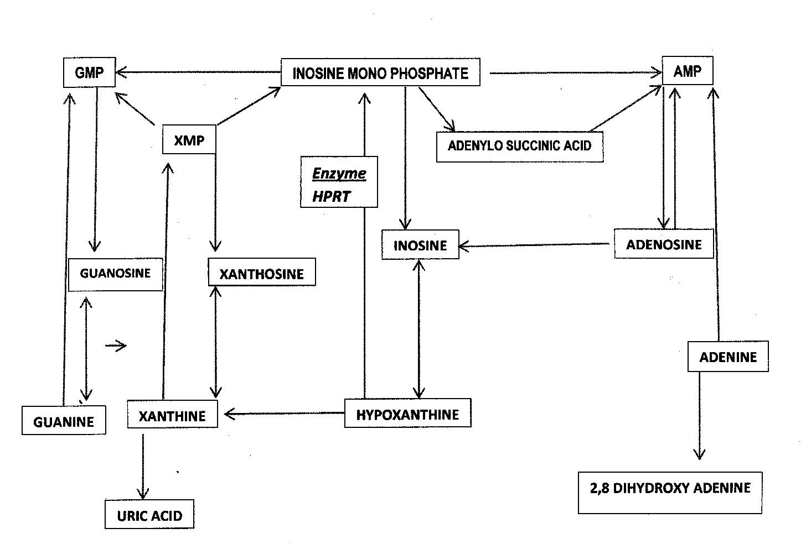

Fig 1. - Schematic diagram of human Purine Metabolism. The Ribo-nucleotides is the main item produced either by synthetic pathway, salvage reactions or degradation of the nucleotides or nucleosides. The UA generated irreversibly passes out through urine or intestine.
General facts & features about Hyperuricemia and Gout:
The symptom of UA built up in circulating plasma is widely known as Hyperuricemia. Among the Gout sufferers, Hyperuricemia is a common event. The manifestation of Gout has been perceived as a painful arthritis. Approximately 6.1 million adults in the US suffer annually from Gout arthritis. The disease inflicts severe pain mostly at the remote joints [14]. The high UA level (greater than 7.0 mg / dl for men & 6.0 mg / dl for women) in serum often indicates onset of the disease and its rising level imposes a number of physical disadvantages:
- Chances of UA or Na-Urate (NaU) crystal deposition within the joint synovium of knees, ankles fingers toes, wrists and elbows, mostly at the faraway places gradually making them immobile.
- The deposits appear like a red lump underneath the skin called Tophi which initiate drastic pain stimulating immune system during the Gout attack.
- If the deposit occurs inside the kidney that leads to the stone formation or urolithiasis, another dreadfully painful event.
As a common phenomenon, Gout inflicts excruciating pain along with swelling and redness at the attacking places adding debilitating stiffness to the affected joints. The disease is viewed more within adult male in comparison to the human female. The prevalence of Gout arthritis is seen for men within ages ranging from 40 to 60 whereas for the women it occurs at considerably higher ages around 60 to 80. But interestingly, the incidence rate of both sexes converges almost to the same level when compared with the similar age groups of menopausal women [15, 16]. The uricosuric effect of circulating estrogen among young-adult women before the menopause is implicated as being the underlying cause behind this inhibitory action although the exact reason(s) remains unexplored [14,17]. Some unknown genetic factors are suspected for having a role. As per further addition, personal life style also plays a significant role that includes excessive alcohol consumption, obesity, high intake of purine enriched foods (Red Meat) and several known medications (like Aspirin) that are frequently prescribed for daily uses. Thus, in addition to various therapeutic measures the dietary restrictions offer a substantial help in managing the Gout attack (Fig – 1).
The biochemical factor(s) behind Gouty arthritis is primarily due to the inherent defects in purine metabolic / catabolic pathway and for physiological reason the blame is offered to impaired clearance of UA / Urate crystals by the kidney [18]. The inheritance of HPRT deficiency increases UA level in plasma which is related to the X- linked recessive gene of which females are the usual carriers. Therefore males are often affected indicating the early onset of gouty arthritis. The enzyme, HPRT is encoded on the long arm of X- chromosome, Xq26 [19].
Further, in the light of human evolution, the event of Hyperuricemia is visible only among the human or large apes because of the lack of Uricase, a strong oxidative enzyme that catalyzes the breaking down of less soluble UA or Urate to more soluble Allantoin which can easily pass through the kidneys, into urinary excretion [20]. The genetic defect arising due to two non-sense mutations inside human Uricase gene make it non-functional to express therefore unlike the other animals except a few birds (Chicken) Hyperuricemia is visible only within the hominoid species. The absence of Uricase raises the UA level in circulation almost 10 fold compared to other living species [21]. Obviously, UA is a powerful anti-oxidant and doubtlessly it offers immense beneficial role preventing cancer and other dreadful diseases but on the flip side its deposition at higher concentrations is a real concern-able factor [22]. Simultaneously, the reduction in the expression of Xanthine oxidase gene is recorded to lower the risk of Hyperuricemia or gout. Interestingly, the enzyme activity is 100 fold lower in human than the other species [23]. Reports showed that transcription as well as core promoter activity of Xanthine Oxidase is substantially repressed in human [24]. Thus to balance the act, Nature possibly concludes that if the Uricase gene expression is repressed so somehow that may favor the lowering of Xanthine oxidase gene expression too.
The impairment in Urate transport during glomerular filtration system due to the mutation of Urate transporters, SLC2A9 and ABCG2 also raises the UA / Urate level in circulating plasma allowing the deposition to take place at the far reaching bone joints or even inside the kidney. The variations in each of them doubly enhance the risk within Caucasian population whereas the mutation only in SLC2A9 gene causes higher risk of gouty arthritis among the Polynesians [25].
Apart from any physiological defects or the life style as already mentioned, a number of medications also influence the UA level in plasma. For example, the diuretics Thiazide, immune suppressant drug Cyclosporine and low doses of Aspirin (< 1.0 g / day) increase the UA level. Interestingly, Aspirin at higher doses (> 3.0 g / day) produces the opposite lowering effect [26 &27]. As an unexpected event the high glucose level in plasma (> 180 mg / dl) causing renal glycosuria also frequently lowers the UA level minimizing the risk of Gout attack [28].
It is important to know that the normal level of UA (178 – 297 μmol / L) in circulation has a necessary beneficial role for acting as an anti-oxidant agent blocking the harmful effect of generated reactive singlet oxygen species (ROS) in human physiologic system [29]. As already known, the enhanced stability of singlet oxygen expedites lipid peroxidation imposing higher incidences of atherosclerosis, tissue damage including many adversarial effects. The circulating UA molecules trap the generated ROS while minimizing its damaging acts. Contrarily, the excessive built up of UA creates undesirable impacts also. The effect is more deleterious in case of patients having atherosclerosis problem. At early stages, UA acts as an antioxidant perhaps the strongest one. But later after the appearance of atherosclerotic plaque, UA, at its elevated level (> 6 mg / dl – female & > 6.5 – 7 mg / dl – male) loses the antioxidant virtue thus paradoxically turns to be an oxidant. The conversion process of antioxidant (UA) → pro-oxidant (Urate?) form as well as its oxidative role depends strongly on the surroundings; nature of the tissues, the presence of oxidant substrates, pH and also the oxidative enzymes nearby [30].
In general, common way to diagnose the Gout is by measuring the level of UA in circulation which is actually an indication of Hyperuricemia often leading to its manifestation. If the normal level (178 – 297 μmol / L) of an average healthy individual exceeds to the level of ~ 400 μmol / L (on the average UA level in Hyperuricemia patients lies within 400 - 535 μmol / L) that will enhance the possibility of Gouty manifestation [17 & 31]. Besides measuring plasma, fluids from the inflamed joints are also frequently tested for identifying Urate crystal-deposition inside the synovium [32]. The deposited crystals eventually stimulate the immune system due to the invasion of infiltrating leucocytes or other immune cells inside the synovium causing pain, swelling and many physical discomforts [33].
Several recent studies additionally provide strong relationship between hereditary and the incidence of Gout arthritis [34 & 35]. But considering all the perspectives, the defective Purine metabolism and mal-transport of UA / Urate are seen to be vastly liable for the disease although the event of Hyperuricemia does not always initiate the Gout attack but on the other way around, all the Gout sufferers show higher level of UA in the circulation as a common denominator [36, 37].
The conversion of UA to Na – Urate, its sodium salt occurs at physiologic media and pH. As dictated by the chemistry the UA undergoes Keto – Enol tautomerism having two Enolic forms. On of the Enolic forms possess pK_{a} ~ 5.8 whereas the other has ~ 10.2. Therefore at physiologic pH ~ 7.5, UA passes to the mono ionized form and as a neutralizing counter ion, the Na⁺ stays with its alongside which at higher concentrations (over 400 μmol / L) undergoes co-precipitation as Sodium mono Urate (MSU) crystals following the conversion as seen below (Fig – 2).
Fig – 2. The tautomerism of UA and chemical mechanism for Sodium Urate formation.

It is proven that at physiologic condition (temperature 37º C, 140 mM NaCl and pH – 7.5) the solubility of Urate is 6.8mg / 100 ml but at 35ºC it drops to 6.0 mg / 100 ml [38]. At 35ºC the normal Urate concentration even reaches nearly to the saturation limit. As a matter of fact, since most Gout attack favors the far away joints therefore conceivably, it is a major possibility that as because the body temperature at those regions is slightly less since the skin temperature is often seen to be few degrees lower than the central core so this phenomenon helps deposit the UA crystals [33]. As per consequence, the deposit of MSU within extracellular fluids at the far away joints occurs where the peripheral temperature is somewhat low. It is somewhat certain that there could be the involvement of other physico-chemical factors also [39, 40]. Whatever may be the cause accumulation of UA / Urate crystals induces phagocytosis setting the stage for vigorous immune response inducing inflammation and excruciating pain [41, 42].
The clinical manifestations of the disease include frequent attack with pain, arthritic inflammation, UA urolithiasis or renal impairment and other secondary effects even cardiovascular disease also. All are happening either due to the excessive UA formation or UA / Urate deposition. In all cases, the subjects show a common symptom of Hyperuricemia [4, 43].
HYPERURICEMIA
Hyperuricemia is diagnosed by the high UA content in circulation compared to the normal level (180 – 290 μmol / L). According to the Framingham Heart Study the chances of developing a Gouty arthritis increases with the rising level of UA for both sexes [18, 44]. In either sex, the Relative Risk factor is exponentially increased with the rise of serum UA level (Fig – 3). The studies around the world also support that view [18, 44 & 45].

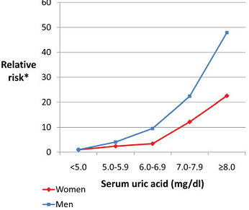
Fig – 3. Framingham Heart Study relating Serum UA with the Relative Risk factor [18, 45, 46]. Reference group = Serum UA < 5.0 mg / dl [Adjusted regarding the age, education, body mass index, alcohol consumption, hypertension, diuretic use, blood glucose level & menopausal status].

Basically, two major reasons are held responsible for the event of Hyperuricemia leading to Gout;
A). The over-production of UA.
B). The lesser excretion of UA through urine.
In either way, there would be higher accumulation of UA inside the plasma. When crosses the normal range it creates the condition of Hyperuricemia enhancing the risk of Gout attack. The effects of high accumulation of UA also produce stone which can deposit inside the kidneys [47 & 48].
A). The Over-production of UA: Hyperuricemia due to UA over-production is a common defect occurred during the course of Purine metabolism. As widely known, that a large number of enzymes are involved in that pathway. But until now, three major enzymatic defects are accounted to bear the main responsibility for UA over production and Hyperuricemia:
1). Glucose – 6 – Phosphatase deficiency (responsible for the Glycogen Storage Disease, GSD – 1;
2). Deficiency of Hypoxanthine Phospho-ribosyl Transferase (HPRT);
3). Hyperactivity of PP – Ribose –P Synthetase.
4). Absence of Uricase.
#1. Glucose – 6- Phosphate Deficiency: The defect due to Glucose 6-Phosphatase deficiency (GSD – 1) enhances the rate of Purine biosynthesis which translates to increased production of UA [49, 50]. The deficiency of this enzyme actually increases the Glucose 6 – Phosphate level which is then metabolized following the Pentose Phosphate pathway releasing more active substrate Ribose -5-Phosphate (R5P), a basic and necessary ingredient of overall Purine synthesis (Fig – 4). Additionally, the accelerated rate of ATP breakdown during catalysis could be accounted also as a major cause in the process of increased UA synthesis [51 & 52]. The disorder created by the deficiency or else total absence of the enzyme (GSD -1) is due to the defective mutation within X - linked autosomal recessive gene. In that regard both parents are identified as being the responsible carriers [53].

Fig – 4. Enzymatic conversion of Ribose 5’ Phosphate (R5P) to Phospho Ribosyl Pyro Phosphate (PRPP), a major ingredient of de-novo synthesis for UA.

#2. The HPRT Deficiency: The deficiency of HPRT also enhances the Hypoxanthine level which in normal course is converted to the Xanthine by Xanthine Oxidase and afterward oxidizes further to UA (Fig – 6). So, high hypoxanthine level enhances UA production. The deficiency of HPRT lies on the mutation of this enzyme. The partial deficiency results in Hyperuricemia whereas the complete one causes Lesch-Nyhan Syndrome exhibiting severe Gout, low muscular control and occasional mental retardation [54 – 56]. Both partial and full deficiencies are linked to the X – linked chromosomal defects [57, 58]. The partial deficiency arises due to incomplete mutation that accelerates the UA production through the usual purine synthesis pathway under physiologic condition.
#3. Hyperactivity of PP – Ribose – P Synthetase: On a similar mode concerning the enzymatic defect, the hyperactivity of PRPP Synthetase offers accelerated PRPP production which also enhances the de-novo Purine biosynthesis resulting in the overproduction of UA (Fig – 6 & 7). Clinically this metabolic disorder leading to Hyperuricemia is exhibited within the male population at earlier stages of life between 21 to 39 years of age. The defect is also transmitted through the X – linked inheritance [58].
Concerning the overall biochemistry, the formation of Inosine mono phosphate (IMP) is identified as one of the crucial ingredients along the pathway for the production and metabolism of any Purine analog (Fig – 6 & 7). Structurally, Purine is the fusion product of pyrimidine and imidazole ring and a primary ingredient of four basic nucleotides (Fig – 5). The substituted purine isomers often show tautomerism making the molecule more interesting and enzymatically reactive in various different ways. A large variety of substituted purines eg, Adenine, Guanine, Hypoxanthine, Xanthine, Uric acid etc are detected as major intermediates either during its production or metabolism (Fig – 5 & 6). The course of enzymatic reactions during the synthesis of a Purine nucleus normally requires 6 mol of ATP for creating one mol of any Purine nucleotide. However the nucleosides also undergo salvage reactions for efficient reutilization and conservation of the cellular energy.

Fig – 5. Chemical structures of important Purine analogs.

The major enzymatic pathways involved in the production and catabolism of the centrally important molecule, IMP are indicated in Fig – 6. Following evolutionary mandate, due to the absence of Inosine and Guanosine kinases in human, the nucleosides cannot be converted to their 5’ mono-phosphates directly therefore the salvaging of Inosine and Guanosine depends majorly on the HPRT enzyme which converts Hypoxanthine and Guanine formed from the phosphorylase catabolic reactions [59]

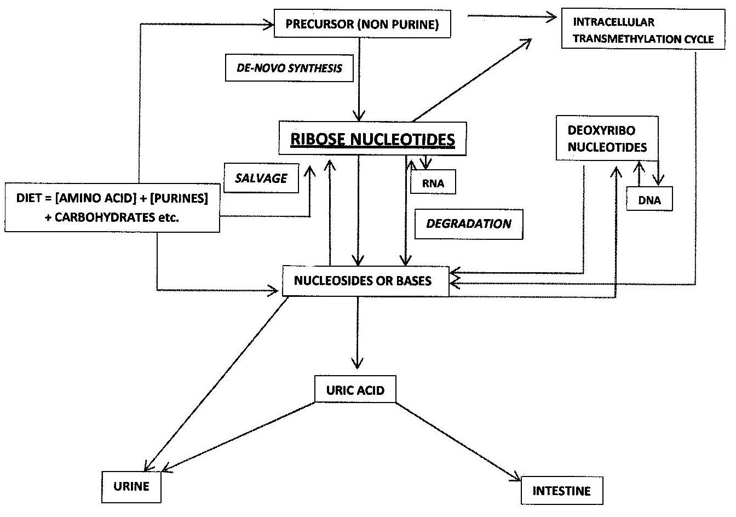

Fig – 6. The catabolic Pathway of Purines showing the importance of enzyme, HPRT [54, 60].

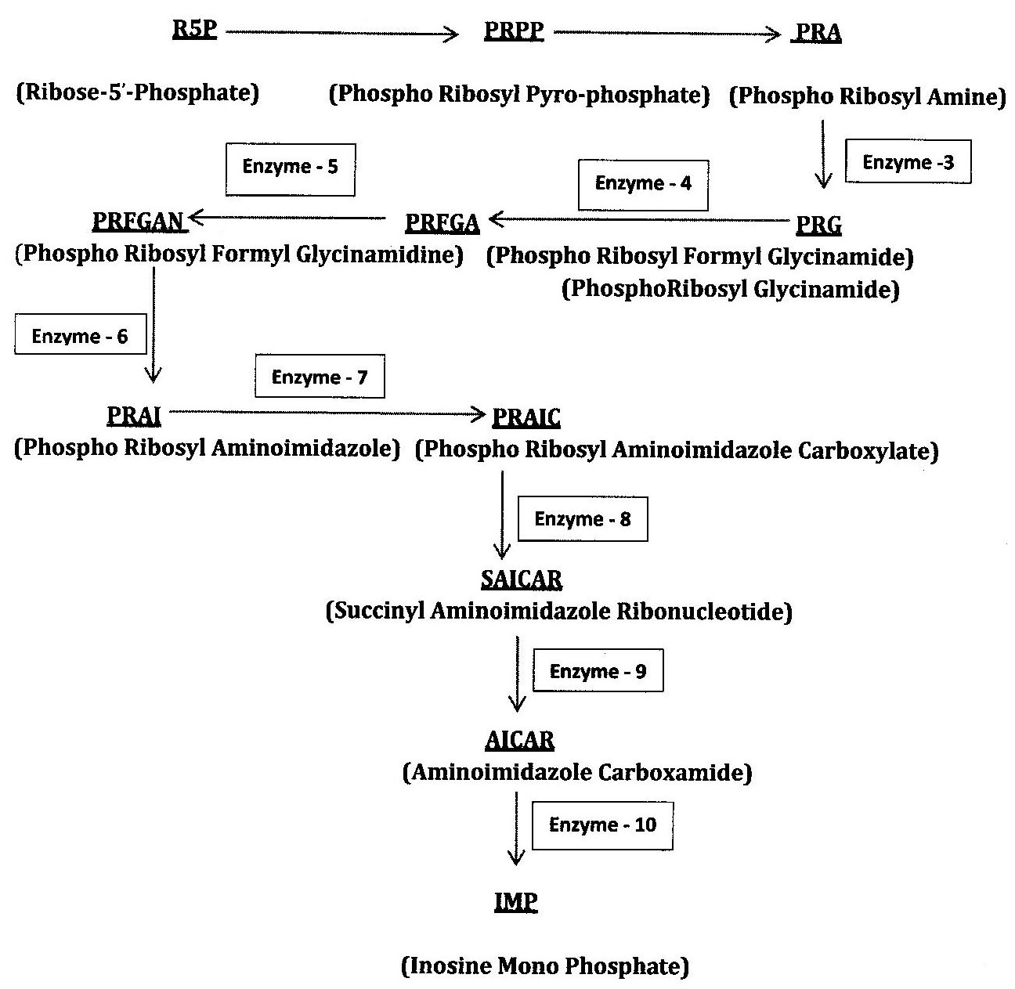

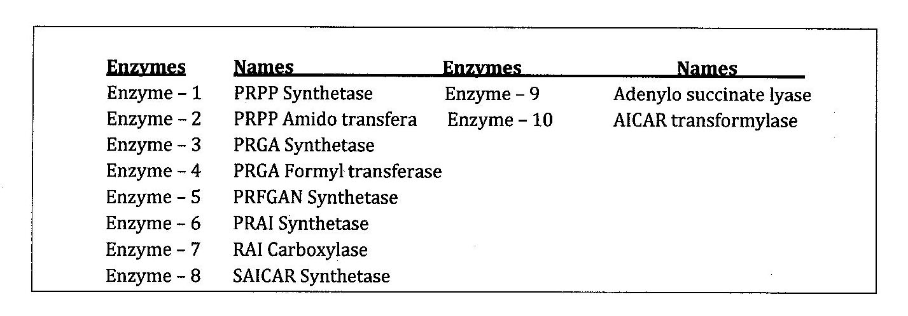

Fig – 7. The Substrates & Enzymes involved along the pathways during IMP synthesis from Ribose 5’ Phosphate [60, 61].
In conjunction with the synthesis, salvaging process of the Purines is uniquely carried out for the efficient utilization and DNA synthesis to maintain the cell growth and division. In that course the enzymes HPRT (Hypoxanthine Phospho Ribosyl Transferase) and APRT (Adenine Phospho Ribosyl Transferase) play the important role (Fig – 6) since they are directly involved in the phosphoribosylation of Purine nucleotide base using PP-Ribose – P by ATP.
Fig – 8. (PP-Ribose – P)

Therefore, PP-ribose – P is also a key regulatory component synthesized from R5’-P (Fig – 8).
As mentioned before, HPRT deficiency is detected to be the most common cause for higher accumulation of UA resulting in the manifestation of Gout. Owing to that deficiency, the conversion of Hypoxanthine (Hyp) to Inosine mono-phosphate (IMP) either becomes slowed or occasionally stopped thereby leading to the over accumulation of Xanthine which subsequently raises the UA level after being oxidized by the enzyme, Xanthine Oxidase following the reactions shown below.
NAD⁺ NADH
Hypoxanthine + H₂O Xanthine + H₂O₂
NAD⁺ NADH
Xanthine + H₂O + O₂ Uric Acid + H₂O₂
The successive oxidation of Purine analogs is noticeable in all situations which are extremely important regarding its excretion and maintenances according to their solubility ranges in plasma or other intracellular fluids. Further the reutilization by capturing through the cell surface receptors for any biological reason is a necessary factor also. Based on those findings large sleuths of drugs have been designed for several different diseases including Gout. One of them is Allopurinol which is often used for treating the Hyperuricemia or Gout.

Fig – 9. Oxidative Pathways involved in the conversion of Hypoxanthine & Guanine to Xanthine and finally to the Uric Acid [61].
Therefore in addition to low Purine diet, the treatment of Gout often includes the drugs Allopurinol or Oxypurinol to inhibit the enzyme, Xanthine Oxidase [62]. Having similarity with the chemical structure, Allopurinol is considered to be a Purine analog and acts as a competitive inhibitor enabling to block the enzyme Xanthine Oxidase (Fig – 9 & 10). In that act Allopurinol itself undergoes oxidation to Oxypurinol; another active metabolite which also efficiently inhibits the enzyme [64]. The treatment reduces the UA load diminishing the risk of Gout attack.
Under normal physiologic condition the rate of synthesis and metabolism are naturally balanced. Since each step is catalyzed by the specific enzymes so any defects either concerning its concentrations (High or low) or abnormal mutations is liable for the over-production of UA leading to Hyperuricemia.
Fig – 10. Conversion of Allopurinol to Oxypurinol, an active metabolite that inhibits Xanthine Oxidase.
As already mentioned that the common cause of Hyperuricemia depends mainly on three enzymes; Glucose – 6 – phosphatase, Hypoxanthine Phsopho-ribosyl Transferase and Phospho-ribosyl Pyrophosphate Synthetase. But in addition to those, the increased activity of the enzyme Adenosine deaminase also can induce Hyperuricemia but with less severity (Fig – 11) [65]. The formation of Inosine and its conversion to Hypoxanthine through de-ribolysation and finally to UA is followed in the pathway.
Fig –11. Deamination of Adenosine to Inosine and later to Hypoxanthine.
As shown in the Fig – 6 & 7 that the catabolic pathways of Xanthine formation also includes oxidation of Guanine by Guanine Deaminase which is later oxidized to UA therefore enhanced activity of the previous enzyme also can raise the UA level. Besides inducing a low level Hyperuricemia it creates much severe problem like Hemolytic anemia inducing Anisopoikylocytosis and Stomatocytosis [66]. On the other hand following a different pathway, the deficiency of Adenine Phospho-ribosyl Transferase (APRT) creates impaired Purine metabolism by blocking the conversion of Adenine to Adenosine mono-phosphate. In that course, it ultimately produces 2,8 di-hydroxy adenine, another insoluble Purine analog like the UA which also creates kidney stones, nephrolithiasis and fatal kidney failure [67].
The deficiency or inefficiency of APRT is due to the mutation of this enzyme linked to X- linked autosomal recessive gene. The person expressing the disorder has both parents carrying that defective mutation [68].
4. Absence of Uricase & its evolutionary role of non-expression: Uricase is a Cu⁺² binding metallo enzyme directed for oxidizing UA to soluble Allantoin (Fig – 12) making it easily passable through the kidney. The Uricase gene is evolutionarily conserved in both eukaryotic and prokaryotic cell systems signifying the necessary functional role of purine metabolic pathway throughout the living world. It is synthesized within the polysomes of liver cells afterward translocate into the peroxisomes [69, 70]. The Cu⁺² binding sequence 121 – 144 of this tetrameric protein is highly conserved throughout the course of evolution [71]. Compared to rats, the cis-acting element (221 to 212 bp) in the primates possibly uses Glucagon induction via cAMP which differs by two point mutations [72]. The two point mutations are visible in each of the CAAT-box (117 – 112 bp) and the palindromic sequence (216 – 207 bp). Presumably, some of the point mutations lower the transcriptional activity during early evolution of the primates. In that way the new-world monkey and old-world monkey possess 2 – 4 fold less Uricase activity in comparison to rabbit or mice [73]. The dysfunctional gene in case of human or great apes stems from a nonsense mutation in exon – 2. Some investigators claim that the loss of Uricase protein expression is a stepwise event contrary to the sudden single step evolutionary affair. The lack of enzyme in human and higher primates help raise the UA level in circulation which often synergizes in the event of shortage of other enzymes involved in the Purine catabolic pathway.
Fig – 12. Conversion of Uric Acid to Allantoin.

B). Reduced excretion of UA through urine: The event of Hyperuricemia is also visible because of the impaired renal mechanisms. Obviously, many biochemical factors play important roles in the course of UA clearance [1, 74]. The renal clearance of UA is a complex phenomenon. The under-excretion is a big reason behind the occurrence of Primary Gout. The previous study involving comparison of UA clearance and its excretion rate shows that most Gout affected persons have a lower UA to Inulin clearance ratio compared to any unaffected or normal subjects [74]. The rate of excretion and also the capacity of UA are same for both but the excretion curve shows a forward shift in case of Gout affected subjects requiring 2 – 3 mg / dl higher UA level in circulation to reach that equivalence rate [75].
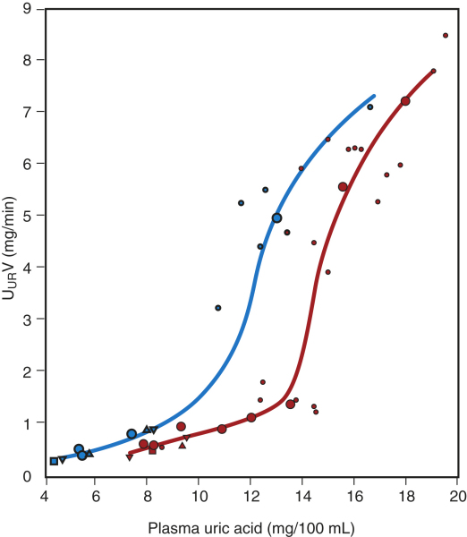
Normal subjects
Gouty subjects
Fig – 13. UA excretion rate as a function of plasma UA level for normal and Gouty subjects [76].
Biologically, UA is primarily synthesized in the liver and cleared mainly (70 - 80 %) via kidney while passing into the urine however a significant part (20 – 30 %) is also excreted into the intestine. But the incident of impaired intestinal UA disposal alone is never considered to be a major cause of Hyperuricemia instead the renal impairment always takes up the higher priority.
The prior studies regarding the handling of UA by kidney follows a four component model: A) glomerular filtration, B) reabsorption of most of the filtered UA, C) secretion of a part of reabsorbed UA and D) post secretory further absorption of secreted UA in the proximal tubules [76]. But those previous studies were based on the assumption that the antiuricosuric action played by the drug Pyrazinamide (Anti - tuberculosis drug) inhibiting the effect of UA secretion in proximal tubules. Unfortunately, the idea turns invalid [77]. Further studies later pointed out that an active metabolite, Pyrazionoate mono-carboxylate (PZA) from Pyrazinamide acts as a stimulus to the tubular reabsorption of Urate anion while serving as a substrate for the Urate – anion exchanger on the apical side of the tubular cells [78, 79]. In that way it induces Hyperuricimic effect by helping raise the Urate level in plasma.
Fig – 14. Conversion of Pyrazinamide to Pyrazinoic acid, an active metabolite, which ionizes at physiologic pH to Pyrazinoiate anion (PZA) influencing Hyperuricemia.
The identification of specific UA transporter in human later revealed the mechanism of Urate transport in kidney at molecular and genetic level. In 2002, Enmoto et al identified Urate transporter, URAT1 in human kidney [1, 80]. It is encoded by SLC22A12 and belongs to the Organic Anion Transporter (OAT) family located on the apical side of the proximal tubule. Characteristically, although URAT1 is identified as being very specific but still it shows some inclination toward other monovalent anions like Nicotinate or Pyrazinoate (PZA) who can adversely affect the UA transport. Besides the specific URAT1 several anion transporters especially those capable of Urate transport are also identified, for example; OAT1, OAT3, OAT4, OATv1/NPT1 and MRP4 [76, 81]. They can transport Urate anions to a varying extent [81& 82]. Like URAT1, the OAT1, OAT4, OATv1/NPT1 and MRP4 exist on the apical membrane of the proximal tubule. By nature, OAT4 is known as a carboxylate (- COO⁻) anion exchanger but can transport the Urate ion also [83]. OATv1 or its human analog NPT1 is voltage dependent organic anion transporter. It works on the voltage sensitive luminal exit pathway of Urate [84]. In human, MRP4 is basically an ATP driven unidirectional efflux pump and transport Urate anions in a positive and co-operative manner (K_{m} = 1.5 mM) [85]. Records further indicate that MRP4 also regulates the hepatic transport of Urate by exporting it to the circulation since it is expressed on the baso-lateral membrane of the liver cells. The proteins OAT1 and OAT3 also express on the baso-lateral side of proximal tubular cell membrane in order to transport the Urate anions (OAT1, K_{m} = 0.94 mM and OAT3, K_{m} = 2.8 mM) [81, 86 & 87]. But the directions of Urate anion transport by OAT1 and OAT3 are often questionable and yet to be determined [88, 89]. On the other hand UAT / Galectin 9 expresses on the apical side and acting as a Urate channel effluxing Urate anions from the cell [90]. The overall interaction mechanism suggests that these three protein molecules (OAT4, NPT1 & MRP4) along with OAT1 usually associate with the scaffolding protein PDZK1 or Na⁺ / H⁺ exchange regulatory factor (NHERF1) subsequently making a multi-molecular complex for transporting the Urate anions [91 & 92]
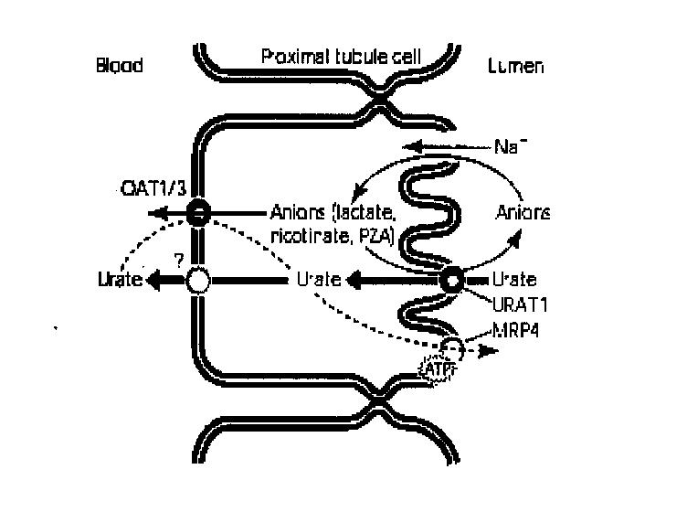
Fig – 15. Urate transport in renal proximal tubule. In case of humans the reabsorption of Urates is a dominating factor excreting less after filtering through glomerulus. URAT1 is liable for Urate reabsorption acting as an anion exchanger on apical memebrane. OAT1 and OAT3 are the basolateral Urate transporters and involved in basolateral Urate uptake. MRP4 is an apical ATP dependent exporting transporter.
Table 1. – Influence of several drugs on Urate level and the accompanying mechanism
Substances | Mechanism Involved
Urate Increasing
Pyrazinoate | Stimulation of URAT-1
Nicotinate | Stimulation of URAT-1
Lactate,β-hydroxybutyrate, Acetoacetate | Stimulation of URAT-1
Salicylate(Low dose) | Decreasing the renal excretion
Diuretics | Enhancing renal tubular reabsorption in conjunction with volume depletion and stimulating URAT-1
Cyclosporine | Enhnaces renal tubular reabsorption while decreasing glomerular filtration
β- Blockers | Not known yet
Tacrolimus | Same as Cyclosporine
Ethambutol | Decreases renal urate excretion
Urate Lowering agents
Uricosurics
Probenecid | Inhibits URAT-1
Sulfinpyrazone | Inhibits URAT-1
Benzobromarone | Inhibits URAT-1
Losartan | Inhibits URAT-1
Fenofibrate | Inhibits URAT-1
Salicylate (High) | Inhibits URAT-1
Amlodipine | Increses renal Urate excretion

Considering the gender specific discrepancy, in men Urate level in circulation starts to increase from the adolescence and stays very much constant throughout the adulthood whereas for the women it shows consistently low level until reaching at menopause state when the level begins to rise until to the extent of adult men. The gender specific differences in OAT1, OAT2 and OAT3 gene expression have been identified. The mRNA for OAT1 is increased right after the birth in both sexes but after reaching the puberty its level declines in the case of female whereas for male it remains constant [93]. The OAT1 expression level at proximal tubule is higher for male than the female. The administration of testosterone enhances that level but on the contrary estradiol lowers it. The discrepancy concerning URAT1 level in either sex has not been strictly identified yet however an androgen responsive element has been located in the promoter of its gene [94]. This may suggest a possibility of gender differences concerning the URAT1 expression which could be higher in case of men.
The continuing high ingestion of alcohol causing Hyperuricemia occurs due to the increased level of lactic acid formation that enhances the level of β – hydroxyl butyrate or any other aceto-acetate during diabetic ketosis [10, 83]. Inhibition studies performed previously showed that the transport paths are selectively shared by several anions and drugs like Lactate, Nicotinate, Acetoacetate and β- hydroxyl- butyrate etc. Therefore the high concentration of these anions like lactates with significant affinity toward URAT1 would be anti-uricosuric when driving the influx of Urate during acting from the intracellular space thus regulating its level as seen in the Table – 1 & 2 [1, 95, 96].

 | Urate Uptake: %
Control | 100.0 ± 15.2
Lactate (10mM) | 46.4 ± 8.0
Aceto-acetate (10mM) | 51.3 ± 5.8
Β – Hydroxy – butyrate (10 mM) | 50.0 ± 4.3
Nicotinate (1.0 mm) | 26.1 ± 3.2
Pyrazine Carboxylate (1.0 mM) | 27.7 ± 3.1

Table -2. Selectivity of URAT1Substrate
Substances Causing Hyperuricemia
The action of drugs like Probenecid, PZA or Aspirin show dual behavior [97, 98]. At low doses they cause Urate retention due to enhanced reabsorption from intracellular side inducing probable Hyperuricemia whereas at high doses they inhibit reabsorption from the luminal side creating an opposite effect.
In addition to URAT1 another similar categories of organic anion exchangers / transporters encoded by the SLC22A12 gene are also identified [99]. The transporter Glut9 encoded by SLC2A9 and normally involved in glucose transport is also identified and found to be capable of transporting Urate anions and plays a significant role in the development of Gout [99, 100]. In human and mice Glut9 expresses in two isoforms (Glut9a & Glut9b) of alternative spliced variants encoding non-identical amino terminal cytoplasmic tails [101, 102]. Glut9b is seen to be expressed mainly in the liver and kidney whereas Glut9a is seen widely distributed in various cells (Leucocytes, chondrocytes) and other internal organs (Liver, kidney and intestine) [101, 103]. The inflammatory cytokines up-regulate Glut9a expression [104]. It has been noticed that joint action of both Glut9a and Glut9b is responsible for ~ 3.5 % variations in plasma Urate level [99, 105]. The transport is not inhibited by either Glucose or Fructose even at extreme doses. The transport is electrogenic by nature and does not depend on either Na⁺ or Cl⁻ level but depends on the membrane potential [99, 106]. The transport is inhibited by uricosuric agents (~90% by Benzobromarone and ~ 50% by Losartan but very little by PZA). Further study also identifies the association of two other Urate efflux transporters in proximal duct belonging to ATP binding Casette G2 family and SLC7A3 encoding NPT4 situated on the proximal tubules acting as Na⁺ / PO₄ ⁻³cotransporter [107]. Polymorphism in SLC7A1 gene encoding NPT1 acting as Na dependent PO₄ is also involved in Hyperuricemia and Gout [99]. The recent studies regarding genomic contribution to Gout indicates that SLC2A9 offers ~ 5 % and the others about less than 1 % to the overall UA level [99].
In physiologic system, kidney plays an immensely important role in transporting Urate anions since it clears 70 % of the total Urate produced in our body. Thus renal Urate control especially in case of under secretion is a major event in the Gout formation. In that regard, the identification of specific Urate transporter URAT1 will help construct more effective uricosuric agent to lower the incident of Hyperuricemia leading to Gout. Hyperuricemia also can create UA stone inside the kidneys. The incidence of renal UA stones is ~ 10 - 20 % higher in case of patients having chronic Hyperuricemia or Gout [1, 76 & 105]. Since Purine level relating to the nature of food intake is one of the primary factor therefore urinary UA excretion also relates to the dietary protein ingestion. Animal proteins are normally high in Purines and further the glandular sources like liver shows the enriched level. Additionally the proteins enriched with sulfur containing amino acids when metabolized, creates sulfuric acid increasing the acidity of urine thus eventually help precipitating the UA / Urate crystals [108]. Typically the pK_{a} of human urine is ~ 5.3, so in acidic urine most UA molecules will be in the un-dissociated form. For its lack of solubility at low pH UA will be deposited as stone. Statistically, UA stones cover almost ~ 10 - 20 % of all the kidney stones analyzed so far [1, 99, 109]. The treatment of UA stones normally involve; A) drinking large amount of water (> 2L / Day) for diluting the urine. B) low protein diet (< 1.0 g / Kg of body weight / Day) and C) taking oral dose of K- citrate to raise the urine pH level (6.5 – 7.0). But pH > 7.0 would not increase the UA solubility significantly whereas on the contrary it may produce an adverse effect by precipitating the calcium apatite. So the uptake of alkali should be kept very limited amounting to 50 – 100 mEq / day. In most cases K- citrate is the preferred choice [110].
Inflammatory action of Gout: Primarily, Gout is an inflammatory disease exerting debilitating pain in the remote joints. In all cases the deposition of Monosodium Urate (MSU) crystals is the root cause for over all inflammatory condition. The conditions of continued Hyperuricemia often lead to the MSU deposition in distal peripheral joints affecting mainly in the areas of foot or knee. In the upper limbs the effect is noticeable to a lesser extent. It is proven that solubility of the Urate ions decreases with the lowering of temperature and more significantly in presence of isotonic condition even at physiologic pH (Fig – 16) [33, 38]. So the appearance of crystal deposition at distal peripheral joints is logically assumed to be due to the possible cooler temperature at those regions which helps nucleation of the crystal growth because of the solubility reduction. Several in vitro experiments lend a support in its favor [38]. However it has been shown that crystallization or nucleation event is better achieved at low pH, in presence of high Ca⁺² or even stirring of the entire concoction close to the saturation limit of UA which can be equated to be equivalent to inflicting a minor physical trauma [33, 99]. It is known that the affected joint fluids often show less pH [111, 112]. Therefore adding up these events is particularly relevant concerning the in ailments in foot [111, 112]. The figures below summarize the events (Fig – 16 & 17).
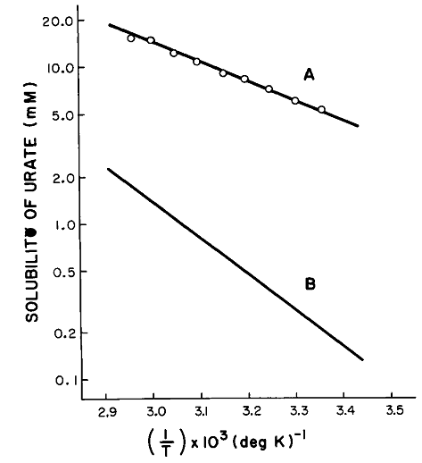
Fig – 16. Effect of temeperature on the solubility of Urate ions. A) Solubility of Na – Urate in water & B) Solubility in presence of 140mM Na⁺ [38].
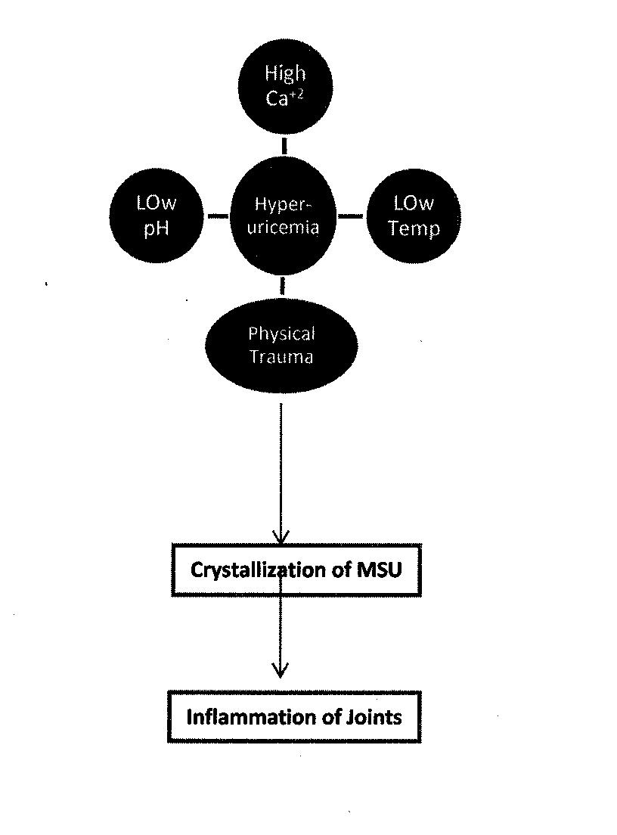
Fig –17. Conditions for MSU nucleation and crystallization to create inflammation.
The evidences of crystal deposition based on clinical and radiographic analysis shows that the lesions taken place at the cartilages are occasionally due to the occurrence of Osteoarthritis (OA) associated with the Gout. Studies around the world factually establish the fact that the incidence of OA associating with Gout is quite significant [33, 113]. Naturally, the question arises how they are associated. There could be two possibilities; either 1) the occurrence of OA might initiate the MSU crystal deposit or 2) the crystals deposited due to Hyperuricemia trigger the immune response causing the cartilage damage. No confirmative answers are founded yet in any one of its favor [25, 39, 40, 114,115]. But noticeably the increased level of chondroitin sulfate and other enzyme degraded products of proteins and polysaccharides inside the articular cartilages reduce the MSU solubility favoring the deposition or crystal growth [115 – 118]. It is also a possibility that the relation between OA and crystallization of MSU is bidirectional [33]. Besides MSU, the deposition of Calcium pyro-phosphate (CPP) also sometimes acts as an added insult in the process although the former is treated with higher priority as an aetiological agent of Gout and also considered as a “danger signal” for starting the inflammatory process. Supposedly, either the MSU or CPP deposition or both together induces inflammation following Caspase -1 activating NALP3 inflammasome producing Interleukin (IL) 1β and IL-18 [41, 113 & 114]. Several recent reports confirmed that MSU crystals by its own merit can cause IL-1β release [118]. Knowingly, the release of IL-1β stimulates inflammatory responses like, PGE2, COX-2 and Matrix metallo-proteases (MMP) [41, 119 – 121]. These exert more damages to the cartilages inflicting pain accompanied by swelling and redness. Further it also stimulates the osteoclasts causing resorption of bones. The incident of bone erosion thus becomes a serious matter and commonly noticed in case of chronic Gout [122].
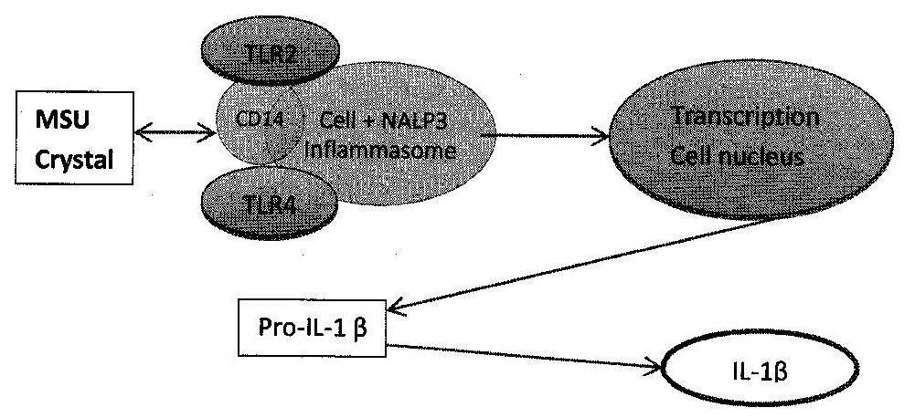
Fig – 18. IL-1β activation by NALP3 inflammasome due to MSU deposition. The cell surface CD14, TLR2 & TLR4 receptors recognize MSU. Afterward it is taken up inside the cell and later utilizes NALP3 through its assembly causing the activation of Caspase -1 and synthesizing pro-IL-1β and subsequently releasing active 1L-1β.
Characteristically, in case of acute Gouty inflammation there are influxes of neutrophil in the joint fluid inside synovium. In normal situations, the immune cells are somewhat absent in that
Table – 3.
Drugs & Categories | Recommended amount | Precautions & Considerations
NSAID |  | Careful for the subjects with renal or hepatic problem, bleeding disorder, allergy or gastrointestinal trouble.
Naproxen | 500 mg twice / day (Orally)
Indomethicine | 50 mg three times / day (Orally)
Colchicine | 1.2 mg at first then 0.6 mg twice daily (Orally)
Gluco-corticoids |  | Precautions for the patients having hyperglycemia or congestive heart failure. Usable for those having any renal impairment.
Prednisolone | 30 – 35 mg / day for at least 5 days
Urate lowering drugs |  | Goal is to maintain UA level 6.0 mg / dl. Dose adjustments may be necessary.
Xanthine Oxidase Inhibitor |  | Used in case of UA overproduction. Avoid in cases of those using 6-Mercapto-purine or Azathioprine because they interact with Xanthine Oxidase.
Allopurinol | 50 – 100 mg / daily (orally) for 2- 4 weeks to reach the target UA level. Median dose of 300 mg / day is often applied but max dose of 800 mg is also used but rarely. | Close monitoring is recommended for those who are using Ampicilln, warfarin, ACE inhibitors or thiazides and several other drugs.
Febuxostat | 40 – 80 mg / daily to achieve the target UA level which takes ~ 2 – 4 weeks. | Used as second line of choice if patients cannot use Allopurinol.
Uricosuric Agents
Probenecid | Initially 250 mg / day (Oral) later can be raised to almost 2 -3 g / day for patients with normal renal function. | High water intake is necessary to avoid nephrolithiasis. Renal UA excretion is needed to be monitored. Identification is also required for patients whether facing the problem of excessive UA production. In case of overproduction this therapy will bring the risk of nephrolithiasis.
Uricase | Intravenous use 8 mg / 2 week. Additional use of anti-histamine & gluco-corticoids is required | Used for patients with chronic Gout when most other drugs fail. Cautions are applied for subjects with congestive heart problem.

region. It is conjectured that the interactions between MSU and resident lining cells triggers the invasion process while allowing the neutrophils to infiltrate which in turn causes pain, swelling etc as frequently seen during the Gout attack. It is confirmed experimentally that MSU can induce the activation of this immune cascade leading to inflammation through the expression of NF-κβ and AP-1 transcription factor thus simultaneously releasing the IL-1, TNF-α and COX-2. The Toll-like receptors, TLR2 and TLR4 including a cell surface adapter CD14 (pattern recognition receptor) play the most vital role during this MSU induced inflammation which ultimately releases the inflammatory cytokine IL-1β (Fig – 18) [41, 120 &121]. It is known that IL-1β production can trigger the formation of other secondary mediators like Prostaglandins, Leucotrienes etc. The Prostaglandin (PG) generation is universally known to be associated with pain and swelling during any inflammation. Biochemically, the PG production is initiated at the onset of Phospholipase - 2 activations, a cell surface enzyme that cleaves Archidonic acid (AA) which afterward is processed to either Prostaglandins or Leukotrienes following either Cyclooxygenase (COX) or Lipooxygenase (LOX) pathway. COX also forms various other PGs (PGE, PGD, PGF & Prostacyclin) including the potent inflammatory mediator Thromboxane (TBx). Prostacyclin generated from the endothelial lining of the blood vessel acts as a natural antagonist of TBx inhibiting the platelet aggregation. As a forward action, these mediators enhance the vascular permeability letting the more flow of invading leucocytes therefore allowing the event of inflammation to continue [123 & 124].
Medications normally used in Gout: The medicines that are commonly used in treating the Gout fall in several categories. Some are directed for short term relief while the others are for long term purposes. For the short term relief the most notable ones fall in these categories; #1) Non-steroidal anti-inflammatory drugs (NSAIDS); #2) Cortico-steroids, #3) Colchicine and #4) Uricosuric agents. They are mainly directed for preventing pain, swelling or flare ups. For example, NSAIDS act by blocking AA metabolism thus preventing the productions of PGs [125].Cortico-steroids prevent the release of phospholipid and simultaneously lower the eosinophils’ actions whereas Colchicine, an antimitotic agent works by disassembling the Tubulin bundle possibly directed to the invading immune cells to block the flare ups including several other adverse effects [126, 127]. For long term treatments the aim is directed mostly to lower the plasma UA which obviously reduces the risk of Gout attack. Those agents fall mostly in two categories; either uricosuric agents (Probenecid, Sulfinpyrzone and others) or any effective inhibitor (Allopurinol, Febuxostat) of xanthine oxidase [62, 128 – 131]. The Table – 4 shows a number of drugs commonly used for Gout treatment. In addition to treat with the medicines, life style management by changing the nutritional aspects or any adjunctive therapies relating to the other ailments are highly recommended for preventing the incident of future Gout attack [133 – 136].

SUMMARY

- Gout occurs due to Hyperuricemia exerting the frequent painful attacks causing inflammatory arthritis at far away bone joints accompanying with tophaceous deposition of UA / Urate crystals.
- Hyperuricemia is defined when serum UA level exceeds > 7.0 mg / dl for men and > 6.0 mg / dl for women.
- Hyperuricemia could be due to due the over-production or under-excretion of UA from the body.
- UA is known to be the final product of human Purine metabolism pathway: a) Purine is either synthesized from non-purine precursors or b) from dietary nucleotide sources or c) from salvage reactions (including inter-conversions and degradation of nucleotides reactions).
- Genetically inherited three enzyme defects are primarily involved in case of overproduction of UA or Hyperuricemia: a) deficiency of Glucose – 6 – phosphatase; b) severe or partial deficiency of HPRT; c) increased activity of PP-ribose-P Synthetase.
- The evolutionary incident of non-expression of Uricase due to nonsense mutation at exon – 2 in human or higher apes along with other enzyme defect is also partly responsible for creating Hyperuricemia.
- About 2 / 3 of the UA produced in the human body are excreted by the kidney and the remaining 1 / 3 are eliminated by bacterial uricolysis inside the intestine.
- The malfunctioning of kidney causing under-excretion of UA also induces Hyperuricemia.
- The genetic alterations of several Urate transporter mostly SLC2A9 or ABCG2) plays a dominant role for causing the under-excretion, intensifying the UA built up inside circulation inducing Hyperuricemia and Gout often viewed in case of kidney malfunctioning.
- The deposition of Urate crystal inside the synovium induces immune response resulting in Gout attack inflicting pain, swelling and stiffness of the joints through the productions of inflammatory mediators.
- The remedies for Gout consist of Anti-inflammatory drugs (NSAID, Gluco-corticoids & Colichicine), enzyme blockers (Allopurinol, Febuxostat) and uricosuric agents (Probenecid, Uricase etc).

ACKNOWLEDGEMENT
The author expresses his sincere gratitude to Dr Rajesh Kumar Barur for his immense help in too many ways including allowing the use of UMASSMED library. Most appreciation is awarded to author’s wife for holding patience in the household during the time of manuscript compilation. The article is dedicated to the memory of Dr Sunil Kumar Das-Gupta of Worcester, MA who was the real inspiration behind this work.

BIBLIOGRAPHY
- Anzai N, Enomoto A, Endou H. Renal Urate handling: Clinical relevance of recent advances. Curr. Rheumatology Report. 2005; p 227 – 234 Vol. 7.
- Becker MA, Roessler BJ. In: Scriver CR, Sly WS, Beaudet AI. eds. Metabolic and molecular basis of inherited diseases. 7th ed. 1995; (ch. 49): p 1655 -1677 Vol 2.
- Gibson T, Simmonds HA et al. A controlled study of diet in patients with Gout. Ann. Rheum. Dis. 1983; p 123 –127 Vol. 83.
- Alderman MH. Uric acid and cardiovascular risk. Curr. Opin. Pharmacol. 2002; p 126 – 130 Vol.2.
- Garcia J, Martinez MA. Hyperuricemia and metabolic syndrome. Curr. Opin. Rheum. 2008; p 187 – 191 Vol. 20.
- Feig DI, Kang DH, Johnson RJ. Uric acid and cardiovascular risk. N. Engl. J. Med. 2008; p1811-1821 Vol. 359.
- Choi HK, Atkinson K, Karlson EW et al. Alcohol intake and risk of incident of Gout in men: A perspective study. Lancet. 2004; p 1277 – 1281 Vol. 363.
- Gibson T, Rodgers AV, Simmonds HA et al. Beer drinking and its effect on Uric Acid. Rheumat. 1984; 203 -209 Vol. 23.
- Eastman GJ et al. The effect of alcoholic beverages on Urate metabolism I gout sufferers. Brit. J. Rheumat. 1995; p 756 – 759 Vol. 34
- Yamamoto T, Moriwaki Y, et al. Effect of ethanol on metabolism of purine bases (Hypoxanthine, Xanthine and Uric acid). Intern. J. Clin. Chem. 2005; p 35 – 57 Vol. 1-2.
- Choi HK, Atkinson K, Karlson EW, Wilett W & Curhan G. Purine rich foods, dairy and protein intake and risk of Gout in men. N. Engl. J. Med. 2004; p 1093 – 1103 vol. 350.
- Choi HK. Diet, alcohol and Gout: How do we advise patients giving recent developments? Curr. Rheumatol. Rep. 2005; p 220 – 226 vol. 17.
- Purine Levels in Foods. www.accumedico.com
- Neogi T. Gout. New Engl. J. Med. 2011; p 443 – 452 Vol. 364.
- Lawrence RC, Felson DT, Helmick CJ, et al. Estimates of the prevalence of arthritis and other rheumatic conditions in the United States.Part – III. Arthritis. Rheumat. 2008; p 26 – 35 Vol. 58.
- Arrondee E, Michet CJ, Crawson CS, et al. Epidemiology of gout: Is the incidence rising? Rheumatol. 2002; p 2403 – 2407 Vol. 7.
- Wallace KI, Riedel AA, Joseph – Ridge N, et al. Increasing prevalence of gout and Hyperuricemia over 10 years among older adults in a managed care population. J. Rheumatol. 2004; p 1582 –1587 Vol. 31.
- Roddy E, Doherty M. Epidemiology of Gout. Arth. Res. & Therap. 2010; p 223 – 234 Vol. 12.
- Shannon M & Handel MA. Expression of HPRT gene during spermatogesis: Implications for sex chromosome inactivation. Biol. Reprod. 1993; p 770 – 778 Vol. 49.
- Lee CC, Caskey CJ, Wu X, et al. Urate oxidase: Primary structure and evolutionary implications. Proc. Natl. Acad. Sci. USA. 1989; p 9412 – 9416 Vol. 86.
- Oda M, Satta Y, Takenaka O & Takahata N. Loss of Urate Oxidase activity in Homonoids and its evolutionary implications. Mol. Biol. Evol. 2002; p 640 – 653 Vol. 19.
- Slott GS & Hooper DC. The role of Uric acid in protection against peroxy-nitrite mediated pathology. Med. Hypotheses. 2001; p 95 – 101 vol. 56.
- Abadeh S, Killachy J, Benoboubetra M & Harrison R. Purification and characterization of xanthine oxidase from human milk. Biochim. Biophys. Acta. 1992; p 25 – 32 Vol. 1117.
- Xu P, Lavalle P and Hoidal JR. Repressed expression of the human xanthine oxido-reductase gene. J. Biol. Chem. 2000; p 5918 – 5926 Vol. 275.
- Merriman T & Dalbeth N. The genetic basis of Hyperuricemia and Gout. Joint Bone Spine. 2011; p 35 – 40 Vol. 78.
- Caspi D, Lubert E, Gaffe E, et al. The effect of mini-dose Aspirin on renal function and uric acid handling in elderly patients. Arthritis Rheumat. 2000; p 103 – 108 Vol. 43.
- Yu TF, Gutman AB. Study of the paradoxical effects of salicylate in low, intermediate and high dosage on the renal mechanisms for excretion of Urate in man. J. Clin. Invest. 1959; p 1298 – 1315 Vol.38.
- Rodriguez G, Soriano LC, Choi HK. Impact of diabetes against the future risk of developing gout. Am. Rheumat. & Dis. 2010; p 2090 – 2094 Vol.69.
- Ames BN, Cathart R, et al. Uric acid provides an anti-oxidant defense in humans against oxidant and radical – caused aging and cancer: A hypothesis. Proc. Natl, Acad. Sci. USA. 1985;p6858–6862 Vol. 78.
- Bagnati M, Perugini C, Cau C, et al. When and why a water soluble anti-oxidant becomes pro-oxidant during Copper induced low-density lipoprotein oxidation: A study using uric acid. Biochem. J. 1999; p 143 – 152 Vol.340.
- Curie WJ. Prevalence and incidence of the diagnosis of gout in Great Britain. Ann. Rheum. Dis. 1979; p 101 – 106 Vol. 38.
- Malik A, Schumacher HR, Dinella JE, et al. Clinical diagnostic criteria for gout: Comparison with gold standard of synovial fluid crystal analysis. J. Clin. Rhematol. 2009; 22 – 24 Vol. 14.
- Roddy E. Revisiting the pathogenesis of podagra: Why does gout target the feet? J. Foot & Ankle Res. 2011; p 13 – 19 Vol. 4.
- Dehgan A, Kottgen A, Yang Q, et al. Association of three genetic loci with uric acid concentration and risk of gout. Lancet. 2008; p 1953 – 1961 Vol. 373.
- Klotz E, Johnson T, Sanna S, et al. Meta-analysis of 28,141 individuals identifies common variants within five new loci that influence uric acid concentration. Ploo Genet. 2009; e1000504-5.
- Campion EW, Glynn RJ, Delbry LO. Asymptotic Hyperuricemia. Risks and consequences in the normative aging study. Am. J. Med. 1987; p 421 – 428 Vol. 82.
- Hall AP, Barry PE, Dawber TR, et al. Epidemiology of gout and Hyperuricemia. A long term population study. Am. J. Med. 1967; p 27 – 32 Vol. 42.
- Loeb JN. The influence of temperature on the solubility of Mono-sodium Urate. Arthritis. Rheumat. 1972; p 189 – 92 Vol. 15.
- Burt HM, Dutt YC. Growth of Mono-sodium urate crystals: Effect of cartilage and synovial fluid on in vitro growth rates. Ann. Rheumatol. & Dis. 1986; p 858 – 864 Vol. 45.
- Katz WA, Schubert M. The interaction of Mono-sodium Urate with connective tissue components. J. Clin. Invest. 1970; p 1783 – 1789 Vol.49
- Liu-Bryan R. Intracellular innate immunity in gouty arthritis: Role of NALP3 inflammasome. Immunol. & Cell Biol. 2010; p 20 – 23 Vol. 88.
- Landis RC, Haskard DO. Pathogenesis of crystal induced inflammation. Curr. Rhematol. Rep. 2001; p 36 – 41 Vol.3.
- Aldermann MH. Uric acid: Role in cardiovascular disease – Effect of Losartan. www.medscape.com/viewarticle/472684.
- Bhole V, de-Vera M, Rahman MM, et al. Epidemiology of gout in women: Fifty year follow up of a prospective cohort. Arthritis Rhemat. 2010; p 1069 – 1076 Vol. 62.
- Roubenoff R, Klag MJ, Mead LA, et al. Incidence and risk factors for gout in white men. JAMA. 1991; p 3004 – 3007 Vol. 266.
- Lin KC, Liu HY, Chou P. The interaction between uric acid level and other risk factors on the development of gout in Kin-Hu, Kinmen. J. Rheumatol. 2000; p 1045 – 1050 Vol. 27.
- Gutman AB. Renal excretion of uric acid in normal and gouty man. Arthritis & Rhematol. 1965; p 665 – 671 Vol.8.
- Kramer HJ, Choi HK, Atkinson K, et al. The association between gout and nephrolithiasis in men: The health professional’s follow up study. Kidney Int. 2003; p 1022 – 1026 Vol. 64.
- Chou JA, Matern D, Mansfield BC, et al. Type -1 Glycogen storage disease: Disorders of the glucose -6- phosphatase complex. Curr. Mol. Med. 2002; p 121 – 143 Vol.2.
- Cohen JL, Vinik A, Falter J, et al. Hyperuricemia in glycogen storage disease Type -1. J. Clin. Invest. 1985; p 251 – 257 Vol.75.
- Kruger NJ, Schaewen A. The oxidative pentose phosphate pathway: structure and organization. Curr. Opin. Plant Biol. 2003; p 236 – 246 Vol.6.
- Williams J. Pentose phosphate pathway, History of. Encyclo. Biol. Chem. 2004; p 216 –246 Vol.3.
- Bali DS, Chen YT, Goldstein JL, et al. Glycogen storage disease Type. Gene Reviews. US National Library of Medicine, National Institute of Health. www.ncbl.nlm.nih.gov/books/NBK1312.
- Scully DG, Dawson PA, Emmerson BT, et al. A review of the molecular basis of hypoxanthine guanine phosphoribosyl transferase (HPRT) deficiency. Hum. Genet. 1993; p 195 – 207 Vol. 90.
- Stout JT, Caskey CT. HPRT gene structure, expression and mutation. Ann. Rev. Genet. 1986; p 127 – 148 Vol. 19.
- Sege-Peterson K, Chamber J, Page T, et al. Characterization of mutations in phenotypic variants of hypoxanthine phosphoribosyl transferase deficeiency. Hum. Mol. Genet. 1993; p 427 – 432 Vol. 1.
- Torres RJ, Puig JG. Hypoxanthine – guanine phosphoribosyl transferase (HPRT) deficiency: Lesch-Nyhan syndrome. Orphn. J. Rare Dis. 2007; p 47 – 57 Vol. 2.
- Richard C, Yen K, William B, et al. Evidence for X- linkage of human phospho-ribosyl pyrophosphate Synthetase. Proc. Natl. Acad. Sci. USA. 1978; p 482 – 485 Vol. 2.
- Friedman T, Seegmillar JE, Subak-Sharpe JH. Evidence against the existence of Guanosine and Inosine Kinases in human fibroblast in tissue culture. Expt. Cell. Res. 1969; p 425 – 429 Vol. 56.
- Purine catabolism. www.gout-aware.com/purine-catabolism.
- Xi H, Schneider BL, Reitzer L. Purine catabolism in Escherichia Coli and function of xanthine dehydrogenase in purine salvage. J. Bactriol. 2000; p 5832 – 5841 Vol.182.
- Bichemistry 5th edition eds Berg JM, Tymoczko JL, Stryer L. New York: W.H. Freeman (2002). www.ncbi.nih.gov/books/NBK22447/
- Pacher P, Nivorozhkin A, Szabo C. Therapeutic effects of xanthine oxidase inhibitors: Renaissance Half a century after the discovery of Allopurinol. Pharmacol. Rev. 2006; p 87 – 114 Vol. 58.
- http://dailymed.nlm.nih.gov.
- Wyngaarden JB. Metabolic defects of primary Hyperuricemia and gout. Am. J. Med. 1974; p 651 – 665 Vol.56.
- Kanno H, Tani K, Iguchi-Ariga SH, et al. Adenosine deaminase over-production associated with congenital hemolytic anemia: Case Report & Molecular Analysis. Jpn. J. Exp. Med. 1988; p 1–8 Vol. 58.
- Funato T, Nishiyama Y, Ioritani N, et al. Detection of mutations in adenosine phosphoribosyl transferase (APRT) deficiency using Light Cycler System. J. Clin. Lab. Analysis. 2000; p 274–279 Vol.14.
- Kamatani N, Adenosine phosphoribosyl transferase (APRT) deficiency. Jpn. J. Clin. Med. 1996; p 3321 – 3327 Vol.54.
- Edwards NL. The role of Hyperuricemia and gout in kidney and cardiovascular disease. Clev. Clin. J. Med. 2008; p S13 – S14 Vol. 75(Suppl. 5).
- Pitts OM, Priest DG & Fish W. Uricase. Subunit composition and Resistance to denaturants. Biochemistry. 1974; p 888 – 893 vol. 13(5).
- Mahler HR, Hubscher G & Baum H. Studies on Uricase – Preparation, Purification and Properties of a Cuproprotein. J. Biol. Chem. 1955; p 625 – 641 vol. 216.
- Izuhara M, Ito M, Takagi Y. Transcription of the rat liver Uricase – encoding gene is regulated via Cis – acting element response to cAMP. Gene. 1995; p 267 – 272 vol. 167.
- Chisten P, Peacock WC, Chisten AE, Wacker WEC. Urate Oxidase in primate phylogenesis. Eur. J. Biochem. 1970; p 3 – 5 vol. 12.
- Dincer HE, Dinser AP, Levinson DJ. Asymptotic Hyperuricemia: To treat or not to treat. Cliv. J. Med. P 594 – 602 vol. 69.
- http://mulla.pri.ee/kelly’stextbookof rheumatology, 8th ed.
- Taniguchi A, Kamatani N. Control of renal uric acid excretion and gout. Curr. Opin. Rheumat. 2008; p 192 – 197 Vol. 20.
- Terkeltaub R, Bushinsky DA, Becker MA. Recent developments in our understanding of the renal basis of Hyperuricemia and the development of novel anti-hyperuricemic therapeutics. Arthritis. Res. Ther. 2006; p S4 – S8 Vol. Suppl. -1.
- Mount DB. Molecular physiology and the four component model of renal urate transport. Curr. Opi. Nephrol. Hypertens. 2005; p 460 – 463 Vol. 14.
- Roch-Ramel F, Guisan B. Renal transport of Urate in humans. News Physiol. Sci. 1999; p 80–84 Vol.14.
- Enomoto A, Kimura H, Chairoungdua A, et al. Molecular identification of renal a Urate anion exchanger that regulates blood Urate level. Nature. 2002; p 447 – 452 Vol.417.
- Anzai N, Kanai Y, Endo H. New insights into renal transport of Urate. Curr. Opin. Rheumatol. 2007; p 151-157 Vol. 19.
- Hediger MA, Johnson RJ, Miyazaki H, et al. Molecular physiology of Urate transport. Physiology (Bethesda) 2005; p 125 – 133 Vol. 20.
- Ekaratanawong S, Anzai N, Jutabha, et al. Human organic transporter 4 is a renal apical organic anion / diacrboxylate exchanger in the proximal tubules. J. Pharmacol. Sci. 2004; p 297 – 304 Vol. 94.
- Jutabha P, Kanai Y, Hosoyamada M, et al. Identification of a novel voltage-driven organic anion transporter present at apical membrane of renal proximal tubule. J. Biol. Chem. 2003; p 27930 – 27938 Vol. 278.
- Van-Aubel RA, Smeets PH, vanden-Heuvel JJ, et al. Human organic anion transporter MRP4 (ABCC4) is an efflux pump for the purine end-product metabolite urate with multiple allosteric substrate binding sites. Am. J. Physiol. Renal. Physiol. 2005; p F327 – 333 Vol. 288.
- Hosoyamada M, Sekine T, Kanai Y, et al. Molecular cloning and functional expression of a multi-specific organic anion transporter from human kidney. Am. J. Physiol. Renal Physiol. 1999; p F122 – F128 Vol. 276.
- Cha SH, Sekine T, Fukushima JL, et al. identification and characterization of human organic anion transporter 3 expression predominantly in kidney. Mol. Pharmacol. 2001; p 1277 – 1286 Vol. 59.
- Zhang X, Graves CE, Bahn A, et al. Relative contribution of OAT and OCT transporters to organic electrolyte transport in rabbit proximal tubule. Am. J. Physiol. Renal Physiol. 2004; p F999 – F-1010 Vol. 287.
- Bakhiya N, Bahn A, Burkhardt G, et al. Human anion transporter 3 (hOAT3) can operate as an exchanger and mediate secretory Urate efflux. Cell Physiol. Biochem. 2003; 272: p 18526 – 18529 Vol. 272.
- Lipkowitz MS, Leal-Pinto E, Cohen BE, et al. Galactin 9 is the sugar-regulated urate transporter / channel UAT. Glycology. J. 2004; 19: p 491 – 498 Vol.19.
- Russel FG, Masereeuw R, van-Aubel RA. Ann. Rev. Physiol. 2002; p 563 – 594 Vol.64.
- Anzai N, Jutabha P. Kanai Y, et al. Integrated physiology of proximal tubular organic anion transport. Curr. Opin. Nephrol. Hypertens. 2005; p 472 – 479 Vol. 14(5).
- Hosoyamada M, Ichida K, Enomoto A, et al. Function and localization of Urate transporter 1 in mouse kidney. J. Am. Soc. Nephrol. 2004; p 261 – 268 Vol. 15.
- Li T, Walsh JR, Ghisan FK, et al. Molecular cloning and characterization of a human Urate transporter (hURAT1) gene promoter. Biochim. Biophys. Acta. 2004; 1681: p 53 – 58 Vol. 1681.
- Gopal E, Fei YJ, Sugawara M, et al. Expression of SLC5a8 in kidney and its role in Na⁺ coupled transport of lactate. J. Biol. Chem. 2004; 279: p 44522 – 44532 Vol. 279.
- Roch-Ramel F, Werner D, Guisan B. Urate transport in brush – border membrane of human kidney. Am. J. Physiol. 1994; p F797 – F805 Vol. 266.
- Cannella AC, Mikuls TR. Understanding treatments for gout. Am. J. Manag. Care. 2005; p S451 – S458 Vol. 11.
- Terketaub R. Update on Gout: New therapeutic strategies and options. Nat. Rev. Rheumatol. 2010; p 30 – 38 Vol. 6.
- So A, Thorens B, Uric acid transport and disease. J. Clin. Invest. 2010; p1791 – 1799 Vol. 120.
- Phay JE, Hussain HB, Moley JF. Cloning and expression analysis of a novel member of the facilitative glucose transporter family SLC2A9 (glut9) Genomics. 2000; p 217 – 220 Vol. 66.
- Keembiyaehetty C et al. Mouse glucose transporter 9 splice variants are expressed in adult liver and kidney and upregulated in diabetes. Mol. Endocrinol. 2006; p 686 – 697 Vol. 20
- Augustin R, Carrayannopoulos MO, Dowd Lo, et al. Identification and characterization of human glucose transporter-like protein -9 (Glut 9): Alternative splicing alters trafficking. J. Biol. Chem. 2004; p16229 -16236 Vol. 279.
- Doege H, Bocianski A, Joost HG, et al. Activity and genomic organization of human glucose transporter (Glut 9), a novel member of the family of sugar-transport facillators predominantly expressed in brain and leucocytes. Biochem. J. 2000; p771 – 776 Vol. 350.
- Shikman AR, Brinson DC, Valbrecht J, et al. Cytokine regulation of facilitated glucose transport in human articular chondrocytes. J. Immunol. 2001; p 7001 – 7008 Vol. 167.
- Li S et al. The Glut 9 gene is associated with serum uric acid levels in Sardinia and Chianti cohorts. PLoS Genet. 2007; e194 – 203.
- Bibert S et al. Mouse Glut 9: Evidences for a urate transporter. Am. J. Physiol. Renal Physiol. 2009; p F612 – F619 Vol. 297.
- Ishibushi K, Matruzaki T, Takata K, et al. Identification of a new member of type1 Na / PO₄ co-transporter in rat kidney. Nephron. Physiol. 2003; p 10 – 18 Vol. 94.
- Robertson WG, Peacock M, Heyburn IA et al. Should recurrent calcium oxalate stone formers become vegetarians? Brit. J. Urol. 1979; p 427 – 431 Vol. 51.
- Choi HK, Mount DB, Reginato AM; Pathogenesis of Gout. Ann. Intern. Med. 2005;p 499 –510 Vol. 143.
- Diet for kidney stones / Kidney stones – diet. www.medindia.net.

- Wilcox WR, Khalaf AA. Nucleation of mono-sodium Urate crystals. Ann. Rhematol. Dis. 1975; p 332 – 339 Vol.34.
- Kippen I, Klinenberg JR, Weinberger A, et al. Factors affecting urate solubility in vitro. Ann. Rhematol. Dis. 1974; p 313 – 317Vol. 33.
- Pascal E, Ordone ZS, Orderly arrayed deposits of urate crystals in gout suggests epitaxial formation. Ann. Rheum. Dis. 1998; p 255 – 259 Vol. 57.
- Muehlman CV, Algner T, Li J, et al. Association between crystals and cartilage degeneration in the ankle. J. Rheumatol. 2008; p 1108 – 1117 Vol. 35.
- Denoble AE, Huffman KM, Stabler TV, et al. Uric acid is a danger signal of increasing risk for osteoarthritis through inflammasome activation. Proc. Natl. Acad. Sci. USA. 2011; p 2088-2093 Vol.108.
- Nowatzky J, Howard K, Pillinger MH, et al. The role of uric acid and other crystals in osteoarthritis. Curr. Rheumatol. Rep. 2010; p 142 – 148 Vol. 12.
- Joosten LA, Netea MG, Mylano E, Koender MI et al. Engagement of fatty acids with Toll-like receptor -2 drives interleukin – 1 β production via ASC/Caspase -1 pathway in Monosodium Urate crystal induced gouty arthritis. Arthritis Rheumat. 2010; p 3237 – 3248 vol. 62(11).
- Laurent TC. Solubility of sodium urate in the presence of Chondroitin – 4 sulfate. Nature. 1964; p1334 – 1335 Vol. 202.
- Landis RC, Haskard DO. Pathogenesis of crystal – induced inflammation. Curr. Rheumatol. Rep. 2001; p 36 -41Vol. 3.
- Di-Giovanni FS, Malawista SE, Nuki G, et al. Interleukin – 1 (IL-1) as a mediator of crystal arthritis, stimulation of T and synovial fibroblast mitogenesis by Urate crystal induced IL -1. J. Immunol. 1987; p 3213 – 3218 Vol.138.
- Coyne DW, Nickels M, Bertrand W, et al. Regulation of messengial cell cyclooxygenase synthesis by cytokines and glucocorticoids. Am J. Physiol. 1992; p F97 – F102 Vol. 263.
- Chen CJ, Shi Y, Hearn A, et al. MyD88 – dependent IL – 1 receptor signaling is essential for gouty inflammation stimulated by monosodium urate crystals. J. Clin. Invest. 2006; p 2267–2272 Vol. 116.
- Martinon F, Petrilli V, Mayor A, et al. Gout associated uric acid crystals activate NALP3 inflammasome. Nature. 2006; p 237 – 241 Vol. 440.
- Dalbeth N, Clark B, Gregory K, et al. Mechanisms of bone erosion in gout. A quantitative analysis using plain radiography and computed tomography. Ann. Rheum. Dis. 2009; 68: p1290-1295Vol. 68.
- Johnston MG, Hay JB, Movat HZ. The modulation of enhanced vascular permeability by prostaglandins through alterations in blood flow. Agents Actions. 1976; 6: p 705 -711 Vol. 6.
- Williams TJ, Morley J. Prostaglandins as potentiators of increased vascular permeability in inflammation. Nature (Lond). 1973; p 215 – 217 Vol. 246.
- Vane R. Introduction: Mechanism of action of NSAIDS. Brit. J. Rheumatol. 1996; p1 – 3 Vol. 35(Spl -1).
- Goppelt – Struebe M, Wolter D, Resch K. Glucocorticoids inhibit Prostaglandin synthesis not only at the level of Phospholipase A2 but also at the level of Cyclo-oxygenase / PGE isomerase. Brit. J. Pharmacol. 1989; p1287 – 1295 Vol. 98.
- Spilberg I, Mandell B, Mehta J, et al. Mechanism of action of Colchicin in acute urate crystal induced arthritis. J. Clin. Invest. 1979; p 775 – 780 Vol. 64.
- Mason RM. Studies on the effect of Probenecid in gout. Ann. Rheum. Dis. 1954; p120 – 130 Vol. 13.
- Hsyu PH, Gislan LG, Hui AC, et al. Interactions of organic anions with organic cation transporters in renal BBMV. Am. J. Physiol. 1988; p F56 – F61 Vol. 254.
- Underwood M. Diagnosis and management of gout. Brit. Med. J. 2006; p1315 – 1319 Vol. 332.
- Stamp LK, O’Donell JL, Chapman PT. Emerging therapies in the long term management of Hyperuricemia and gout. Int. Med. J. 2007; p 258 – 266 Vol. 37.
- Schelsinger N, Schumacher HR. Jr. Gout: Can management be improved? Curr. Opin. Rheumatol. 2001; p 240 – 244 Vol. 13.
- Gout Diet. www.mayoclinic.com/health/gout-diet/MY01137.
- Medline Plus. (Gout). www.nlm.nih.gov./medlineplus/gout.

