Effect of Metformin on pathological indices related to cardiovascular disease in diabetes
Arpita Chakraborty¹, Tanusri Karmakar¹, Subhankar Chowdhury², Maitree Bhattacharyya*
¹ Department of Biochemistry, University of Calcutta, 35 Ballygunge Circular Road, Kolkata-700019, INDIA and ²Institute of Postgraduate Medical Education and Research, 224, Acharyya Jagadish Chandra Bose Road,
Kolkata-700020, INDIA.
Address: Department of Biochemistry, University of Calcutta, 35 Ballygunge Circular Road, Kolkata-700019, INDIA
E-mail: bmaitree@gmail.com, Tele Phone: + 91-33-24614712, Fax: + 91-33-24614849
*Corresponding author
Published: June 9, 2012 Received: April 07, 2012
AJBBL 2012, Volume 01: Issue 01 Page 53-64 Accepted: May 30, 2012

ABSTRACT
This study investigates the effect of metformin, the widely known oral hypoglycemic agent, regarding its several common pathological indices often responsible in case of Cardio Vascular Disorder (CVD) within most of the diabetic patients. Those enrolled in the study were randomized providing metformin and placebo for a period of 24 weeks. The production of Reactive oxygen species (ROS) as well as mitochondrial membrane hyperpolarization was noticeably decreased whereas nitric oxide production was restored in case of diabetics treated with the metformin. The level of Homo-cysteine was seemingly higher after treating with metformin (16.97+5.63 vs 15.85+5.35µmol/l) but not enough significant (p=0.067). On the other hand vitamin B12 level was greatly reduced in those treated with the metformin compared to placebo controlled counterpart (p=0.001). The observation emphasizes the possibility of lowering CVDs among the Type 2 diabetes mellitus (T2DM) patients after treating 24 weeks with the Metformin

INTRODUCTION
It is certain that hyperglycemia itself can induce several toxic effects by elevating the reactive oxygen species and nitrosative stress. These reactive radicals (ROS, NO) modulate redox signaling while changing the cell phenotype, inducing mitochondrial hyper-polarization and thus becoming the contributor in the pathogenesis of cardiovascular diseases [3]. Recently, several authors reported the event of mitochondrial membrane hyper-polarization in human lymphocytes obtained from both type 1 & 2 diabetics [4, 5]. Usually, the mitochondrial membrane potential is viewed as an indicator of its membrane integrity and necessary for producing the ROS. During oxidative stress there is an alteration of the membrane potential which is associated with the phenomenon of electron leak.
Over the last decade, evidences confirmed that, apart from the classical risk factors, elevated serum concentration of Hcy is closely associated with the atherosclerosis, cardiovascular disease and stroke in humans [6]. Moderate elevation of Hcy level is often related to abnormal genetic mutations associated with enzyme abnormalities in the metabolic pathway involving folate and vitamin B complex. Therefore, inadequate intake of folate and vitamins B6 or B12 may have a crucial role in Hcy metabolism thereby elevating its level [7,8]. The continuing intake of metformin exerts a significant impact in those vitamin levels which could have a deleterious influence on health. Despite a few adversarial roles the biguanides or its common analog Metformin is the most preferred choice considering its safety, tolerability and superior pharmacodynamics behavior in treating the T2DM patients [9]. In T2DM patients the drug lowers the vitamin B12 absorption through the intestine which could possibly up regulate the Hcy level in plasma [10, 11]. As per further concern the B12 deficiency is also frequently seen among the anemic or aged groups or those live on strictly vegetarian diet [12, 13].
The current study explores the comparative status of intracellular ROS production, nitrosative stress and mitochondrial membrane potential among diabetic patients treated either with the metformin or placebo. Hcy, Vitamin B12 and Folic acid levels were also estimated in the serum of the subjects being treated with these drugs. Finally the results were analyzed to reveal the further potential role of metformin for preventing any cardiovascular disorder.
MATERIALS AND METHODS

Study design
A double blind randomized study was conducted for 24 weeks among the type 2 diabetes patients in IPGMER/SSKM hospital, Kolkata, India. Eligible patients were 30-55 year old, had a BMI of 23 - 29 kg/m² ,HbA1C >7% and suffering from type 2 diabetes for at least 1 year but no longer than 5 years. Patients were capable to carry out self-monitoring of blood glucose concentration. Patients, who had been treated with hypoglycemic agents, had been free from therapeutic drugs for at least 3 weeks before screening. After primary screening the base line data was recorded and patients were randomly assigned for metformin (Group I) and placebo (Group II) treatment. The study was approved by the Calcutta University Biosafety and Ethics Committee and informed consent form was signed by the patients. Patients randomized to metformin took (850 - 2000 mg) /day. After randomization study medications were administered once daily (before breakfast) during the 1st week and twice daily (before breakfast and evening meal) during the 2nd week. Amendment of medications was performed if the mean daily glucose level was greater than 130 mg/dl and the HbA1C was greater than 7.5% .The maximum allowable total daily doses were 2000mg of metformin. Patients with the subsequent conditions were eliminated from the study: noticeable abnormal renal function (considered as serum creatinine >125µmol/l), addicted to smoking, previous history of severe cardiomiopathy, anemia and taking vitamin capsule. Lifestyle was not changed during the entire study in order to eliminate other factors influencing the estimated parameters .Physical check-up, glucose monitoring, counseling on diet, exercise and laboratory data analysis were performed during clinical visits

Sample size
Initially 285 patients were enrolled for the study, after primary screening 250 patients were randomized, 127 to Metformin (Group I) and 123 to placebo (Group II) .Among all the patients 110 Metformin administered and 98 placebo were finally able to continue the study and rest of the patients were excluded due to loss of follow up, lack of efficiency and personal conflict.
Isolation of serum
Blood samples were collected from the subjects after 12 hr fasting in vials without adding any anticoagulant. The serum was isolated from clotted blood by centrifugation at 1500 g for 15 min. and was stored in −80ºc for analysis.
Flow cytometric and confocal microscopic analysis of intracellular (wbc) ros generation
Leukocytes were isolated from whole blood after the lysis of RBCs using lysis-buffer (0.15 mol / L NH4 Cl, 10 mMol / L NaHCO3 and 10 mMol / L EDTA, pH 7.4) [14]. After 10 minutes centrifugation at 350, 4ºC, leukocyte pellet was suspended in Hanks’ balanced salt solution (HBSS; pH 7.3).The observed cell viability was ~ 90 % as checked by Trypan Blue exclusion. The isolated leukocytes were incubated at 37ºC for fifteen minutes with 50 μmol / L 2’,7’- dichlorofluorescin diacetate (DCFH-DA) (purchased from Sigma). The ROS production was later monitored on FACS and confocal microscope by measuring the intensity of fluorescence emission at 525 nm (FL1) .
Assay of intracellular (wbc) nitric oxide
Nitric Oxide production in white blood cells was assessed after incubating with DAF-2 DA (Cayman chemical co) followed by its intracellular de-esterification to DAF-2 [15]. In that process, the leukocytes were incubated with 10 μmol / L of DAF-2DA at 37◦C for 1 h, fluorescence intensity was measured by using a fluorescence microscope, Olympus DX51 .NO provided the third nitrogen to form a tri-azo ring with the two amino groups of the non-fluorescent DAF-2 and converted it into DAF- 2T (Diamino-triazolo-fluorescein),which was monitored at 490 nm excitation and 530 nm emission.
Measurement of mitochondrial membrane potential (ΔΨM)
Mitochondrial membrane potential was determined using by the cationic dye JC-1 (5,5’,6,6’-tetrachloro-1,1’,3,3’- tetra ethyl benzimidazolyl carbocyanine iodide) (Sigma). The white blood cells were washed twice with PBS and then incubated with the above dye (1 μg /1 ml) in a buffered medium for 30 min [16]. The stained cells were then washed and placed under a fluorescence microscope (Olympus DX51).

Homocysteine assay
Serum Hcy level was measured spectrophotometrically by a using commercial assay kit (Spinreact). The values for controlled patients lies around 15 μmol / L .The concentration of Hcy in the sample was indirectly proportional to the amount of NADH converted to NAD⁺ (Difference was noted at Optical density at 340 nm).
Vitamin b12 and folic acid assay
Serum vitamin B12 and Folic acid were estimated by radioimmunoassay technique (SimulTrac-SNB Radioassay Kit) . Co ⁵⁷ and I ¹²⁵ isotopes were used to estimate vitamin B₁₂ and folic acid respectively . According to SimulTrac-SNB Radioassay Kit reference range of of vitamin B₁₂ was 118 - 716 pmol / L and normal range of serum folic acid level was >3.4 nmol / L.

STATISTICAL ANALYSIS
The results have been expressed as mean ± standard error. Differences between the groups were considered significant at p<0.05. Student’s t test was used for comparing biochemical variables. Data was interpreted using the analysis of variance (ANOVA) followed by Schaeffer’s method of multiple [17] comparisons. Statistical evaluation was performed by Statistica 6.0 and SPSS 10.0 software.
RESULTS
The baseline demographic and hematological characteristics like, levels of fasting blood glucose, total cholesterol, LDL, and triglycerides of group 1 and group 2 patients have been presented in Table -1. The post treatment phase in case of metformin administered patients revealed significant disparity in total cholesterol and triglycerides (p < 0.001) .Metformin also exerts important effect in case of BMI, Fasting, PP, HbA₁C, and LDL (p < 0.05). But HDL level (p = 0.67) did not differ significantly after the treatment period.

PARTICULARS | METFORMIN  No:110 (M:61,F:49)Age: 30-55 |  | PLACEBO  No:98 (M:45,F:53) Age: 30-55 |  | p value  Metformin treatment vs. baseline values
PARTICULARS | Before treatment | Post treatment | Before treatment | Post treatment | p value  Metformin treatment vs. baseline values
Body Mass Index  (Kg/m² ) | 27+2.4 | 23+ 3.9 | 27+1.3 | 26.5+2.5 (N.S) | <0.05
Blood pressure  (mm Hg ) | 140+5.9/89+2.6 | 132+7.9/85+4.3 | 141+5.1/89+2.1 | 138+5.8/88+4.9 (N.S) | 0.18
Fasting blood glucose level (mg/dl) | 170+20 | 130+15 | 171+19 | 168+24 (N.S) | <0.05
PP blood glucose level (mg/dl) | 211+31 | 169+24 | 210+30 | 202+22 (N.S) | <0.05
Glycated hemo-globin (HbA1c % ) | 8.7+1.4 | 6.9+0.75 | 8.7+1.5 | 8.8+1.5 (N.S) | <0.05
Tryglicerides(mg/dl) | 210+20.85 | 165+14.67 | 211+20.87 | 215+17.8 (N.S) | <0.001
Total Cholesterol (mg/dl) | 202+29.49 | 159+17.23 | 203+29.50 | 206+12.8 (N.S) | <0.001
HDL (mg/dl) | 39+5.33 | 40+7.64 | 38+5.30 | 38.6+6.4 (N.S) | 0.67
LDL(mg/dl) | 124+13 | 102+9 | 124+13.4 | 122+10.8 (N.S) | <0.05
Hcy (μmol/l) | 15.51+5.25 | 16.97+5.63 | 15.57+5.20 | 15.85+5.35(N.S) | 0.067
Folic acid( nmol/l) | 19.35+3.55 | 19.20+3.25 | 19.29+3.20 | 18.89+3.60(N.S) | 0.14
TABLE 1: Base line and Post-treatment demographic characteristics of the participants in the study

Intracellular Ros generation

Figure 1a, 1b illustrates the ROS formation at baseline level. After 24 weeks of treatment, metformin therapy provided greater reduction in ROS generation in white blood cells in comparison to placebo (Figure 1c,1d) . FACS analysis showed that mean fluorescence intensity (MF) of DCF (reflect ROS generation) was much higher in placebo (MF=63.03) compared to metformin administered patients counterpart (MF=5.12).

Intracellular nitric oxide production
Figure 2a 2b demonstrate the intracellular nitric oxide formation at baseline level. After 24 weeks of treatment, metformin therapy improved the production of nitric oxide generation in white blood cells in comparison to placebo (Figure 2c,2d) .

Disruption of mitochondrial function
Any disruption in mitochondrial permeability and function is normally assessed by measuring the changes of mitochondrial ΔΨm. At base line level (Figure 3 a , 3 e) strong accumulation of red color indicates hyper polarization of lymphocyte of type 2 diabetic patients. The Red : Green fluorescence ratio of diabetic patients was 2.1. After 24 weeks of treatment, metformin administered group lowered the ratio to 1.68 compared to its base line (Figure 4). Placebo group made no significant changes from baseline. The event suggests that metformin treatment help diminish the hyperpolarization of mitochondrial membrane potential while saving the cells from disrupting of mitochondrial function

Evaluation of Hcy in different groups
The serum total Hcy level in Group I and Group II patients are depicted in Table-1. Significant difference (p = 0.067) was not noticed between the patients exposed to metformin and non exposed patients.
Estimation of vitamin B₁₂
Vitamin B12 is known to play a crucial role in regulating the metabolic pathway of Hcy. Serum vitamin B12 level decreased significantly (p <0.001) from baseline in metformin administered patients compared to the untreated group (Figure - 5).
Estimation of folic acid in two groups
No significant change was observed from the baseline in serum Folic acid level between group I and group II in our study (Table 1) .The p value was insignificant 0.14. Both metformin and non-metformin groups offered normal range of serum folic acid level (Low<3.4 nmol/l, Normal>3.4 nmol/l.).

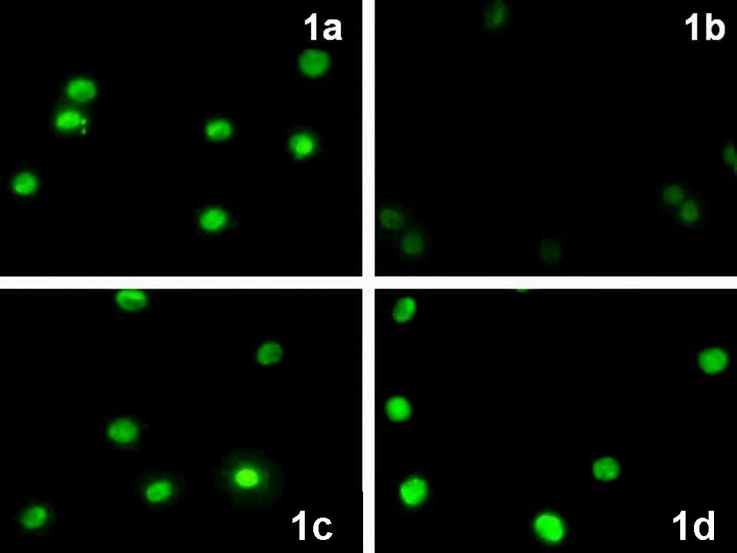 | 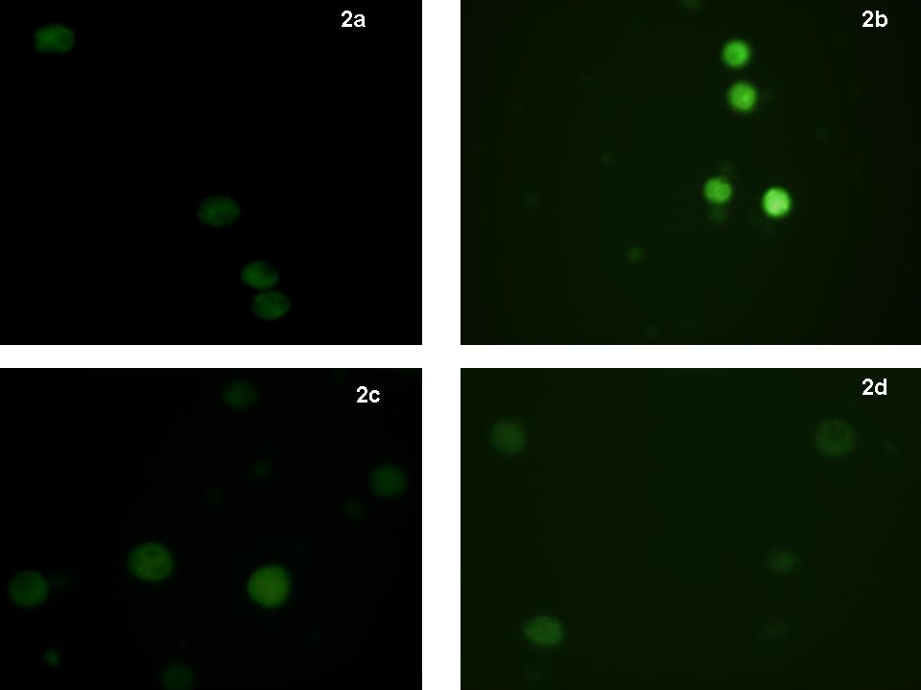
Fig 1: Production of Reactive oxygen species in white blood Cells, labeled by 2’,7’-dichlorofluorescin: produced from DCFH-DA by intracellular esterase and fluoresces after oxidation dye. a: Baseline, b: After metformin treatment. After 24 weeks of metformin treatment reactive oxygen species reduced significantly. No change in ROS generation in placebo patients: c-Before treatment, d - After treatment. | Fig 2: Nitric oxide generation in white blood Cells, labeled by DAF2DA. a: Baseline, b: After metformin treatment. After 24 weeks of metformin treatment Nitric oxide production increased significantly. No change in Nitric oxide generation in placebo patients: c-Before treatment, d - After treatment.

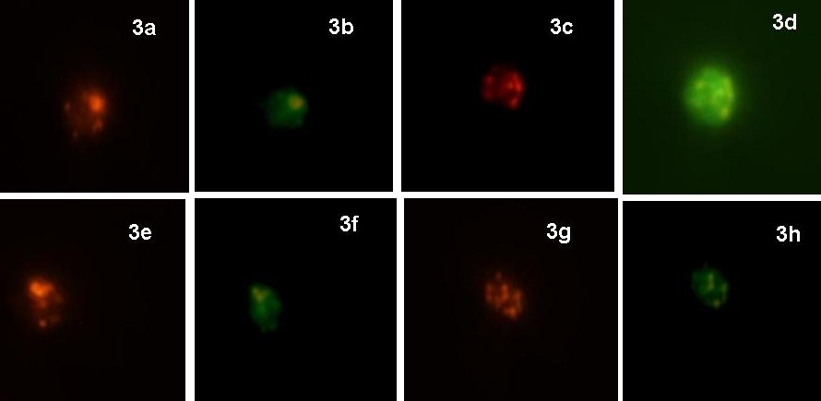
Fig 3: Confocal images of white blood cells reflecting JC-1 localization in T2DM patients (metformin treated :a,b,c,d and placebo e,f,g and h). At base line level (Figure 3 a ,3 e) strong accumulation of red color indicates hyper polarization of lymphocyte of type 2 diabetic patients. After 24 weeks of treatment, metformin administered group reflect lower red: green fluorescence ratio.

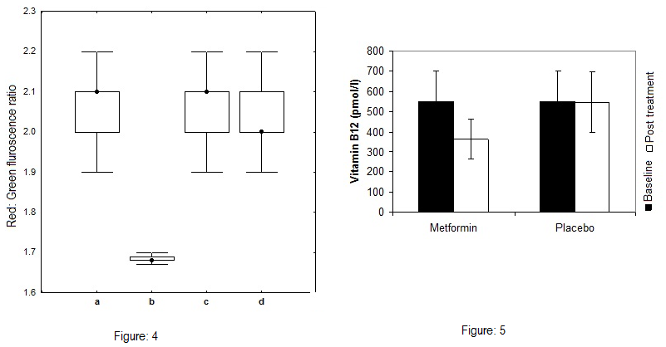

Fig 4: Mitochondrial membrane potential in white blood Cells, labeled by JC1. a: Baseline, b: After metformin treatment. After 24 weeks of metformin treatment. Red : Green fluroscence ratio decreased noticeably after 24 weeks of metformin treatment . In placebo patients mitochondrial hyperpolarisation persist : c-Before treatment, d - After treatment.
Figure 5: Concentration of Vitamin B12( pmol/l) content in metformin and placebo treated subjects. Results are expressed as mean + S.E. p <0.001 vs. baseline (Patients treated with metformin)

DISCUSSION
The increment of cardiovascular risk factors for patients having type-2 diabetes has been well established in recent days. The Framingham Heart study showed about 2 – 4 folds higher risk of CVD among the diabetes mellitus sufferers than those without it [18,19, 20]. The T2DM’s association with the environment or genetics is hitherto unknown which in future might answer number of unanswered questions [21].
The study presented here confirms that metformin therapy reduces the level of ROS formation in the WBC of diabetic subjects (Figure -1) .This finding indicates that chronic hyperglycemia induced oxidative stress can be trimmed down by treating with metformin. In general, hyperglycemia stimulates oxidative stress through three main mechanisms: NAD(P)H oxidase, xanthine oxidase and electron transport chain [22]. The target site of metformin is AMPK [23], a major control device of glucose and lipid metabolism [24]. In a simultaneous manner the drug inhibits both PKC and NAD(P)H oxidase [25].This incorporated regulatory mechanism effectively help scavenging the ROS thereby preventing any cardiovascular disorder since knowingly, hyperglycemia increases the oxidative stress elevating the level of ROS accelerating the cardio vascular disease [26,27].
A deficiency of the endogenous vasodilator, NO has been implicated as a potential cause of cardiovascular disorder [28]. Its level is lowered in most diabetic patients compared to non-diabetic control. NO originates from the L-arginine by enzymatic catalysis of nitric oxide synthase (NOS).In that course, oxygen acts as a cofactor. Insufficient oxygen can dampen the action of NOS subsequently lowering the NO level too which, is often viewed in many diabetic patients. The metformin therapy markedly restores that lowering event. This is one of the helpful actions of this common drug as seen in Fig – 2.
The measurement of membrane potential (ΔΨm) is an established index for mitochondrial health concerning the cardiovascular disorder. During hyperglycemic challenges oxidative stress is rapidly enhanced insisting over production of the free radicals while producing an imbalance of ion transport in mitochondrial membrane. In that maneuver, the excessive production of ROS triggers hyperpolarization of the mitochondrial membrane [29]. The incident plays a crucial role in the pathophysiology of cardiovascular diseases among the diabetic patients. In this study we explored that metformin treatment balanced the mitochondrial homeostasis by normalizing the ion transport. Possibly, the effective scavenging of free radicals in presence of metformin might be the basis of this finding.
Hcy is a metabolic intermediate in methyl group metabolism which depends on number of cofactors [30]. During catalytic action of Methionine Synthase, Vitamin B₁₂ acts as a cofactor therefore its deficiency reduces the remethylation process. This results in elevated plasma Hcy levels; by inhibiting the breakdown of Hcy. The Elevated level of Hcy has been reported to be observed in the serum of metformin administered diabetes patients. The intestinal malabsorption of vitamin B12 may be regarded as the possible cause. Interestingly, the present study shows that vitamin B12 level in serum was significantly decreased in the metformin administered subjects compared to non-metformin group (Figure-.5) whereas on the contrary, serum Hcy level did not differ significantly in the two groups (Table-1). Thus the effect of reduced vitamin B12 concentration may not be the only probable cause behind the alteration of Hcy level in serum. Further, it is also a possibility that the daily losses of vitamin B12 due to metformin administration can not affect the abundance of the total body vitamin B12 pool.
Altogether, the study revealed that metformin significantly diminished intracellular ROS generation, mitochondrial hyperpolarization and restored nitric oxide production in Type 2 Diabetic patients compared to placebo control therefore might play an important role to prevent the CVD although acceptably, a contrasting feature arises concerning the slight high Hcy level in serum. The clinical significance of this event is unclear at this moment but in no way it should be ignored since the persistent increase of serum Hcy is associated with increasing risk of coronary heart disease and stroke within the diabetic individuals.
This study also indicated that vitamin B12 supplementation is essential for patients to avoid T2D related risk of CVD in case of metformin administered subjects.
CONCLUSION
A number of unanswered questions still remain regarding the pathology or etiology of CVD including its role in diet, lifestyle or else any gene-environment interaction. The study presented here confirms the fact that metformin administration can offer an added protection, beneficial to the risks involved in CVDs among the diabetic subjects.
ACKNOWLEDGEMENTS
We offer thanks to Drs. Bibek Roy Chowdhury, IPGMER, Sudip Chatterjee and S. Batabyal, Park Clinic of Kolkata for allowing us using the Υ - Counter including other technical facilities. Additionally, we acknowledge the UGC–RFSMS program for providing fellowship to one of the author, AC. The financial support from RSSDI is also gratefully acknowledged in addition to the UGC-CAS (Phase-I) and DST-FIST funding. Last but not the least, we extend our sincere gratitude to all the 285 participants taken part in this study program.

Conflict of interest: None

REFERENCES

- Adak S, Saha A, Chowdhury S, Bhattacharyya M . Enhanced oxygen releasing capacity and oxidative stress in diabetes mellitus and diabetes mellitus associated cardiovascular disease: a comparative study. Clinica Chimica Acta. 2005;p141-149,Vol 361.
- Zachary T. Bloomgarden. Insulin Resistance, Dyslipidemia, and Cardiovascular Disease. Diabetes Care 2007; p2164-2170,Vol 30( 8).
- Shah A M , K M Channon. Free radicals and redox signaling in cardiovascular disease. Heart . 2004; p48,Vol 90(5).
- Widlansky M E, Wang J, Shenouda S M, Hagen T M, Smith A R, Kizhakekuttu T J, Kluge M A, Weihrauch D, Gutterman D D, Vita J A. Altered mitochondrial membrane potential, mass, and morphology in the mononuclear cells of humans with type 2 diabetes .Translational Research 2010; p15-25, Vol156(1).
- Matteucci E , Ghimenti M, Consani , Maria Chiara Masoni , Giampietro O.Exploring Leukocyte Mitochondrial Membrane Potential in Type 1 Diabetes Families Cell. Biochem Biophys 2011;p121–126,Vol 5.
- Tarkun I, Cetinarslan B, Cantürk Z, Tarkun P, Agaçdiken A, Komsuoglu B. Homocysteine concentrations in type 2 diabetic patients with silent myocardial ischemia: a predictive marker. Diabetes Complications 2004;p165-8,Vol18(3).
- Song Y, R. Cook N, M. Albert C. Effect of Homocysteine-Lowering Treatment With Folic Acid and B Vitamins on Risk of Type 2 Diabetes in Women. Diabetes 2009; p1921-1928, Vol58.
- Koike T, Kuzuya M, Kanda S.et.al. Raised homocysteine and low folate and vitamin B-12 concentrations predict cognitive decline in community-dwelling older Japanese adults.Clinical Nutrition 2008; p865-871, Vol27.
- Kadhe G ,.Arasan R.Z .Advance in drug delivery of oral hypoglycemic agents. Current Science 2002; p1539-1543,Vol83.
- Shaw JT, McWhinney B, Tate JR, Kesting JB, Marczak M, Purdie D, et al. Plasma homocysteine levels in indigenous Australians. Med J Aust 1999; p 19-22, Vol170.
- Tomkin GH, Hadden DR, Weaver JA, Montgomery DA. Vitamin-B12 status of patients on long-term metformin therapy. Br Med J 1971; p 685-7,Vol2.
- www.nlm.nih.gov/medlineplus/ency/article/000574.htm
- Herrmann W, Schorr H, Obeid R, Geisel J .Vitamin B 12 status,particularly holotranscobalamin and methylmalonic acid concentration ,and hyperhomocysteinemia in vegetarians.Amj J Clin Nutr 2003; p131-136,Vol78.
- Der-cherng T, Huang T, Liu T, Chen H, Sung Y ,Wei Y. Effect of vitamin E- bonded membrane on the 8-hydroxy 29-deoxyguanosine level in leukocyte DNA of hemodialysis patients . Kidney International 2000; p 790–799,Vol 58.
- Nakatsubo N, et al Direct evidence of nitric oxide production from bovine aortic endothelial cells using new fluorescence indicators: diaminofluoresceins. FEBS Lett.1998; p263,Vol427 Abstract
- Widlansky M E, Wang J,. Shenouda S M,. Hagen T,. Smith A R,. Kizhakekuttu T J , Kluge M A, Weihrauch D, Gutterman D D , and Vita J A .Altered mitochondrial membrane potential, mass, and morphology in the mononuclear cells of humans with type 2 diabetes. Translational Research 2010;p15-25Vol156.
- Scheffe H. The analysis of variance. New York7 John Wiley. 1959.
- Ingelsson E, M. Sullivan L, M. Murabito J, S. Fox C, et.al. Prevalence and Prognostic Impact of Subclinical Cardiovascular Disease in Individuals with the Metabolic Syndrome and Diabetes.Diabetes 2007;p1718-1726,Vol56.
- Uusitupa M. I. J, L. K. Niskanen , O. Siitonen , E. Voutilainen , K. Pyorala, Ten-year cardiovascular mortality in relation to risk factors and abnormalities in lipoprotein composition in Type 2 (non-insulin-dependent) diabetic and non-diabetic subjects Diabetologia 1993; p1175-1184,Vol36.
- Ming W , M. Haffner.S, P. Gaskill.S , P. Stern.M , E ffects of Diabetes and Level of Glycemia on All-Cause and Cardiovascular Mortality. Diabetes Care 1998; p1167-1172,Vol21.
- Ueland P, Refsum H, AA Beresford S, Emil Vollset S, The controversy over homocysteine and cardiovascular risk .Am J Clin Nutr 2000; p324-332,Vol 72.
- Gopalakrishna R, Jaken S: Protein kinase C signalling and oxidative stress. Free Radic Biol Med 2000; p1349 –1361,Vol28.
- He TC, Zhou S, Da Costa LT, Yu J, Kinzler KW, Vogelstein B: A simplified system for generating recombinant adenoviruses. Proc Natl Acad Sci U S A 1998 ; p2509 –2514, Vol95.
- Hou X, Xu S, Maitland-Toolan KA, Sato K, Jiang B, Ido Y, Lan F, Walsh K, Wierzbicki M, Verbeuren TJ, Cohen RA, Zang M. SIRT1 regulates hepatocyte lipid metabolism through activating AMP-activated protein kinase. J Biol Chem 2008 ; p15-26,Vol283(29).
- Gallo A, Ceolotto G, Pinton P, Iori E, Murphy E, Rutter G, Rizzuto R, Semplicini A, Avogaro A. Metformin Prevents Glucose-Induced Protein Kinase C-_2 Activation in Human Umbilical Vein Endothelial Cells through an Antioxidant Mechanism. Diabetes 2005; p 1123-1131,Vol54.
- Chakraborty A, Chowdhury S, Bhattacharyya M, Effect of metformin on oxidative stress, nitrosative stress and inflammatory biomarkers in type 2 diabetes patients Diabetes Res Clin Pract. 2011; p56-62,Vol93(1).
- Formoso G, Filippis E A D, Michetti N, Fulvio P D, Pandolfi A, Bucciarelli T, Ciabattoni G, Nicolucci A, Davì G, Consoli A. Decreased in vivo oxidative stress and decreased platelet activation following metformin treatment in newly diagnosed type 2 diabetic subjects . Diabetes/Metabolism Research and Reviews 2008; p 231–237, Vol24 (3).
- Hassanabad Z F, Catherine B. Chan , Brian L. Furman. Reactive oxygen species and endothelial function in diabetes. European Journal of Pharmacology 2010; p8–17,Vol636.
- Reddy M K , Banerjee A , Banks W A, Ercal N .Highly active antiretroviral therapy drug combination induces oxidative stress and mitochondrial dysfunction in immortalized human blood–brain barrier endothelial cells .Free Radical Biology & Medicine 2011; p 801–810,Vol50.
- Ayav A, Alberto J M, Barbe F, Brunaud L, Gerard P, Merten M, Gueant J L Defective remethylation of homocysteine is related to decreased synthesis of coenzymes B2 in thyroidectomized rats . Amino Acids 2005; p 37–43,Vol28.

