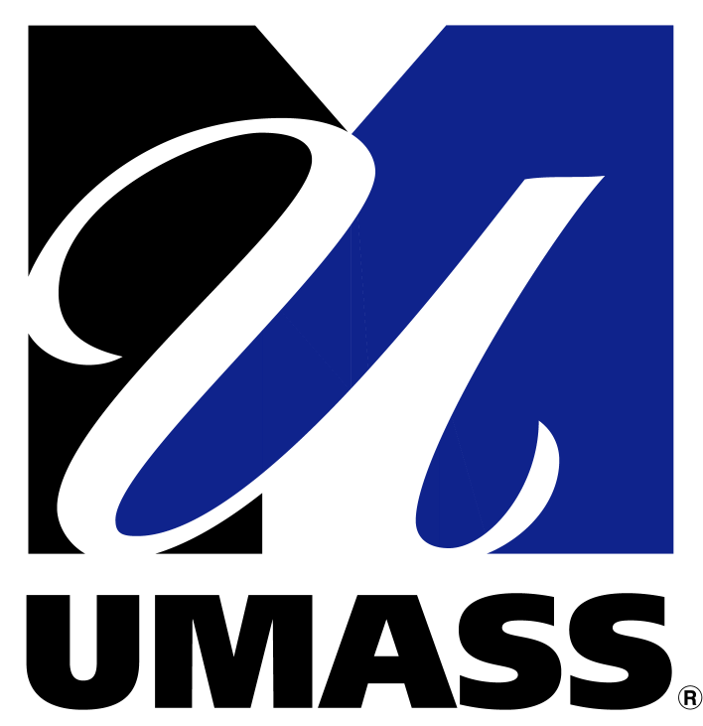
Barur R. Rajeshkumar PhD
Senior Research Scientist
S3-734 Department of Surgery
University of Massachusetts Medical School
55 Lake Avenue North, Worcester, MA 01655
508.856.6225 (office) 508.340.3127 (cell)
Email:barur.rajeshkumar@umassmed.edu

University of
Massachusetts
Medical School

May 10, 2011
Dr. R. Rajasekaran, PhD
Controller of Examinations
Thiruvalluvar University
Serkadu, Vellore -632 106
Dear Dr. Rajasekaran:

Sub: “TVU/COE/PhD/ Thesis evaluation/2011/No 3182: dated 10-01-1. Reg.”
Thank you for your invitation to be a member of Board of examiner to adjudicate the Doctoral thesis submitted by Mr. R. Arunkumar, department of chemistry, Islamiah College, Vaniyambadi. I request you to accept my expert report and comments. I congratulate both the Doctoral student Mr. R. Arunkumar and Professor K. Subramani for their contribution to the Science. If you have any question or concern please feel free to contact me.

Thank you

Sincerely,

Barur R. Rajeshkumar, PhD
Senior Research Scientist

