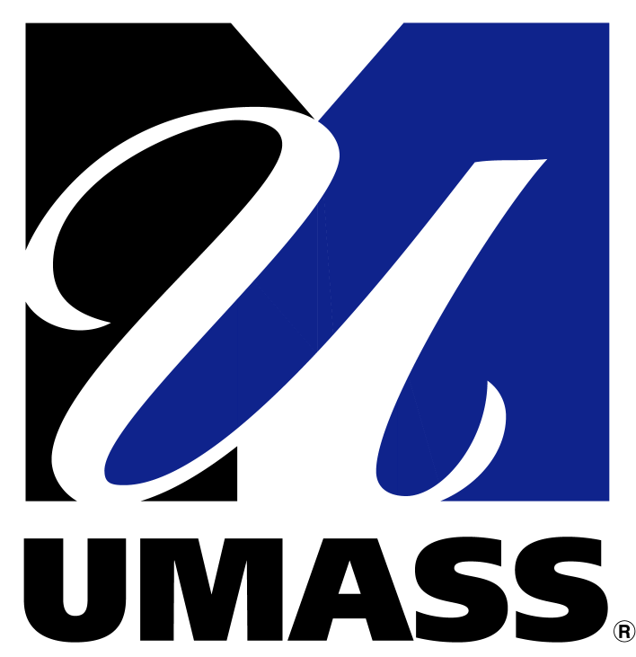
Barur R. Rajeshkumar PhD
Laboratory Manager-Senior Research Scientist
Cardiovascular Medicine
University of Massachusetts Medical School
368 Plantation Street, Worcester, MA 01655
University of
Massachusetts
Medical School

Message:

It gives me immense pleasure to offer my congratulations and greetings to the “National Conference on
Natural Products as therapeutics, Medical Microbiology, Nanobiology and System biology: current Scenario and Emerging Trends” – PG and Research Department of Biochemistry, Microbiology, Biotechnology and Bioinformatics, Mohamed Sathak College of Arts and Science, Sholinganallur, Chennai 600119, Tamil Nadu, India.

Certainly, this much deserved conference brings together the notable scientists, research faculties and students from all over the world to present and discuss about the recent progress and also future trends in the Natural products as therapeutics for the common human disease.

On this occasion, I would like to express my cordial gratitude to those who contributed to this National Conference on Natural Products as therapeutics, Medical Microbiology, Nanobiology and System biology: current Scenario and Emerging Trends and concomitantly helped the event for its resounding success globally.

Being honored to be a member of the International Advisory Committee, I intend to extend my warm wishes to all the faculties, research scientists and students, and additionally encourage them to seize this moment of opportunity to be benefitted from the latest advancements in the field of Natural medicine and its role in the betterment of human disease. In that regard I must congratulate the conference organizers for their intense effort.

Barur R. Rajeshkumar, PhD
International Advisory Committee

