
Barur R. Rajeshkumar PhD
Laboratory Manager-Senior Research Scientist
Cardiovascular Medicine ASC7-1046
University of Massachusetts Medical School
368 Plantation Street, Worcester, MA 01655
508.856.6225 (office) 508.340.3127 (cell)
Email:barur.rajeshkumar@umassmed.edu

University of
Massachusetts
Medical School

January 23, 2015
Dr. S. Thirumagan
Controller of Examinations
University of Madras, Chepauk
Chennai - 600 005
Dear Dr. Thirumagan:
Sub: “PhD/synopsis / Mr. K. Thulasi Raman -Reg.”
Thank you for your invitation to be a member of Board of examiner to adjudicate the Doctoral Thesis submitted by Mr. K. Thulasi Raman, Dept. of Biochemistry, and University of Madras. I am gladly accepting your invitation. I will be happy to evaluate and submit my expert report to your office as soon as possible. Please dispatch the thesis to the above address. If you any further questions or concerns please feel free to contact me.

Thank you

Sincerely,

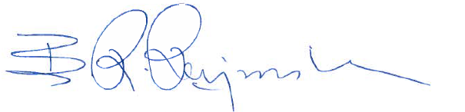

Dr. Barur R. Rajeshkumar, PhD

