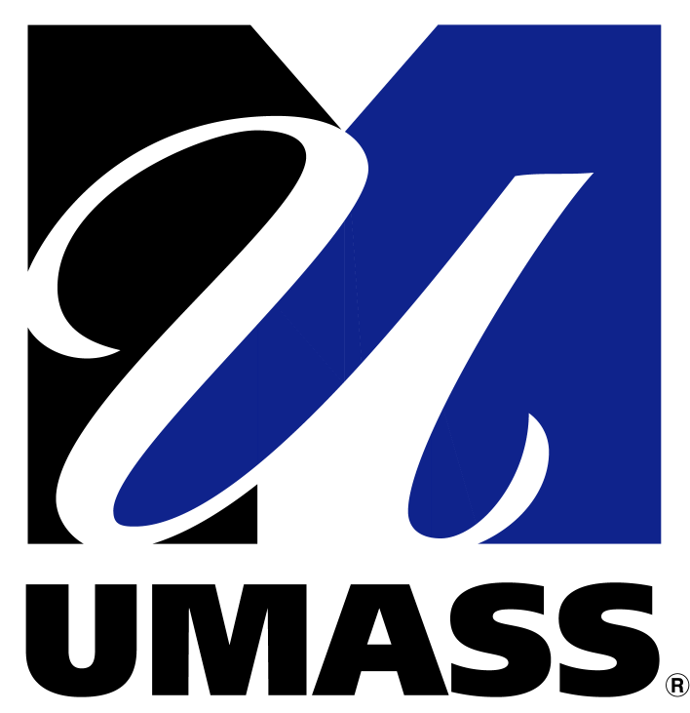
Barur R. Rajeshkumar PhD
Senior Research Scientist
S3-734 Department of Surgery
University of Massachusetts Medical School
55 Lake Avenue North, Worcester, MA 01655
508.856.6225 (office) 508.340.3127 (cell)
Email:rajeshbr@gmail.com

University of
Massachusetts
Medical School

March 04, 2013
Dr. G .Koteswara Prasad, PhD
Dean Research
University of Madras
Chennai – 600 005
Sub: “Ph.D. Eval. / 569 / 2012 / dated 4th March 2013- Reg.”
Dear Dr. Prasad:

Thank you for your invitation to be a member of the Board of Examiner to Adjudicate the PhD thesis entitled “A Phycoremediation approach for the treatment of Dairy Effluent (Botany)” submitted by Ms. M. Kotteswari, Post Graduate and Research Department of Botany, Pachaiyappa's College, University of Madras, Madras. I am gladly accepting your invitation. I will be happy to evaluate and submit my expert report to your office as soon as possible. If you any further questions or concerns please feel free to contact me.

Thank you

Yours truly,
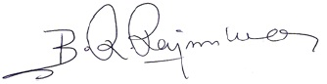

Barur R. Rajeshkumar, PhD
Senior Research Scientist

