American Journal of Bio-pharmacology Biochemistry and Life Sciences
Dr. Barur R. Rajeshkumar, PhD ISSN: 2166-126X
Founding Editor-in-Chief Phone: 508 340 3127
305 Goodale Street www.ajbbl.com
West Boylston, MA 01583 Email:editor@ajbbl.com

October 28, 2016

To
Dr. Kolia K. Innocent
Laboratory of medical biochemistry
University Hospital Center of Yopougon / Abidjan (Côte d’Ivoire)

Dear Dr. Innocent:

It is a pleasure to inform you that after a thorough scrutiny by the reviewers your revised manuscript entitled “Phytochemical screening, anti-inflammatory and antioxidant effects of aqueous extract of Alternanthera pungens (Amaranthaceae) in rats” has been accepted for publication in the American Journal of Biopharmacology Biochemistry and Life-Sciences. As per our policy as previously mentioned, we will send you the final electronic copy after receiving a cheque or Money order or western Union for $50/- and can be mailed to the above address. Once that process is completed, we will release the exact official version.

Thanks for choosing AJBBL for your esteemed publication and we will certainly look forward to you in the future. If you have any questions and comments, please feel free to contact us through email or at 508 340 3127.

Sincerely
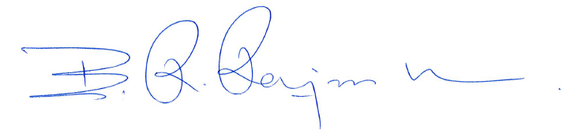
Dr. Barur R. Rajeshkumar, PhD
Editors AJBBL Details required for Western Union
First name: Barur
Last Name: Rajeshkumar
305 Goodale Street
Town: West Boylston
State: Massachusetts 01583
Country: USA
Phone: 508 340 3127

