Wound Healing Activity of Tinospora cordifolia in Tropical wound of Wilstar Rat.

J.Albinjose1, Srinivasakumar.K.P¹, Selvankumar.T2

1. Department of Bio-technology, Techno Global University, Anita Mansion, Bishnupur Shillong, Meghalaya, India.
2. Department of Bio-technology, Mahendra Arts and Science College, Kallipatti ,Namakkal, Tamil Nadu, India.

Abstract

Tinospora cordifolia is a glabrous and succulent shrub which is native to and widely distributed

in India, Burma, Ceylon and China (Srivastava 2011). In in-vivo studies, the wound infected rat treated with petroleum ether extract of T. cordifolia cured within 4 days. Medicinal components from plants play an important role in conventional as well as western medicine. Plants with possible antimicrobial activity should be tested against an appropriate microbial model to confirm the activity and animal models to ascertain the parameters associated with it. Thus this research work is proposed to screen effective phyto drugs against infectious of surgical and non surgical wound.

Key words: Tinospora cordifolia, Haematological parameters, Biochemical Parameters, Kidney function tests, Liver Function Test, Habitual observations of experimental animals, Quantitative determination of weight.

Introduction

The optimal management of surgical or non surgical wounds is often not achieved, because healing of surgical wounds is perceived to be uncomplicated compared to the management of chronic wounds such as pressure ulcers, leg ulcers and diabetic foot ulcers (Dowsett, 2002). Most of the synthetic drugs are currently used for the treatment of surgical or non surgical wounds are not only expensive but also create problems such as allergy, drug resistance etc. This situation has forced to the scientists to seek alternative drugs (Sai and Babu, 1998).Herbal drugs are aimed to accelerate the healing process and also to maintain the quality and aesthetics of the healing. Therefore, the plant T. cordifolia can be chosen as a source for the development of industrial products for treatment of various diseases (Preeti, 2011).There are recent reports on wound healing efficacy of the redox-active grape seed proanthocyanidins (Khanna et al., 2002), the chitosans (Thakur et al., 2001) and chitins (Cho et al., 1999), polysaccharides (Taranalli et al., 2004) and (Bedi and Shenefelt, 2002) the terpenoidal compounds oleanolic acid (Letts et al., 2006) and lupeol (Harish et al., 2008).
Material and methods
1. Guidelines
OECD principles for the testing of chemicals are periodically reviewed in the light of scientific progress. The original guideline 407 was adopted in 1981. This chapter experiments on animal toxicology is in accordance with the updated version of Guideline 407, which is the outcome of a consultation meeting of an adhoc working group of experts on systemic short-term and (delayed) neurotoxicity, held in Paris on February 1992 (OECD, Paris, 1992). This study also follows OECD – GLP recommendation by European Community, EC Directive 99/11/EEC of 8 March 1999 - (OJ No. L 77/8-21, 23/3/1999)
2. Comparative determination of body weight
The body weight of the test animal was assessed using sensitive balance during the acclimatization period, once before commencement of dosing, once in ten days (day 1, 5, 9, 11 and 14) during the dosing period and on the day of sacrifice.
3. Clinical signs and Mortality
General clinical observations and mortality pattern were observed on daily basis once before dosing, immediately after dosing and up to four hour after dosing ± 1 hour. The health condition of the animals was also recorded. All animals were observed for morbidity and mortality. The clinical observations of experimental animals were recorded using scoring systems (OECD, 1992). Signs noted should include changes in skin, fur, eyes, mucous membranes, occurrence of secretion sand excretions and autonomic activity (e.g. lacrimation, piloerection, pupil size, and unusual respiratory pattern). Changes in gait, posture and response to handling as well as the presence of tonic movements, stereotypes (e.g. excessive grooming, repetitive circling) or bizarre behavior (e.g. self mutilation, walking backwards) were also recorded according to (Tupper and Wallace, 1980). In the fourth exposure week sensory reactivity to stimuli of different types (e.g. auditory, visual and proprioceptive stimuli) according to (Gad, 1982), assessment of grip strength (Moser, 1997) and motor activity assessment (Crofton, 1990) were also conducted.
4. Food Consumption
Average food consumption per group was recorded weekly. In the present study 40 gm of pelleted diet (V1) was served per group and the unfed feed (V2) was replaced on daily basis. The dispersed out feed (V3) by animals are also collected and taken into account. The average consumption per animal (V) is calculated as V= V1-(V2+V3) / N. where N is the number of animals in a group.

5. Experimental animals

Studies were carried out with inbred two weeks old male wilstar rats of 25 ± 2.4 gm weight. The animals were housed in polypropylene cages with dark/light cycle (14/10 h) under controlled temperature and hygienic conditions. All animals were fed with standard pellet diet and water. Tests were performed only after the rat had acclimated to the local environment for at least 14 days.
6. Experimental design
Animal batch design
The male wilstar rats were divided into six groups consisting of six animals in group 1 (control group) and 36 animals each in other six groups. The grouping pattern of animals, investigational product (IP) administration schedule is modified from Steve et al. (2008).

Table 1: Animal experimentation design
Group No | Drug administered groups |  |  |  | Dosing concentration tropical application (1ml) per day. | Daily tropical supplement (1ml) per day | Total animals used
1 | Control wilstar rat |  |  |  | NA | NA | 2
2 | Infection in wilstar rat treated with burnol. | Eey | Xx | V | 7 | 7 | 6
3 | Pathogen injected in wilstar rat. | Eey | Xx | V | 7 | 7 | 6
4 | Infection in wilstar rat treated with chloroform extract of T. cordifolia. | CH-Eey | CH-Xx | CH- V | 7 | 7 | 6
5 | Infection in wilstar rat treated with methanol extract of T. cordifolia. | ME-Eey | ME-Xx | ME- V | 7 | 7 | 6
6 | Infection in wilstar rat treated with petroleum ether extract of T. cordifolia | PE-Eey | PE-Xx | PE- V | 7 | 7 | 6
CH-chloroform, ME-methanol, PE-petroleum ether (Eey) Escherichia coli, (Xx) Klebsiella pnemoniae, (V) Staphylococcus aureus.
Experiments were carried out as group-1 with control rats, group-2 with bacterial infection rats treated with burnol, group-3 with bacterial infection rats, group- 4 with infected rats treated chloroform extract of T. cordifolia, group-5 with infected rat treated with methanol extract of T. cordifolia, group-6 with infected rat treated with petroleum ether extract of T. cordifolia and one control group was maintained across five batches (Table 6.1). The animals were anesthetized by intramuscular injection of ketamin (40 mg/kg) and diazepam (4 mg/kg). The back of each animal, in the lumbar region, was shaved and prepared for aseptic surgery. A circular piece of skin with a radius of 2 cm was surgically excised, creating full-thickness type wounds.
On the 14th day of dosing period the overnight fasten test animals were anaesthetized with chloroform anesthetics and withdrawn blood samples by cardiac puncture technique. One batch of blood sample were collected in test tubes and allowed to stand for 10 minutes and were centrifuged at 4000 rpm for 10 minutes and clear plasma samples were aspirated and stored frozen. The stored plasma samples were used to analyze various biochemical parameters such as ALT, AST, ALK, blood urea and serum creatinine. Hematological investigation blood samples were used to examine the following hematological parameters includes total and differential leukocyte count, platelets and hemoglobin.
7.Analysis of haematological parameters
7.1 Estimation of haemoglobin concentration
Haemoglobin concentration was determined as described by Cheesbrough and Macarthur (1976). Blood (20 μl) was mixed with 5 ml of Drabkins reagent and kept undisturbed for 5 min at room temperature. A reaction complex of cyanomethemoglobin will form by ferricyanide, hemoglobin and cyanide which can be spectroscopically measured against reagent blank at 540 nm. Haemoglobin content was calculated using by the formula,
g % of HB = O.D. of the test x 251x Conc. of Std.
O.D. of the Std. 1000
7.2. Estimation of total count (TC) of leucocytes
To determine the total leucocyte count (TLC) 20 µl blood was added to 380 µl of Turk’s fluid, which contains a weak acid (glacial acetic acid) to lyses RBC within 2-3 minutes of incubation at room temperature. After incubation the cells were mixed gently and loaded into the hemocytometer and allowed to settle at the bottom of chamber for 2 minutes. Four large corners are counted under a microscope using 10 X objective. Total WBC count was determined using the formula,
TC = Number of cells counted (N) × dilution factor × depth factor Area counted
= N × 50
= x cells / mm³
TC = x cells X 10³ / ml of sample.
7.3. Differential count (DC) of leucocytes
Leishman’s staining method was performed to understand the morphology of leucocytes. The majority of the functions of the white blood cells occur when they leave the blood circulation to enter other body tissues. Thin blood smear was prepared to analyze the differential cell population by spreading the drop of blood evenly across the glass slide using a glass spreader. The blood smear was air dried for 2 minutes and flooded with Leishman’s stain for 3 minutes and distilled water for 10 minutes. The setup was kept undisturbed for 10 minutes and washed with tap water. The cells were observed under oil immersion microscope. The differential count of WBC was performed on a minimum count of 100 cells to identify lymphocytes, neutrophils and eosinophils in the blood smear. Counting was done in triplicates and obtained results were tabulated and discussed.
7.4. Determination of platelets count
Fill blood into red pipette up to 0.5 marks and fill the reagent up to 101 mark. Rotate the pipette horizontally for complete mixing of blood and diluting fluid. Discard the first 3-4 drops and fill in the haemocytometer nicely. Allow platelets to set down in moisture chamber for 15 minutes, count the platelets under microscope (x 400). Calculate the platelet concentration by use the formula
Volume of 4 WBC square = 0.1 X 4 cu.mm.
= 0.4 cu.mm.

8. Analysis of Biochemical Parameters
8.1. Serum preparation
The blood samples were collected by cardiac puncture technique, stored in test tubes and allowed to stand for 15 minutes. Clotted blood samples were centrifuged at 3000 rpm for 10 minutes and serum samples were drawn off and stored at -20ºC for further analyses.
8.2. Kidney function tests
8.2.1 Estimation of Blood Urea
The urea level in the blood was experimented using Oxime method (Friedman, 1953). In this method Diacetyl monoxime in a hot acid medium reacts with urea producing a specific pink colored complex, which can be measured colorimetrically at 520 nm.
About 0.1 ml of serum and standard (Benzoic acid, 0.2% and Urea, 40 mg/dl) were transferred into test tubes containing 1.9 ml of distilled water giving 1: 20 dilution of serum and standard. Test tube with 2 ml of water acts as blank. About 3 ml of oxime solution (Diacetyl monoxime (1 g), thiosemicarbazide (0.2 g), sodium chloride (9 g) dissolved in 1000 ml of distilled water and 3ml of acid solution (conc sulphuric acid (60 ml), 85% phosphoric acid (10 ml), ferric chloride (0.1 g) dissolved in 1000 ml of distilled water was added in each tube. To this mixture 0.25 ml of serum, standard and water was added to respective tubes. The content was mixed thoroughly and kept it on water bath for 10 minutes and cooled immediately in running tap water for 5 minutes. Then the absorbance of the test ‘T’ and standard (‘S’) against the blank was measured. Unknown concentration of nitrogen was estimated by using standard graph.
Blood urea concentration (mg / dl) = (A_{T} / A_{S}) x 40 (Conc. of urea in standard)
8. 2.2. Estimation of Creatinine
The creatinine estimation was carried out by alkaline picrate method (Folin, 1905) where creatinine gives red color with alkaline solutions of picric acid.
The protein free filtrate was prepared by adding 1 ml of serum, 1.0 ml of sodium tungstate (5%), 1.0 ml of 0.66 N sulphuric acid and 1.0 ml of water in a clean test tube. Then the added contents were mixed thoroughly and centrifuged at 2000 rpm for 5 minutes. For the colour reaction three tubes were taken and labeled as ‘T’, ‘S’ and ‘B’ for test, standard and blank. The labeled tubes were added with the following reagents as indicated in the following table.
Then the reaction mixture was allowed to stand for 20 min. Further the absorbance readings were performed at 520 nm.
Contents | Test (‘T’) (ml) | Standard (‘S’) (ml) | Blank (‘B’) (ml)
Distilled water | 2.0 | 3.5 | 4.0
Creatinine standard (20 mg dissolved in 1 ml of 0.1 N HCl) | 0 | 0.5 | 0
Blood serum | 2.0 | 0 | 0
Picric acid solution (1.05% in water), | 1.0 | 1.0 | 1.0
Sodium hydroxide (0.75 N) | 1.0 | 1.0 | 1.0
Concentration of creatinine (mg / dl) = (A_{t} / A_{S}) x 2
A_{t} = Absorbance of the test, A_{s} = Absorbance of the standard and
2 = Concentration of the standard (20 mg/dl)
9. Liver Function Test
9.1. Estimation of serum glutamic oxaloacetic transaminase (SGOT)
The estimation of serum glutamic oxaloacetic transaminase (SGOT) was carried out using standard procedure described by Bergmeyer and Bernt (1974).
About 0.5 ml of substrate (1.78 g of D-alanine and 30 mg of α-ketoglutamate) dissolved in 20 ml buffer containing 1.25 ml of 0.4N sodium hydroxide. The solution was made to 100 ml with 100 nM phosphate buffer (pH 7.4 and kept at 4ºC) and incubated for 3 minutes at 37ºC. After incubation 0.1 ml of serum was added and mixed well and incubated for 30 minutes at 37ºC. About 0.5 ml of 2, 4 dinitro phenyl hydrazine (DNPH) was added to this mixture and kept in room temperature for 20 minutes. The reaction was stopped by adding 5ml of 0.4N NaOH, vortexed and kept at room temperature for 5 minutes. The absorbance was measured at 520 nm. The enzyme activity was expressed as a measure of pyruvate formed, which was calculated from the standard curve of pyruvate and expressed as unit per litre.
9.2. Estimation of serum glutamic pyruvic transaminase (SGPT)
The estimation of Serum glutamic pyruvic transaminase (SGPT) was carried out using standard procedures described by Bergmeyer and Bernt (1974 a).
Working reagent was prepared by adding 14mg NADH and 250 units lactate dehydrogenase in 100 ml buffer substrate (L-alanine) (500 mmol / hydrochloric acid pH 7.4). About 100 μl of the serum was pipetted out into 1ml of working reagent mixed well and after approximately 1 minutes, measured the decreased in absorbance every minutes for 3 minutes at 520 nm. The enzyme activity (U/I) measured ∆A/minutes.
9.3. Estimation of serum alkaline phosphatase activity (ALK)
The estimation of serum alkaline phosphatase activity (ALK) was carried out using standard procedures described by King and Armstrong (1934). About 1 ml of the substrate (Disodium phenyl phosphate (100mmol/l), 0.5 N sodium hydroxide, 0.5 N sodium bicarbonate, 0.6 % 4 aminoantipyrine and 2.4 % potassium ferricyanide) was incubated with 1 ml bicarbonate buffer (6.36 g of sodium bicarbonate / L of distilled water with pH 10) for 3 minutes at 37ºC. About 0.1 ml of serum was added, vortexed well and incubated again for 15 minutes at 37ºC. After incubation 0.8 ml of NaOH, 1.2 ml sodium bicarbonate, 1 ml of aminoantipyrine and 1 ml of potassium ferricyanide were added, mixed well and the resultant purple color was measured at 520 nm. The enzyme activity was expressed as amount of phenol produced and calculated from standard graph of phenol and expressed as King Armstrong units per liter.
Result and discussion
Habitual observations of experimental animals
Food consumption
In this present study, the food and water consumption rate were normal in the entire experimental period. The mean food consumption of the control group was 2.3 ± 0.24 gm / day. The fed consumption rate reveals that the overall 14 day fed study of the feed wastage / day was considerably high with an average of 17.8 ± 1.34 gm of feed (45.75 ± 1.5 %) which was higher than the consumption rate. However, there was a noticeable increment of 15.7% in the average food and water consumption on following such as Escherichia coli, Pseudomonas aeruginosa, Klebsiella pnemoniae and Staphylococcus aureus treated animal groups. There was no significant change in the water consumption throughout the dosing period except for pathogens administered group, which increased water consumption.
Cage behavior
The behaviors of the grouped rats were noticed frequently throughout the entire experimental periods. Frequent barbering was an observed in pathogens administered groups. Repetitive movements, anxiety, tremors, convulsions and aggressive behavior were occasionally observed in the pathogens induced animal groups.
Quantitative determination of weight
As indicated in (Fig.4.1), the initial mean (± SD) weight of rat in the control group was 132.6 ± 1.8 gm, and final mean weight 120.10 ± 1.2 gm. Weight assessment was done on day 1st and 7th day of wound healing process. The result points up that plant drug prepared from petroleum ether administered groups shows significant weight gain of 18.25 gm (23.8%, P<0.001) and 19.28 gm (26.6%, P<0.001) respectively. Several previous reports also confirm these findings. Yokayama and Araki (1992) noted 15% decreased in final body weight gain, where lead acetate was administered via drinking water to Wilstar rats. Later, Dieter et al. (1993) reported 14-20% decrease in body weight of male rats. However, Steve et al. (2008) reported that the treatment with the extract of Parinari curatellifolia did not show any decrease water and food consumption of animals. Treatment of the diabetic and normal rats with the extract did not produce any significant changes in the body weights of the animals while the diabetic animals treated with Parinari curatellifolia showed a significant gain in weight.
The E. coli (Eey) infected rats treated with chloroform extract of T. cordifolia and E. coli (Eey) infected group of wilstar rat treated with petroleum ether extract of T. cordifolia, K. pnemoniae (Xx) infected group of wilstar rat treated with methanol extract of T. cordifolia and K. pnemoniae (Xx) infected group of wilstar rat treated with petroleum ether extract of T. cordifolia, S. aureus (V) infected group of wilstar rat treated with methanol extract of T. cordifolia were gain weight during the experimental study. This was due to the earlier wound healing. The weight loss in the control group may be due to stress, poor intake of food and water.
The weight reduction in lead toxicity in the present study (Fig:1, 2 and 3) was also similar to the findings of some other researchers such as Szymezak et al. (1983), who reported reduced weight gain after intoxication with lead acetate in a dose of 400 mg/kg body weight. Haque (2005) and Kamruzzaman (2006) also noticed similar results. The reduction in body weight might also due to interruption in absorption and metabolism of feed nutrients essential for health (Marchlewicz et al., 2006). This protective effect might be due to presence of some therapeutic agents in the methanol, chloroform and petroleum ether stem extract of T. cordifolia.Fig: 1: Body weight of wilstar rat infected E. coli treated with various extract of T. cordifolia
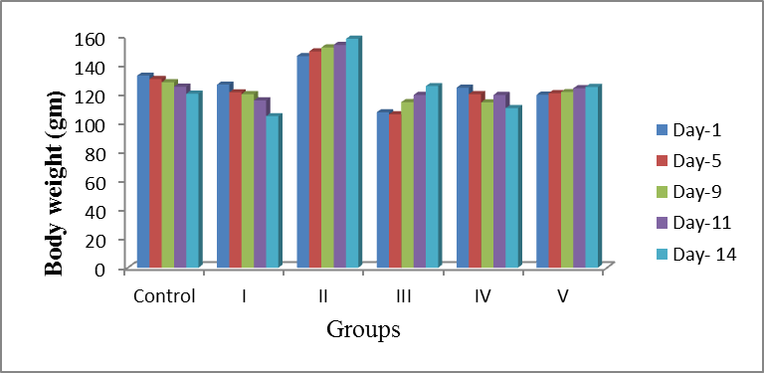
(I)- Escherichia coli (Eey) injected in wilstar rat day 14. (11) - Escherichia coli (Eey) infected group of wilstar rat treated with burnol day 14. (III) Escherichia coli (Eey) infected group of wilstar rat treated with chloroform extract of T. cordifolia day 14. (IV). Escherichia coli (Eey) infected group of wilstar rat treated with methanol extract of T. cordifolia day 14. (V)- Escherichia coli (Eey) infected group of wilstar rat treated with petroleum ether extract of T. cordifolia day 14.
Fig: 2: Body weight of wilstar rat infected K. pnemoniae treated with various extract of Tinospora cordifolia
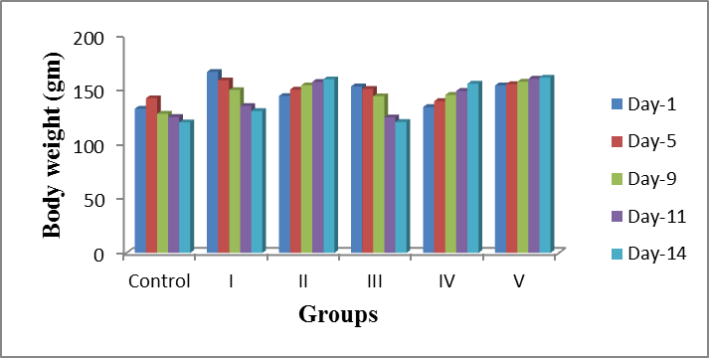
(I)Klebsiella pnemoniae (Xx) injected in rat day 14. (II), Klebsiella pnemoniae (Xx) infected group of wilstar rat treated with burnol day 14. (III). Klebsiella pnemoniae (Xx) infected group of wilstar rat treated with chloroform extract of T. cordifolia day 14 (IV). Klebsiella pnemoniae (Xx) infected group of wilstar rat treated with methanol extract of T. cordifolia day 14. (V) Klebsiella pnemoniae (Xx) infected group of wilstar rat treated with petroleum ether extract of T. cordifolia day 14.
Fig: 3: Body weight of wilstar rat infected Staphylococcus aureus treated with various extract of Tinospora cordifolia
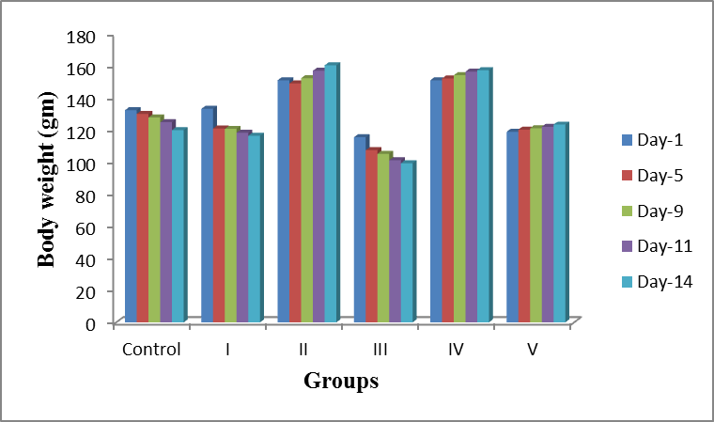
(I) Staphylococcus aureus (V) injected in rat day 14. (II) Staphylococcus aureus (V) infected group of wilstar rat treated with burnol day 14. (III) Staphylococcus aureus (V) infected group of wilstar rat treated with chloroform extract of T. cordifolia day 14. (IV). Staphylococcus aureus (V) infected group of wilstar rat treated with methanol extract of T. cordifolia day 14. (V). Staphylococcus aureus (V) infected group of wilstar rat treated with petroleum ether extract of T. cordifolia day 14.
The wound infected with E. coli (Eey) treated with chloroform and petroleum ether extract of T. cordifolia was cure within 5 days. K. pnemoniae (Xx) infected treated with methanol extract of T. cordifolia and K. pnemoniae (Xx) infected wound of wilstar rat treated with petroleum ether extract of T. cordifolia wound healed within 5 days. S. aureus (V) infected wound of wilstar rat treated with methanol and petroleum ether extract of T. cordifolia heal within 4 days.
Hematological assessment
Studying hematological parameters such as total leukocyte count (TLC), hemoglobin (Hb) and differential leucocytes (DC) during toxicity study in rat is very important in providing reliable information concerning hematological changes (Table 1, 2 and 3). The interesting observation that the T. cordifolia was able to improve the deranged blood parameters to some extent which were altered by tropical administration. T. cordifolia has been extensively used in the treatment of various types of hematological, hepatic, neurological, diabetic and inflammatory conditions (Bishayi et al. 2002).
Hemoglobin level was significantly (P < 0.05) high (15.86 ± 0.33 g/dl) in the E. coli (Eey) infected wilstar rat treated with chloroform extract of T. cordifolia than in the control (13.93 ± 0.2 g/dl). But hemoglobin level was very low in K. pnemoniae (Xx) infected rat treated with burnol (Table 2). Kaur et al. (2013) reported a hemoglobin level was high in the rat groups treated with Emblica officinalis and Azadirachta indica. The increase in the hemoglobin count might be speculated to be due to the immunopotent effect of X. aethiopica (Ameyaw and Owusu, 1998).
The total leucocyte count of control rat was 3811 ± 26.08 lakh cu.mm and it was increased in the infected rat treated with various extracts of T. cordifolia (Table – 1, 2 and 3). Among the extract, chloroform extract of T. cordifolia showed high significant (P < 0.001) increase of leukocyte in K. pnemoniae (Xx) infected rat. The regulatory effect of phenolic compounds of T. crispa on macrophage modulation and inflammatory mediator secretion from macrophages and other leucocytes (Ramiro and Castell, 2009). Kaur et al.(2013) reported total leukocyte count in Emblica officinalis and Azadirachta indica treated groups was reduced as compared to the infected control.
The total neutrophils count of control rat was 26.33 ± 1.24 % and it was increased in the K. pnemoniae (Xx) infected wilstar rat treated with chloroform extract of T. cordifolia (40 ± 1.63%). In present study chloroform stem extract T. cordifolia showed significance (P < 0.05) increase of neutrophils in K. pnemoniae (Xx) infected rat. Daswani and Radha (2002), observed no significant was not changes were observed in the neutrophils. Although it may increase of neutrophils treated with chloroform extract of T. cordifolia, due to cells in phagocytes action.
Lymphocytes level was significantly (P < 0.05) high (89.66 ± 2.86 %) in the S. aureus infected wilstar rat treated with chloroform extract of T. cordifolia than in the control (69.99 ± 1.24 %). In the study low percentage of lymphocytes (57 ±1.63%) noted in K. pnemoniae infected wilstar rat treated with chloroform extract of T. cordifolia. Bhardwaj et al. (2012) find out the total lymphocyte count was increased in the stem extract of T. cordifolia.
The total monocyte count of control rat was 1.66±0.47 % and it was increased in the S.aureus (V) infected rat treated with burnol (Table 3). Valentine and Lawrence (1971) reported T.cordifolia alcoholic extract having immunomodulatory effects show cutaneous reaction which is attributed to liberation of lymphokines, skin reactive factor and monocytes, chemotactic factor from sensitized T‐cells. This mechanism may be occurred in the S. aureus infected rat treated with burnol.
Eosinophil level was significantly (P < 0.05) high (3 ± 1.63 %) in the K. pnemoniae (Xx) infected wilstar rat treated with chloroform extract of T. cordifolia and K. pnemoniae (Xx) infected in rat. Basophil was completely absent in the entire test animal. The total platelet count of control rat was 2.16 ± 0.04 cu.mm and it was increased in S. aureus (V) infected wilstar rat treated with chloroform extract of T. cordifolia (4.03 ± 0.44) (Table 3). Increased platelet rich fibrin (PRF) can be used to promote wound healing, bone regeneration, graft stabilization, wound sealing, and hemostasis (Balaram et al., 2013).
In the present study Serum glutamic oxaloacetic transaminase (SGOT (V/L)) level was significantly (P < 0.001) high (526.66 ± 12.28 (V/L)) in the S. aureus infected wilstar rat treated with chloroform extract of T. cordifolia than in the control (28 ± 0.81 (V/L)). Serum glutamic pyruvic transaminase (SGPT (V/L)) level was significantly (P < 0.001) high (526.66 ± 12.28 (V/L)) in the S. aureus infected wilstar rat treated with chloroform extract of T. cordifolia than in the control (41.5 ± 0.45 (V/L)). The alkaline phosphatase (ALK) value of control rat was 46.33 ± 1.24 (V/L) and it was increased in the infected rat treated with various extracts of T. cordifolia (Table – 1, 2 and 3). Among the extract, chloroform extract of T. cordifolia showed high significance (P < 0.001) increase of ALK in S. aureus infected rat. Steve et al. (2008) describes that the ALT levels increased in the diabetic animals treated with the extract and glibenclamide while AST levels were unaffected. It implied that the extract and glibenclamide at the doses did not produce any harmful effects on the heart tissues but did provoke some detrimental effects on liver tissues.
Very high serum Creatine (4±0.81) (mg /dl) level was recorded in wilstar rat infected S. aureus treated with chloroform extract of T. cordifolia (357.33 ± 7.58 mg/dl). But low level in control batch 0.49±0.06 mg/dl. The elevation in plasma creatinine concentration indirectly suggests kidney damage, specifically the renal filtration mechanism (Wasan et al., 2001). The present observation of liver enzyme elevation is in agreement with earlier reported studies (Kume et al., 2006), which have shown that the amount of diagnostic marker enzymes present in plasma is directly proportional to the number of necrotic cells present in the liver tissue.
Laboratory diagnosis | Batch – I Control |  | Escherichia coli (Eey) injected in wilstar rat - Day 14. | Escherichia coli (Eey) infected group of wilstar rat treated with burnol- Day 14. | Escherichia coli (Eey) infected group of wilstar rat treated with chloroform extract of T. cordifolia - Day 14. | Escherichia coli (Eey) infected group of wilstar rat treated with methanol extract of T. cordifolia - Day 14. | Escherichia coli (Eey) infected group of wilstar rat treated with petroleum ether extract of T. cordifolia - Day 14. | Reference Value
Laboratory diagnosis | Day 1 | Day 14
Hemoglobin (Hb) (g/dl) | 13.76±0.28 | 13.93±0.20 | 14.06±0.24 | 13.43±0.24 | 15.86±0.33 | 14.23±0.40 | 14.96±0.36 | 11 – 19.2
Total count (WBC) (lakh cu.mm) | 3811± 26.08 | 3807.66±39.75 | 2419.33±30.21 | 2953 ± 89.94 | 3511 ± 53.23 | 3034 ± 158.41 | 4042 ± 124.55 | 6 – 8 X 1000
Differential blood Count (DC)
Neutrophils (%) | 26.33±1.24 | 25.66±1.69 | 15.66±1.24 | 18±0.81 | 21±0.81 | 16.66±1.24 | 22±0.81 | 10 – 40
Lymphocytes (%) | 69.99±1.24 | 73.33±2.49 | 79.66±1.24 | 80±0.81 | 73±2.44 | 79.66±1.24 | 76.33±1.24 | 65 – 85
Monocytes (%) | 1.66±0.47 | 1.33±0.47 | 2.0±0.81 | 2.66±0.47 | 1.66±0.47 | 2.66±1.24 | 2.33±0.47 | 0 – 5
Eosinophils (%) | 2.33±0.47 | 0 | 1.33±0.47 | 0 | 2±0.81 | 1.66±0.94 | 1.33±0.47 | 0 – 6
Basophils (%) | 0 | 0 | 0 | 0 | 0 | 0 | 0 | 0 – 1
Platelet (cu.mm) | 2.16±0.04 | 2.1 ±0.08 | 1.33±0.47 | 0.83±0.04 | 1.8±0.72 | 1.2±0.16 | 1.73±0.12 | 500 – 1300 x 1000
Biochemistry
SGOT (V/L) | 28±0.81 | 28±0.81 | 16.26±0.32 | 28.5±0.08 | 134±4.54 | 177±5.34 | 73.53± 0.81 | 28 – 140
SGPT (V/L) | 41.5±0.45 | 42.33±2.05 | 66.13±0.20 | 62.33±2.05 | 79.43±0.53 | 87.16±0.28 | 28.33±0.57 | 35 – 80
ALK (V/L) | 46.33±1.24 | 48.66±0.47 | 48.0±0.81 | 16.33±0.33 | 16.56±0.36 | 60.28±0.55 | 18.66±0.28 | 16 – 50
SerumCreatine (mg/dl) | 0.49±0.06 | 0.58±0.004 | 1.23±0.20 | 0.16±0.04 | 0.3±0.08 | 0.08±0.008 | 0.16±0.09 | 0.2- 0.9
Urea (mg /dl) | 12.5±0.16 | 13.06±0.24 | 125.23±0.36 | 11.18±0.21 | 15.1±0.45 | 10.49±0.24 | 13.26±0.38 | 10- 50
Table: 1.Hematological and biochemistry analysis of Escherichia coli (Eey) infected wilstar rat treated with Tinospora cordifolia
X- Serum glutamic oxaloacetic transaminase (SGOT), Serum glutamic pyruvic transaminase (SGPT) and Alkaline phosphatase (ALK).
Table: 2. Hematological and biochemistry analysis of Klebsiella pnemoniae (Xx) infected wilstar rat treated with Tinospora cordifolia
Laboratory diagnosis | Batch – II Control |  | Klebsiella pnemoniae (Xx) injected in Rat - Day 14. | Klebsiella pnemoniae (Xx) infection in wilstar rat treated with burnol - Day 14. | Klebsiella pnemoniae (Xx) infection in wilstar rat treated with chloroform extract of T. cordifolia - Day 14. | Klebsiella pnemoniae (Xx) infection in wilstar rat treated with methanol extract of T. cordifolia - Day 14. | Klebsiella pnemoniae (Xx) infection in wilstar rat treated with petroleum ether extract of T. cordifolia - Day 14. | Reference Value
Laboratory diagnosis | Day 1 | Day 14
Hemoglobin (Hb) (g/dl) | 13.76±0.28 | 13.93±0.20 | 8.5±0.32 | 8.21±0.21 | 10.22±0.50 | 12.36±0.30 | 11.66±0.33 | 11 – 19.2
Total count (WBC) (lakh cu.mm). | 3811± 26.08 | 3807.66±39.75 | 7185±128.90 | 8417.33±232.81 | 8987.66±432.42 | 6170.66±175.46 | 8235±241.72 | 6 – 8 X 1000
Differential blood Count (DC)
Neutrophils (%) | 26.33±1.24 | 25.66±1.69 | 25.33±1.24 | 18±0.81 | 40±1.63 | 11.66±1.24 | 37±1.63 | 10 – 40
Lymphocytes(%) | 69.99±1.24 | 73.33±2.49 | 72.66±2.05 | 78.66±2.86 | 57±1.63 | 88±2.44 | 60.33±2.05 | 65 – 85
Monocytes (%) | 1.66±0.47 | 1.33±0.47 | 0 | 0 | 0 | 0 | 1.33±1.24 | 0 – 5
Eosinophils (%) | 2.33±0.47 | 0 | 3±1.63 | 2±0.81 | 3±1.63 | 0 | 2±0.81 | 0 – 6
Basophils (%) | 0 | 0 | 0 | 0 | 0 | 0 | 0 | 0 – 1
Platelet  (Cu.mm). | 2.16±0.04 | 2.1 ±0.08 | 2±0.81 | 1.13±0.26 | 2±0.81 | 1.63±0.32 | 1.26±0.24 | 500 – 1300 x 1000
Biochemistry
SGOT (V/L) | 28±0.81 | 28±0.81 | 291.66±6.23 | 145.33±8.17 | 522.66±18.35 | 140±11.51 | 128.66±3.68 | 28 – 140
SGPT (V/L) | 41.5±0.45 | 42.33±2.05 | 124.66±4.92 | 197.33±5.73 | 204±5.35 | 79.33±2.05 | 69±2.94 | 35 – 80
ALK (V/L) | 46.33±1.24 | 48.66±0.47 | 93.33±3.68 | 38.33±2.49 | 154±4.54 | 43.33±2.49 | 47.66±2.86 | 16 – 50
Serum Creatine (mg /dl) | 0.49±0.06 | 0.58±0.004 | 4±0.81 | 1.23±0.205 | 0.46±0.12 | 0.4±0.08 | 1.03±0.12 | 0.2- 0.9
Urea (mg /dl) | 12.5±0.16 | 13.06±0.24 | 12.16±0.24 | 13.03±0.28 | 40.33±2.05 | 48±2.94 | 30.66±2.05 | 10- 50
X- Serum glutamic oxaloacetic transaminase (SGOT), Serum glutamic pyruvic transaminase (SGPT) and Alkaline phosphatase (ALK).

Table: 3. Hematological and biochemical analysis of Staphylococcus aureus (V) infected wilstar rat treated with Tinospora cordifolia
Laboratory diagnosis | Batch – III Control |  | Staphylococcus aureus (V) injected in rat - Day 14. | Staphylococcus aureus (V) infection in wilstar rat treated with burnol - Day 14. | Staphylococcus aureus (V) infection in wilstar Rat treated with chloroform extract of T. cordifolia - Day 14. | Staphylococcus aureus (V) infection in wilstar Rat treated with methanol extract of T. cordifolia - Day 14. | Staphylococcus aureus (V) infection in wilstar Rat treated with petroleum ether extract of T. cordifolia - Day 14. |  | Reference Value
Laboratory diagnosis | Day l | Day 14
Hemoglobin (Hb) (g/dl) | 13.76±0.28 | 13.93±0.20 | 14±0.81 | 13.96±0.20 | 12.04±0.44 | 12.8±0.35 | 10.9±0.29 |  | 11 – 19.2
Total count (WBC) (lakh cu.mm) | 3811± 26.08 | 3807.66 ± 39.75 | 2378±20.84 | 3016.66±62.36 | 8427 ±156.15 | 1151.66±71.91 | 6066.66±124.72 |  | 6 – 8 X 1000
Differential blood Count (DC)
Neutrophils (%) | 26.33±1.24 | 25.66±1.69 | 15 ± 0.81 | 15±1.63 | 11±0.81 | 31.33±2.64 | 18±0.81 | 10 – 40
Lymphocytes (%) | 69.99±1.24 | 73.33±2.49 | 80.66 ±2.05 | 80 ±2.44 | 89.66 ±2.86 | 63 ±3.26 | 81.66 ±3.09 | 65 – 85
Monocytes (%) | 1.66±0.47 | 1.33±0.47 | 2.33 ±0.47 | 3 ±0.81 | 0 | 0 | 0 | 0 – 5
Eosinophils ( %) | 2.33±0.47 | 0 | 1.33 ±0.47 | 0 | 0 | 2.15 ±0.24 | 2.26 ±0.44 | 0 – 6
Basophils (%) | 0 | 0 | 0 | 0 | 0 | 0 | 0 | 0 – 1
Platelet (cu. mm) | 2.16±0.04 | 2.1 ±0.08 | 1.08 ±0.15 | 0.89 ±0.08 | 4.03 ±0.44 | 3.2 ±0.24 | 2.6 ±0.29 | 500 – 1300 x 1000
Biochemistry
SGOT (V/L) | 28±0.81 | 28±0.81 | 17 ±0.24 | 18.5 ±0.45 | 526.66 ±12.28 | 137.66 ±3.39 | 136 ±5.09 |  | 28 – 140
SGPT (V/L) | 41.5±0.45 | 42.33±2.05 | 66.46 ±2.04 | 62.33 ±2.86 | 546 ±4.32 | 79.33 ±3.68 | 76 ±4.08 |  | 35 – 80
ALK (V/L) | 46.33±1.24 | 48.66±0.47 | 48.33 ±3.29 | 12.8 ±0.24 | 193.66 ±7.40 | 26 ±3.74 | 27 ±3.74 |  | 16 – 50
Serum Creatine (mg /dl) | 0.49±0.06 | 0.58±0.004 | 1.2 ±0.24 | 0.5 ±0.24 | 2.86 ±0.26 | 0.7 ±0.16 | 1.01 ±0.10 |  | 0.2- 0.9
Urea (mg /dl) | 12.5±0.16 | 13.06±0.24 | 125.73 ±3.28 | 11.27 ±0.21 | 357.33 ±7.58 | 49.66 ±4.49 | 45 ±3.26 |  | 10- 50
X- Serum glutamic oxaloacetic transaminase (SGOT), Serum glutamic pyruvic transaminase (SGPT) and Alkaline phosphatase (ALK).
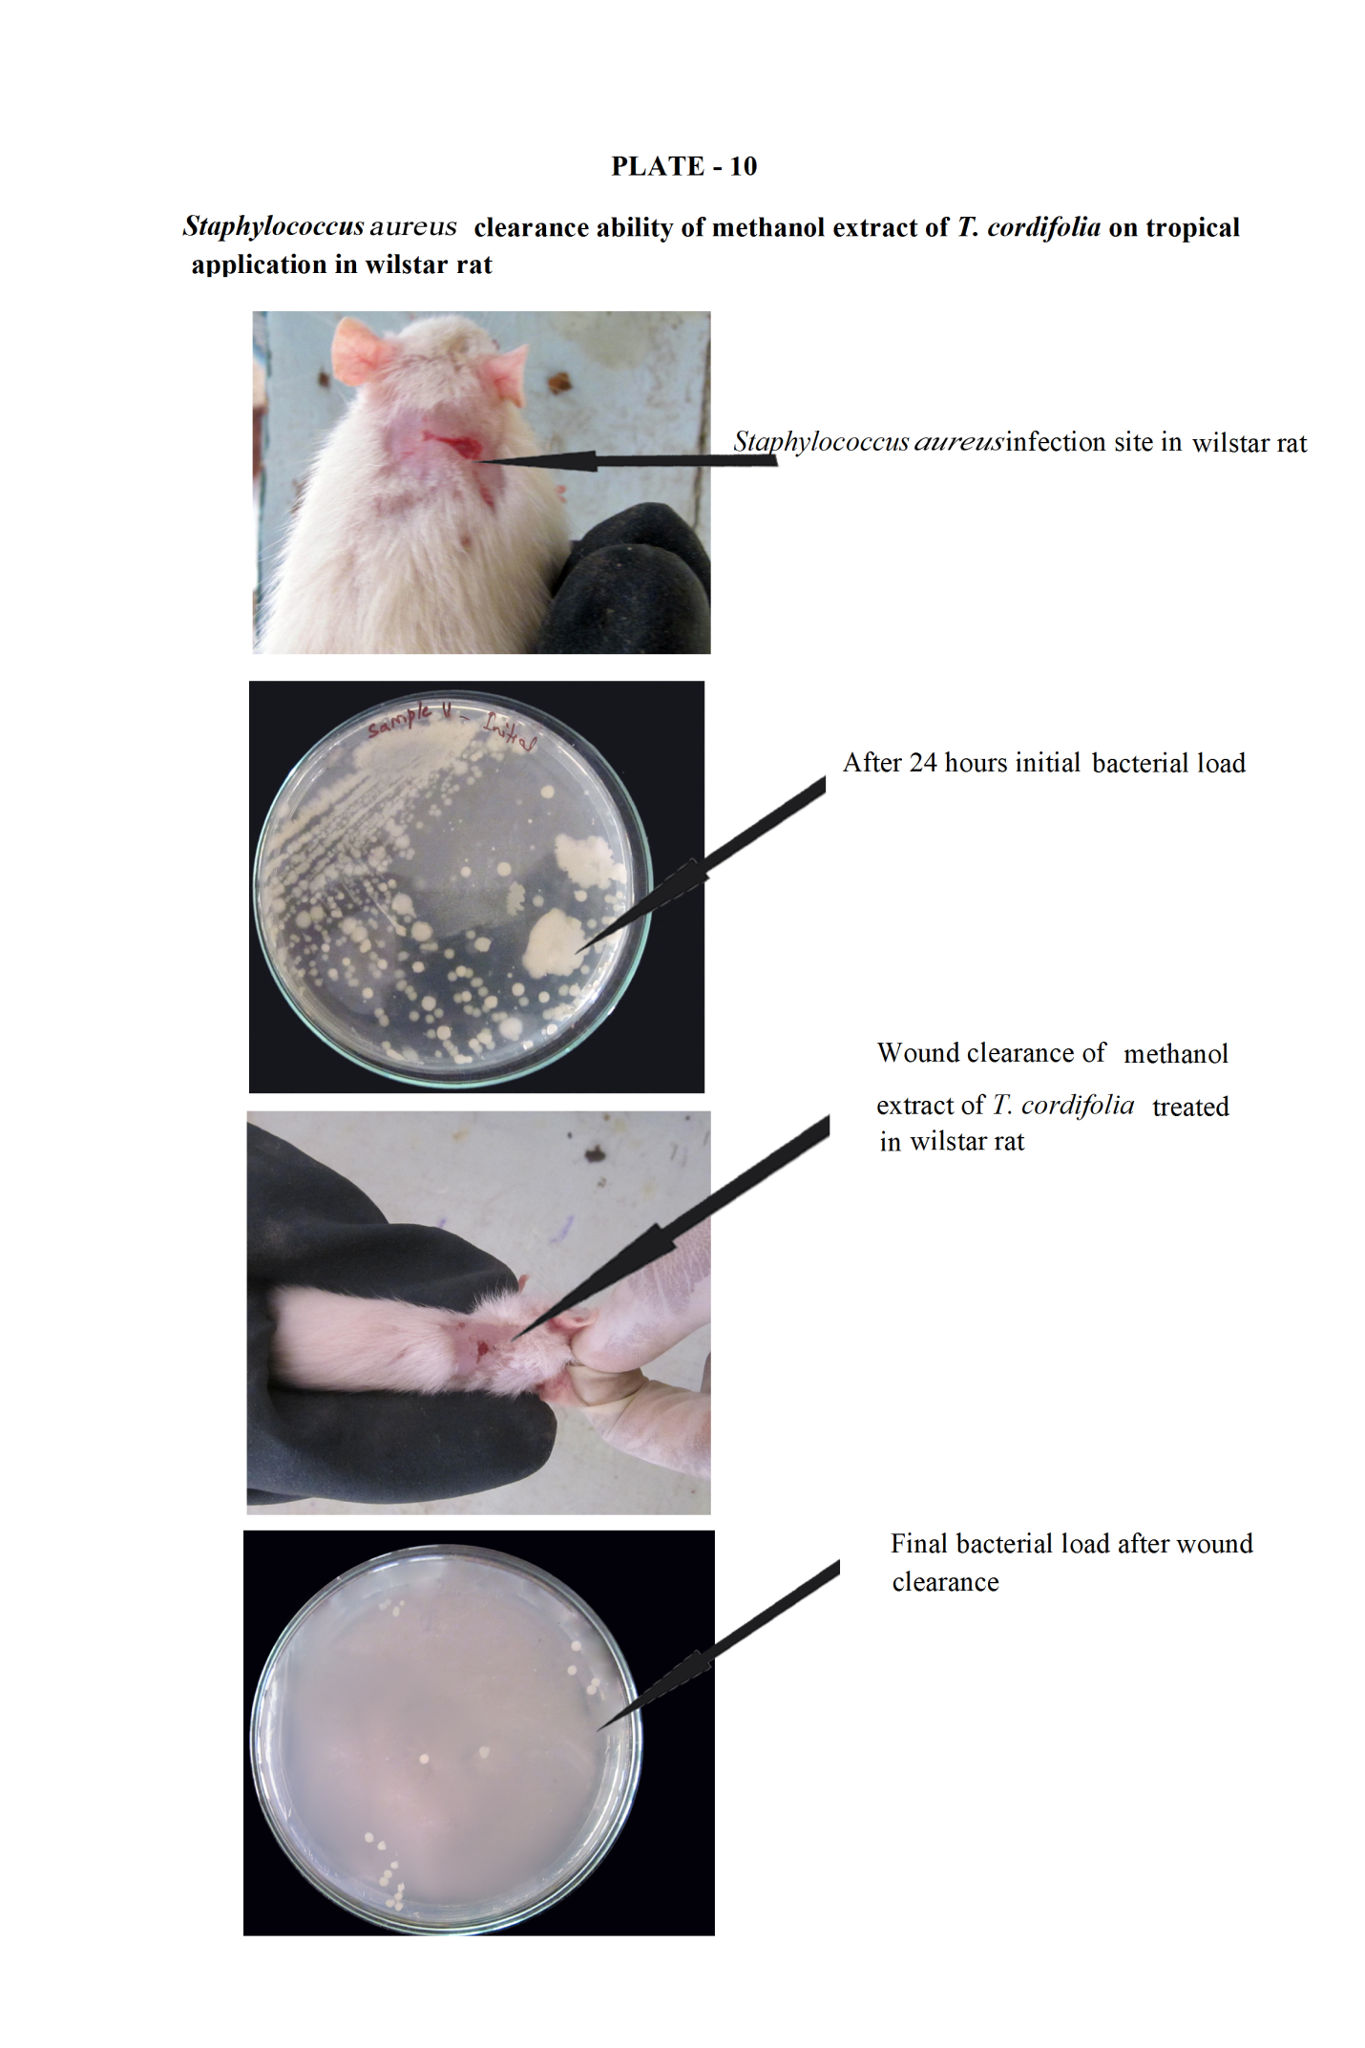
Reference
Ameyaw, Y and Owusu, A. E. 1998. Morphohistological studies of two plant species used in Ethnomedicine. J. Herbs. Spic. Medic. Plant. 5: 60-85.
Balaram, N., Karunakar, P., Jayadev, M and Rahul , M. 2013.Role of platelet rich fibrin in wound healing. Arom. Plant,1(2): 57-61.

Bedi, M. K and Shenefelt P.D. 2002. Herbal therapy in dermatology. Arch Dermatol. 138,232.
Bergmeyer, H. U and Bernt, E. 1974. Glutamate-pyruvate transaminase.723-733. In Bergmeyer HU (Etd) Methods of Enzymatic Analysis. Academic Press, London.
Bhardwaj, U., Tiwary, B. K., Prasad, A and Ganguly. S. 2012. Effect of Tinospora cordifolia extract on immune response and serum biochemical profile in broilers.Indian Journal of Animal Sciences 82 (4): 379–381.
Bishayi, B., Roychowdhury, S., Ghosh, S and Sengupta, M. 2002. Hepatoprotective and immunomodulatory properties of Tinospora cordifolia in CCl4 intoxicated mature albino rats. J. Toxicol. Sci. 27:139-146.
Cho Y.W., Cho Y.N., Chong S.H., Yoo, G and Ko, S.W. 1999. Biomaterials 20, 2139.
Crofton, K. M. 1990.Reflex modification and the detection of toxicant-induced auditory dysfunction. Neurotoxicol Teratol, 12: 461-468.
Daswani, B. R and Radha, Y. 2002. Immunomodulatory Activity of Septilin, a Polyherbal Preparation.Phytotherapy Research. (16), 162-165.
Dieter, M. P., Matthews, H. B and Jeffcoat, R. A. 1993. J. Toxicol. Environ. Health.39:79-93.
Dowsett, C. 2002. The management of surgical wounds in a community setting. British. J. Communi. Nursi. 7 (6) 33-38.
Folin, 0. 1905. Alkaline picrate method for the estimation of creatinine. Ameri. J. Physi. 13: 45-46.
Friedman, H. S. 1953. Modification of Determination of Urea by Diacetyl Monoxime Method. J. Analy. Chemi. 25: 662–664.
Gad, S.1982. A neuromuscular screening for use in industrial toxicology. J.Toxicol. Ennviron. Health. 9: 691-704.
Haque, M. M. 2005. Effects of calcium carbonate, potassium iodide and zinc sulfate in lead induced toxicities in mice. MS. Thesis, Department of Pharmacology, BAU, Mymensingh.
Harish B.G., Krishna, V., Santhosh Kumar H.S., Khadeer Ahamed, B. M., Sharath, R and Kumara Swamy H.M.2008.Phytomedicine 15 :763.IJMedi and Aro pla, 1(2):57-61.
Kamruzzaman. 2006. Effects of ascorbic acid (vitamin c) and α-tocopherol (vitamin E) in lead induced toxicities in rats. MS thesis, Department of Pharmacology, BAU, Mymensingh.
Kaur, S., Kaur,G., Sachdeva,H., Kaur, J. 2013.In vivo evaluation of the antileishmanial activity of two immunomodulatory plants, emblica officinalis and azadirachta indica in balb/c mice. Int. J. Ayur. Herba. Medici. 3(1)1066-1079.
Khanna,S., Venojarvi, M., Roy, S., Sharma, N., Trikha, P., Bagchi, D., Bagchi, M and Sen, C. K. 2002. Free Radical Biology and Medicine. 33: 1089.
Kume, H., Okazaki, K and Sasaki, H. 2006. Hepatoprotective effects of whey protein on D-galactosamine-induced hepatitis and liver fibrosis in rats. Afri. J. Biotech. 70: 1281-1285.
Letts, G. M., Villegas, L. F., Marcalo, A., Abraham, J., Vaisberg and Hammond, G. B. 2006. J. Nat.Prod, 69, 978.
Marchlewicz, M., Wiszniewska, B., Gonet, B., Baranowska, B. I., Safranow, K., Kolasa, A., Glabowski, W., Kurzawa, R., Jakubowska, K and Rac, M. E. 2006. Increased Lipid Peroxidation and Ascorbic Acid Utilization in Testis and Epididymis of Mice Chronically Exposed to Lead. Biometals. 13.
Moser, V. C. 1997. Behavioural screening for neurotoxicity. In: Lowndes, H. E and Reuhl, K. R.(Etd) Comprehensive toxicology. V(11). Nervous system and behavioural toxicology. New York, Pergamon Press. 351-362.
OECD. 1992. Chairman's Report of the Meeting of the ad hoc Working Group of Experts on Systemic Short-term and (Delayed) Neurotoxicity. Paris.
Preeti, 2011. Tinospora cordifolia- A miracle herb and lifeline to many disease.Int. J.Med.

Ramiro, P. E and Castell, M. 2009. Cocoa: Antioxidant and immunomodulator.Br. J. Nutr. 101(07):931–940.
Sai, K. P and Babu, M. 1998. Burns. 24; 387.
Srivastava, P. 2011.Tinospora cordifolia(Amrita)-A miracle herb and lifeline to many disease.
Steve, O. O., Adekunle, A., Stella, O.O.D., Emmanuel, N.A., Veronica, N.E and Moses, O. 2008. Assessing plasma glucose and lipid levels, body weight and acute toxicity following oral administration of an aqueous ethanolic extract of Parinari curatellifolia Planch, (Chrysobalanaceae) seeds in alloxan-induced diabetes in rats. Afri. J. Biotech. 7: 2998-3003.
Szymezak, J., Zechalko, A and Biernat, J.1983. Effect of fodder fat type on blood plasma lipids in mice intoxicated with lead. Bromatol Chem Toksykol. 16(2):98-94.
Taranalli, A.D., Tipare, S.V., Sivakumar and Torgal S.S . 2004. Indi. J. Pharm. Sci. 444.
Thakur, R., Jain, N., Pathale, R and Sandhu, S. S. 2001. Evidence based Complementaryans alternative medicine. 1.
Tupper, D. E and Wallace, R. B.1980. Utility of the Neurologic Examination in Rats. Journal of Acta Neurobiology Experiments 40: 999-1003.
Valentine, F and T. Lawrence.1971.Cell Mediated Immunity. In: Adv Int. Med.17: 51‐93.
Wasan, K. M., Najafi, S., Wong, J and Kwong, M. 2001. Assessing plasma lipid levels, body weight, hepatic and renal toxicity following chronic oral administration of a water soluble phytostanol compound FMVP4, to gerbils. J. Pharma. Sci. 4: 228- 234.

