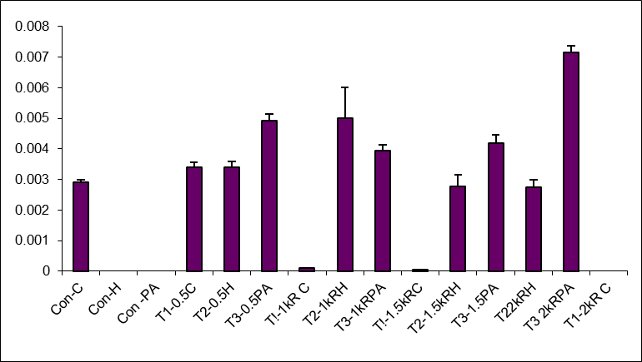

4.7 GRAPH SHOWING THE EFFECT OF GAMMA IRRADIATION
ON ANDROGRAPHOLIDE PRODUCTION

