ENHANCED PRODUCTION OF ANDROGRAPHOLIDE THROUGH THE EFFECT OF GAMMA IRRADIATION ON ANDROGRAPHIS PANICULATA

Dr. Susila Kuruvilla¹ and Dr. P. R. Unnikrishna Pillai ²
- Department of Botany, St. Joseph’s College for Women, Alappuzha-688 001, Kerala, India.
- Department of P.G. Studies and Research in Botany, S.D.College, Alappuzha-688 003, Kerala, India.

ABSTRACT
Andrographis paniculata Nees. (Acanthaceae) known, as Kalmegh in Ayurveda is an annual herb. The genus Andrographis consists of twenty species of small herbs of which Andrographis paniculata is the most popular. The herb is reported to possess an astringent, anodyne, tonic and alexipharmic properties and is useful in dysentery, cholera, diabetes, consumption, influenza, bronchitis, swellings, itches and piles. A. paniculata is found in the Indian pharmacopoeia and is prominent in at least twenty-six Ayurvedic formulas(Anon, 1985)(1). In Traditional Chinese medicine, A. paniculata is an important “cold property herb”. Most of the biological actions of A. paniculata has been described due to the presence of Andrographolide, a diterpenoid lactone present in these plants. Chakravarthi and Chakravarthi (1952) observed that the leaves of Kalmegh contain the maximum amount of andrographolide content (2.5%) from the leaves and the stem posses the lesser amount (2). Secondary metabolites isolation from callus will help to satisfy the needs to some extent.
One of the most widely applied empirical approaches to optimize the synthesis and accumulation of secondary plant products is the use of physical mutagen like γ –ray. The effects of gamma irradiation on secondary metabolite production in callus cultures derived from four doses of γ-irradiated seedlings of A.paniculata were studied. The result of this study indicated that γ-irradiation positively influenced andrographolide production in A.paniculata from the callus cultures. The significant impact of this study was that the callus cultures produced from non-irradiated seedlings showed the absence of andrographolide.
The effect of four doses of γ-irradiation on the invitro production of andrographolide from the leaf explants of A .paniculata was studied. An enhanced rate of andrographolide was found in all the doses of samples using HPLC analysis after gamma irradiation.Low doses of radiation have been found to have a stimulatory effect in the production of secondary metabolites. Gamma irradiation had a significant effect on germination of seeds. The supply of an exogenous precursor to culture medium may also increase the yield of the desired control.
The presence of the important secondary metabolite andrographolide is not yet reported in the callus of A. paniculata and also in the in vitro condition ..So far the andrographolide is extracted from intact plants only. This study provides the feasibility to produce the important secondary metabolite in vitro.

MATERIALS AND METHODS

The seedlings were subjected to four doses of gamma irradiation at the Rubber Board, Puthuppally, Kottayam, ,Kerala,.India. The doses were 0.5kR, 1kR, 1.5kR and 2kR. The time taken for each irradiation was calculated using the formula 276.7475⁰Kilorad/Hour. Based on this calculation 0.5kR irradiation was done by giving gamma irradiation for 7 seconds, 1kR by 13 seconds, 17 seconds for 1.5 kR and 26 seconds for 2kR.

The seedlings after irradiation were allowed to grow in the green house. After ten days the third leaf from the apical portion was selected for in vitro inoculation..For callus induction, each treatment consisted of 10 explants in test tubes, with three replications and observations were recorded.

The proliferated calli, after fifteen days, were sub-cultured into callus proliferating medium containing basal MS medium supplemented with various concentrations of cytokinins (BA/KIN) or in combination with auxins (NAA, 2,4D).The medium was also enriched with vitamins, phenylalanine and the additive polyethyleneglycolin various concentrations of auxins and cytokinins. For callus proliferation, each treatment consisted of ten experimental bottles, with three replications and the fresh weight of the callus after forty and seventy days of inoculation were taken. Relative growth rate (RGR) of calluses was estimated.(Graph 4.5,4.6)

The medium used for callus proliferation was taken as medium for callus andrographolide accumulation (Table2.7). The calli kept in the proliferating medium were grown for 70 days and were taken out and allowed to dry in the hot air oven at 33⁰C. Before drying the fresh weight of the calli was taken. The dry weights of the calli were also taken after proper drying and they were stored at 4⁰C, after proper labeling. The andrographolide content was estimated by HPLC analysis

RESULTS AND DISCUSSION

EFFECT OF THE GAMMA IRRADIATION ON ANDROGRAPHOLIDE PRODUCTION ( L-PHENYL ALANINE IN COMBINATION WITH KINETIN AND NAA)

0.5kR
Stock calluses were transferred into MS medium fortified with 50mg|l phenyl alanine, 1mg|l kinetin and 2mg|l NAA and the impact of auxins and cytokinins together with L-phenyl alanine on andrographolide synthesis was analysed after a period of seventy days. The fresh weight observed was 10930mg. The presence of alkaloid was 0.0049%W|W which was greater in the non-irradiated plants .The precursor L-phenyl alanine and gamma irradiation promoted the alkaloid production when the seedlings of A.paniculata were irradiated with 0.5kR of γ ray
1kR

Stock calluses transferred to full MS medium favoured an increase in the andrographolide production. The positive influence of precursor, L-phenyl alanine was exhibited by the callus cultures with an increase in andrographolide production, 0.0039%w|w. In non-irradiated calli the andrographolide content was (0.0). In the MS medium supplemented with 1mg|lkinetin, 2mg|l NAA and 50mg|l L-phenyl alanine the andrographolide showed a remarkable increase with gamma irradiation at the dose of 1kR to the seedlings (TABLE 4.4)
1.5kR
1.5kR of γ-irradiation together with L-phenyl alanine induced andrographolide production significantly and a progressive increase in the andrographolide production was noticed (0.0042%w|w). 1.5kR gamma irradiation favoured callus proliferation (fresh weight: 11040mg) and andrographolide production. Even though the precursor was supplemented into MS medium there was no significant impact on andrographolide production in control explants where the content was negligible (0.0). Thus γ- irradiation favoured andrographolide production and maximum accumulation of andrographolide using precursor was reported in this dose.
2kR

The positive influence of gamma irradiation and L-phenyl alanine was significant in callus proliferation and andrographolide production. The andrographolide production enhanced up to 0.0072%w|w. In the control plant calluses, the presence of andrographolide was not reported. Maximum callus growth and proliferation recorded was 19242mg of fresh weight. It was found that by increasing the dose of γ – irradiation the accumulation of andrographolide was also increased.(GRAPH 4.7)
Gamma irradiation had a significant impact on andrographolide production in A.paniculata. In non–irradiated seedlings, the presence of andrographolide is not reported from calluses produced from nutrient media supplemented with various growth regulators.
In the present study, the 2kR irradiated seedlings exhibited a large increase in andrographolide production in the callus cultures when the medium was fortified with 50mg|l phenylalanine, 1mg|l kinetin and 2mg|l NAA. The andrographolide produced was 0.0072%w|w.The gamma irradiation up to 2kR increased the andrographolide production from the calluses.

Maximum andrographolide production was found in the callus produced from seedlings irradiated with 2kR of γ-irradiation proliferated in a medium supplemented with the precursor-phenylalanine. In A.paniculata the andrographolide content in callus produced from non irradiated explants raised in a medium containing phenylalanine was negligible (0.0). But a significant increase in andrographolide accumulation (0.0072%w\w) was noticed in the callus produced from explants after 2kR of γ-irradiation. This observation was in contrast to the observations made by Butcher and Conolly (1971)(3). They reported that callus and suspension cultures of A.paniculata had been shown to produce three new sesquiterpene lactones, which had been named paniculides, A, B, C and not the andrographolide (diterpenes) produced by the intact plant. They also reported that the callus derived from leaves, stems, hypocotyls, roots and embryos accumulated paniculides, but no andrographolides were detected. They attributed this abnormal terpenoid metabolism is due to the lack of organized tissues in these cell cultures. This result was in agreement with the reports of Zhang-Hua et al (1999) (4). They studied the influence of gamma ray on Shikonin formation on cultured cells of Onasma paniculatum. The optimum gamma radiation dose was 1500 R, which gave a 144.6% increase in Shikonin content compared to the control (unirradiated) callus gamma irradiation together with the presence of higher level of PEG. Andrographolide production did not show gamma irradiation dose dependence in all the samples studied.
This result was in agreement with the reports of Zhang-Hua et al (1999)(4). They studied the influence of gamma ray on Shikonin formation on cultured cells of Onasma paniculatum. The optimum gamma radiation dose was 1500 R, which gave a 144.6% increase in Shikonin content compared to the control (unirradiated). Li et al (2005) studied the effect of γ-irradiation on development, yield and quality of micro tubers in vitro in Solanum tuberosum L(5).The report of the present study was in agreement with the study on Solanum tuberosum done by Li et al, 2005. When plantlets were irradiated with 4Gy a significant increase in the fresh mass and low doses of irradiation increased the starch content of micro tubers and also significantly increased the protein content of micro tubers. Subodh Kumar (1987) had reported that gamma rays induced mutants showed changes in phenolic compounds in Chrysanthemum.(6)The positive effect of gamma rays on Capsicum annum was observed by the enhanced capsicine content (Bansal, 1969)(7). According to of Kurz and Constabel (1979) the enrichment of the culture medium with additives or amino acids was highly beneficial for the intracellular accumulation of andrographolide(8). Yeoman (1987) was of the opinion that the rate of cell growth directly regulates secondary metabolism by affecting the kinetic partitioning of precursors between primary and secondary metabolic pathways.(9)
. The increase in biomass caused an increase in andrographolide accumulation in 2kR-irradiated explants and this indicates that concentration of andrographolide increased with the increase of cell mass.
Rech S.B et al (1998) reported that in Rauwolfia sellowii alkaloids were found in the suspension cultures from early growth stages and the maximum product accumulation was observed with the end of exponential growth phase. They also observed that product formation is growth associated, since the concentrations of alkaloids increased with increase in cell mass.(10)
The accumulation of metabolites in callus produced from γ- irradiated seedlings can be explained on the basis of the experimental studies of Chagvardieff et al (1989) on Euphorbia characias. They studied the effect of gamma irradiation in photoautotropic suspension cultures of E.characias and observed the arrest of cell divisions and a subsequent over accumulation of sucrose and dry matter when gamma irradiation was applied.(11) The arrest in cell division may cause over accumulation of sugars, which may lead to the synthesis of other metabolites.
In this study, the effect of gamma irradiation on secondary metabolite production may be accelerated by the presence of additives and precursor. Gunckel and Sparrow (1961) reported that gamma rays are known to influence plant growth and development by inducing cytological, genetical, biochemical physiological and morphogenetic changes in cells and tissue.(12) The use of optimal levels of phytohormones for the growth and addition of various chemically defined compounds to the medium as inducers stimulated the production of secondary metabolites.
The studies on accumulation of andrographolide in callus raised from explants after various doses of γ-irradiation proved that the andrographolide accumulation showed a dose dependent variation and maximum andrographolide production was found in the callus produced from seedlings irradiated with 2kR of γ-irradiation.

BIBLIOGRAPHY
1. Anon, (1985) Trial Data Report. Twelfth All India Workshop of AICRP on Medicinal and Aromatic plants at CCS, Haryana Agricultural University. 192-198.
2. Chakravartni and Chakravarthi (1952) Andrographolide. International Journal. Chem. Soc.p.1697.
3. Butcher and Conolly (1971) Journal of Experimental Botany, Vol.22, 314.
4. Zhang-Hua., Cao- Riqiang., Yang-Yang Hua., Zhang H., Cao R Q.,and Yang Y.H (1999). Influence of gamma ray on shikonin formation in cultured cells of Onasma paniculatum Bur et Franch. Journal of plant science and environment. 8: 42-45.
5. Li H.Z., Zhou W.J., Zhang Z.J., GU H.H., Takechi Y and Yoneyama K. (2005) Effect of γ-irradiation on development, yield of micro tubers in vitro in Solanum tuberosum L.Biologia Plantarum. Volume 49,December 2005.
6. Subodh Kumar (1987)Induced changes of Phenolic compounds in Mutants.New Botanists
Vol.14:17-19.
7. Bansal, 1969) Induced chilli mutant containing high capsicine and low carotenoidsin fruit.in:Radiations and low radiomimetic substances in Mutation breeding,Bombay:285-292
8. Kurz and Constabel (1979)Plant cell suspension cultures and their biosynthetic potential.Microb.Technol1:389-416.
9. Yeoman (1987) Bypassing the plant.Annals of Botany 60,Supplement 4:157-174.
10. Rech S B,Batista,CVF,SchripsemaJ,VerpoorteR,Henriques AT (1998) Cell cultures of Rauwolfia sllowi:growth and alkaloid production ,Plant Cell Tissue and Organ Culture 54:61-63
11. Chagvardieff et al (1989) Cell division arrest by gamma –irradiation in Photoautotropic suspension culture of Euphorbia characias: Maintenance of photosynthetic capacity and over accumulation of sucrose. Plant cell Tissue and Organ Culture 19: 141-149.
12. Gunckel J.E and Sparrow A.H. (1961). Ionization radiation: Biochemical, Physiological and Morphological aspects of their effects on plants. In: Encycl.Plant. Physiol.(ed) W. Ruhland. XVI: pp. 555-611, Springer-verlag, Berlin.

TABLE 2 EFFECT OF VARIOUS HORMONES ON CALLUS PROLIFERATION
AND RELATIVE GROWTH

Medium  Strength  Full MS  Explant  Leaf | 2,4 D | BA | KINETIN | NAA | PEG  mg/l | RGR AT  30 DAYS | RGR AT  70 DAYS
Medium  Strength  Full MS  Explant  Leaf | 0.5 |  | 0.5 | . | 2 | 0.00375 | 0.00285
Medium  Strength  Full MS  Explant  Leaf | 0.5 |  |  |  |  | 0.00342 | 0.00235
Medium  Strength  Full MS  Explant  Leaf | 0.5 | 0.5 | 0.1 |  |  | 0.0499 | 0.03970
Medium  Strength  Full MS  Explant  Leaf | 0.5 |  | 1 |  |  | 0.00315 | 0.00305
Medium  Strength  Full MS  Explant  Leaf |  | 0.5 | 1 | 3 |  | 0.00491 | 0.00252

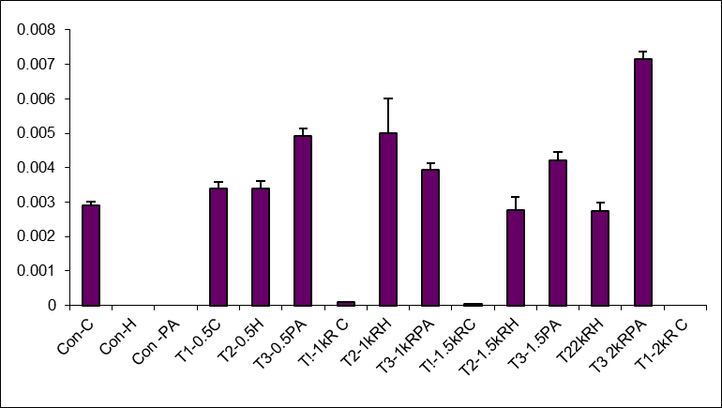

4.7 GRAPH SHOWING THE EFFECT OF GAMMA IRRADIATION
ON ANDROGRAPHOLIDE PRODUCTION

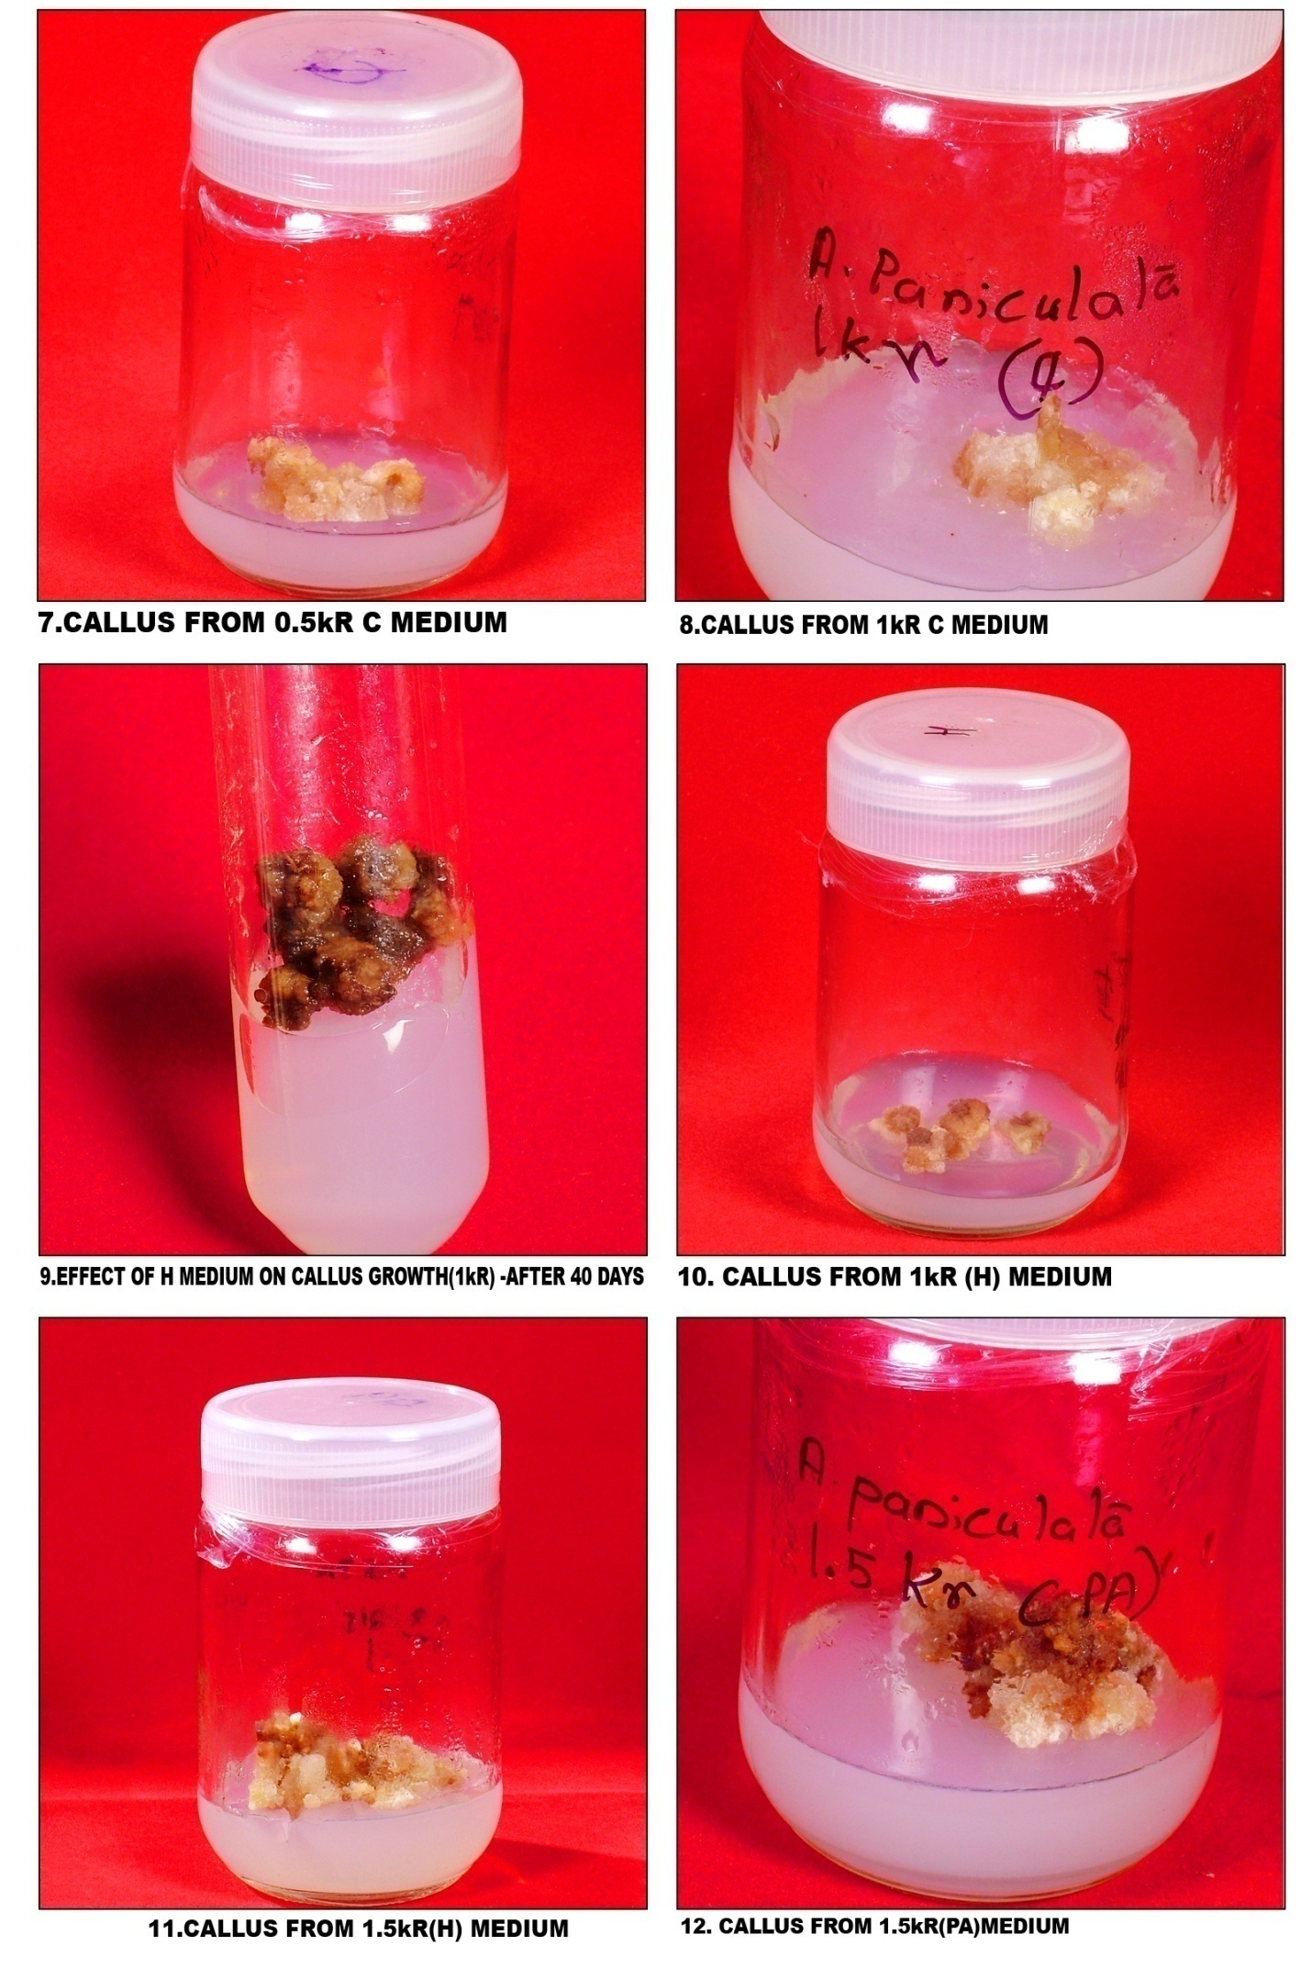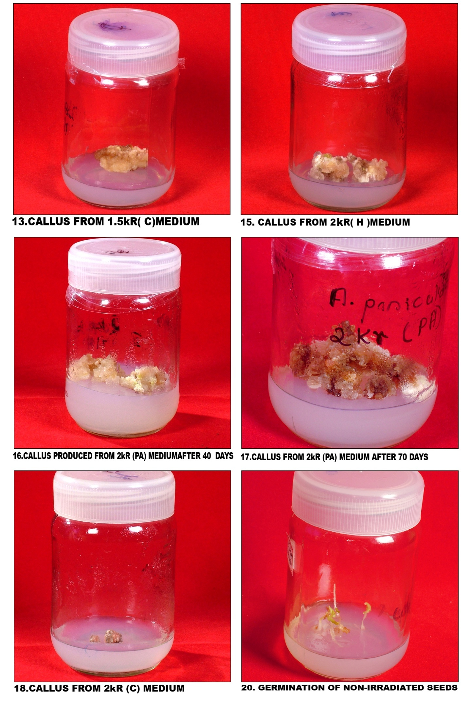
ABBREVATIONS
BA Benzyl adenine
GA₃ Gibberellic acid
IAA Indole -3-acetic acid
IBA Indole -3-butryic acid
KIN 6-furfuryl amino purine
2, 4-D 2,4-dichlorophenoxy acetic acid
PEG6000 Polyethylene glycol 6000
kR kilo rad
Gy gray
MS Murashigue&Skoog

ACKNOWLEDGEMENT
I duly acknowledge the financial assistance from University Grants Commission, New Delhi, India towards this project

