Hippasa agelenoides spider venom gland extract exhibits myotoxic, fibrino(gen)lytic and platelet agregation inhibitory properties.
S. Devaraja¹, K.S. Girish1 and K. Kemparaju^{2*}
¹ Department of Studies and Research in Biochemistry, Tumkur University, Tumkur, India –572103, ²Department of Biochemistry, Manasagangotri, University of Mysore, Mysore, India-560 006.
Correspondence for author: K. Kemparaju Ph.D
E-mail: kemparajuom@gmail.com Tel: +91 821 2419625, Fax: + 91 821 2415390
*Corresponding author
Published: 20 April 2015 Received: 08 January 2015
AJBBL 2015, Volume 04: Issue 02 Page 54-79 Accepted: 13 March 2015
ABSTRACT
The present study explores the biochemical and pharmacological examination of H. agelenoides spider venom gland extract for the proteolytic activity and along with other pharmacological properties. The venom gland extract hydrolyzed casein, the proteolytic activity was further confirmed by the activity staining on casein zymogram. The venom gland extract showed two translucent activity bands on casein zymogram in the region of 16 kDa and 29 kDa suggesting the presence of two isoforms of proteases. However, both the activity bands were sensitive to PMSF but insensitive to EGTA, EDTA, 1, 10, phenanthroline and IAA, suggesting both isoforms are belongs to serine protease family. The venom gland extract was devoid of hemorrhage and cytotoxicity but caused edema and myotoxicity in experimental mice. The histopathology of transverse section of mice skeletal muscle treated with the venom gland extract showed extensive destruction of myocytes. Further, the histopathology of venom gland extract treated skin tissue revealed extensive damage of extra cellular matrix (ECM) of hypodermis with out causing any damage to dermis, epidermis, blood vessels and capillaries. The degradation of ECM components was further confirmed by in-vitro studies using ECM components such as collagen types-I and IV and fibronectin. The venom gland extract hydrolyzed specifically collagen type-I and fibronectin in a dose dependent manner, but it did not degrade gelatin and collagen type-IV. Interestingly, the venom gland extract caused procoagulation in the citrated human plasma. Further, the venom gland extract showed fibrino(geno)lytic activity. It readily and preferentially hydrolyzed the Aα-chain followed by Bβ-chain, but without affecting the γ-chain of human fibrinogen. However, it hydrolyzed all the subunits of partially cross-liked fibrin clot (α-polymer, α-chain, β-chain, and γ-γ dimers). In addition, the venom gland extract was also interfered in platelet function. It inhibited the collagen induced platelet aggregation in platelet rich plasma (PRP) and washed human platelets.
KEYWORDS: Hippasa agalenoides, venom gland extract, Tissue necrosis, Hemostasis, platelet aggregation

INTRODUCTION

Spider venom is an intricate combination of principally enzymatic and non-enzymatic protein and peptide toxins. In addition, polyamine neurotoxins, free amino acids, monoamines and inorganic salts are also present [1]. The primary purpose of the venom is to paralyze the prey during the process of acquisition and with an eventual digestive function. The venom has been shown to cause a wide range of pharmacological properties such as hemorrhage, dermo/myonecrosis, edema, hemolysis, inflammation, neurotoxicity, cytotoxicity, platelet aggregation and interference in plasma coagulation [2, 3]. Several neurotoxins and enzymes such as hyaluronidase, protease, phospholipase D and sphingomyelinase D were isolated and characterized from spider venoms. Majority of spider bites found to cause only minor effects [4], but a few groups cause more severe envenomation that include the Australian funnel web spider Atrax and Hadronyche species [5] and the armed or banana spider (Phoneutria sp.) from Brazil [6] while, spiders of the genera Trechona, Atrax, Harpactirella, Loxosceles, Lactrodectus, Phoneutria, Lithyphantus and rarely Mastrophora, Cheitacanthium have been reported to cause lethal bites [7].
The current world list of spiders includes about 40,000 species in more than 3600 genera in 110 families [8]. According to the comprehensive description on Indian spiders by Siliwal et al ., (2005) there are about 1442 species in 361 genera of 59 families. The spider of the genus Hippasa, namely Hippasa agelenoides exhibits varied geographical distribution that is native to Karnataka (South western state of India) [9]. This spider belongs to the Phylum: Arthropoda, Class: Arachnida, Order: Araneae, family: Lycosidae and Genus: Hippasa. This is endemic to hilly regions of Western Ghats and it is commonly called ‘funnel web spider’ [10]. Our initial survey on toxic bite by this spider revealed ample number of cases especially in farm and plantation workers of this region. Severe edema and itching, acute pain, and some times hemorrhage following tissue necrosis at the bite site are the general symptoms of envenomation but there are no reports of mortality. As of now there are no reports on the detailed and systematic characterization of proteolytic activity of H. agelenoides spider venom gland extract for its biochemical and pharmacological properties. Therefore, this study was focused to examine the biochemical and pharmacological properties of the H. agelenoides spider venom gland extract with special emphasis on the identification of pharmacology of proteolytic activity.
MATERIALS AND METHODS
The female spiders, H. agelenoides were collected from Bisile forest region, Hassan district (Western Ghats in Karnataka, India) during the month of February and March. The spiders were identified based on specifications by Tikader and Malhotra (1980), and confirmed by Manju Siliwal, Wildlife Information and Liaison Development Society, Zoo Outreach Organization, Coimbatore, Tamilnadu, India. Fat free casein, phenyl methyl sulphonyl fluoride (PMSF), ethylene diamine tetra acetic acid (EDTA), ethylene glycol-N, N, N!, N!-tetra acetic acid (EGTA), iodoacetic acid (IAA), 1, 10, phenanthroline were purchased from Sigma chemicals company. (St. Louis, USA). Human plasma fibrinogen, fibronectin, collagen types-I and IV were purchased from Sigma chemicals Co. St Louis, USA. All other chemicals used were of analytical grade. Molecular weight markers were from Bangalore Genei Private Limited, India. Serum creatine kinase and lactate dehydrogenase diagnostic kits were purchased from Agappe Diagnostic Pvt. Ltd. Ernakulam, Kerala, India. Fresh human blood was collected from healthy donors for the preparation of platelet rich plasma (PRP) and platelet poor plasma (PPP). Swiss albino mice weighing 20-25 g (from the central animal house facility, Department of Zoology, University of Mysore, Mysore, India) were used for pharmacological studies. Animal care and handling compiled with the National Regulation for Animal Research.
Preparation of venom gland extract
The venom was extracted from wild caught spiders that were kept under captivity for 5 days without food. The venom gland extract was prepared as described by da Silveira et al., (2002) [11]. The adult female spiders were anaesthetized using diethyl ether inhalation, dissected and pairs of venom glands were collected into ice-cold phosphate buffered saline (PBS; 10 mM pH 7.3 disodium hydrogen phosphate, sodium dihydrogen phosphate and 0.9 % Sodium chloride). The glands were washed in PBS for three times and the venom was harvested in PBS by gentle compressing of the glands. The suspension was clarified by centrifugation at 8000 xg for 10 min and the venom gland extract was stored at -20º C until use.

Protein estimation

Protein concentration was determined according to the method of Lowry et al., (1951) [12] using bovine serum albumin (BSA; 0-75 μg) as standard. BSA standard solution, 0.1 mL aliquots were taken in clean and dry test tubes, 5 ml Lowry’s reagent (98 ml of 4 % sodium carbonate + 1 mL of 2 % sodium potassium tartarate + 1 mL of 2% CuSO₄) was added. After 15 min 0.5 mL of FC (Folin Ciocalteu’s Phenol) reagent (1:1 diluted with water) was added and left for 30 min. The O.D was measured at 660 nm.
SDS-PAGE
Sodium dodecyl sulphate polyacrylamide gel electrophoresis (SDS-PAGE) was carried out according to the method of Laemmli (1970) [13] under both reduced and non-reduced conditions. Resolving gel (10%) was prepared by mixing 1.67 mL of monomeric acrylamide solution (30 % acrylamide, 0.8 % N’-N’ bisacrylamide made up to 100 mL with distilled water), 1.25 ml of 4 X separation gel buffer (1.5 M Tris-HCl buffer pH 8.8), 0.1 mL of 10 % SDS, 0.1 mL of 10% ammonium per sulfate (APS) and distilled water and made up to 5 mL. The mixture was deaerated and 10 μl of TEMED was added. The contents were poured into a vertical slab gel plate to form 1 mm thick gel slab. Stacking gel (4.5%) was prepared by mixing 0.75 mL monomeric acrylamide solution, 1.25 ml 4 X stacking gel buffer (0.5 M Tris-HCl buffer pH 6.8), 0.1 mL of 10% SDS, 0.1 mL of 10% APS and 2.89 mL of distilled water. The mixture was deaerated and 10 μl TEMED was added and mixed. The contents were overlaid on top of the resolving gel. Molecular weight markers (prestained) (14.3-200 kDa) and venom gland extract samples, 80 μg each prepared independently with equal volumes of reducing and non-reducing sample buffers (4% SDS, 2% Glycerol with and without 10 % β-mercaptoethanol in 0.125 M Tris-HCl buffer pH 6.8) and kept in boiling water bath for 3 to 5 min. The samples were then cooled to room temperature and a suitable amount of bromophenol blue was added as a tracking dye. The samples were loaded into each well and electrophoresis was carried out using Tris-glycine buffer (0.25 M Tris and 0.192 M glycine pH 8.3 containing 0.1 % SDS) at a constant current of 100 volts for 2 h. The gels were stained for protein with 0.1 % (w/v) Coomassie brilliant blue R-250 and destained using methanol, acetic acid and water (30:10:60 v/v).

Proteolytic activity
Proteolytic activity was assayed according to the method of Satake et al., (1963) [14]. Fat free casein (0.4 mL, 2% in 0.2 M Tris-HCl buffer pH 8.5) was incubated with 50 μg of venom gland extract in a total volume of 1 mL for 2 h 30 min at 37º C. Adding 1 mL of 0.44 M trichloroacetic acid (TCA) and left to stand for 30 min and stopped the reaction. The mixture was then centrifuged at 2000 xg for 10 min. Sodium carbonate (2.5 mL, 0.4 M) and Folin ciocalteus reagent (diluted to 1/3 of the original strength in water) were added sequentially to 1 mL of the supernatant and the colour developed was read at 660 nm. One unit of enzyme activity was defined as the amount of the enzyme required to cause an increase in OD of 0.01 at 660 nm/min at 37ºC. The specific activity was expressed as the units/min/mg of protein. For inhibition studies, similar reaction was performed independently after pre-incubating the venom gland extract (50 μg) for 30 min with 5 mM each of EDTA, 1, 10, phenanthroline, EGTA, PMSF and IAA. In all the cases appropriate controls were used.
SDS-PAGE zymogram
SDS-PAGE (10 %) was prepared according to the method of Laemmli (1970) [13] and polymerized at a final concentration of 0.2 % with casein. The venom gland extract 50 μg prepared under non-reduced condition was subjected to electrophoresis using Tris (25 mM), glycine (192 mM) and SDS (0.1 %) for 3 h at 90 V at room temperature. After electrophoresis, gel was washed with 10 mM sodium phosphate buffer containing 2.5 % of Triton X-100 with constant agitation for 1 h to remove SDS. The gel was incubated overnight at 37º C in Tris-HCl buffer (50 mM) pH 7.6 containing 10 mM CaCl₂ and 150 mM NaCl. Gel was then stained with Coomassie brilliant blue R-250 and destained with 25% ethanol in 8% acetic acid and water (30:10:60 v/v) to observe the translucent activity bands.
Cytotoxicity
Cytotoxicity was determined according to the method of Chwetzoff et al ., (1989) [15]. Ehrlich ascites tumor (EAT) cells grown in the peritoneal cavity of Swiss Webster albino mice were used. Cells (~10⁶) suspended in 1 mL Tyrodes ringer buffer (13.7 mM NaCl, 2.7 mM KCl, 12 mM NaHCO₃, 0.4 mM NaH₂PO₄, 1 mM MgCl₂ and 5.6 mM glucose) were incubated independently with various concentrations (0-40 μg) of venom gland extract for one hour at 37ºC. Tryphan blue (10 μl in 1 % saline) was then added, stained and unstained cells were counted independently using a hemocytometer. Cells in buffer alone served as negative control and H. partita spider venom served as positive control.

Myotoxicity
Myotoxicity was determined according to the method of Gutierrez et al ., (1990) [16]. The venom gland extract (10 mg/kg body mass) in 50 μl saline was injected intramuscularly into the right thigh of a separate group of five mice. Mice were anaesthetized after 3 h by diethyl ether inhalation. Abdominal cavities opened and blood was drawn from the abdominal vena cava. The 1:25 diluted serum was assayed for cytoplasmic marker enzymes, lactate dehydrogenase (LDH, EC no: 1.1.1.28) and creatine kinase (CK, EC no: 2.7.3.2) levels were determined in the serum using AGAPPE diagnostic kits (Agappe diagnostic pvt. Ernakulam, Kerala, India). In both the cases, the activity expressed as units/L. Group of mice receiving saline alone and vipera russelli venom served as negative and positive controls respectively. A portion of the tissue at the H. agelenoides spider venom gland extract injected site at the time interval of 1 h, 2 h and 4 h was taken and processed for histopathology as given below.
Hemorrhagic activity
Hemorrhagic activity was assayed as described by Kondo et al ., (1969) [17]. A different concentration of the venom gland extract (25, 50 and 75 μg) was injected (intradermal) independently into groups of five mice in 50 μl saline. After 3 h, mice were anaesthetized using diethyl ether and sacrificed. Dorsal patch of skin surface was carefully removed and observed for hemorrhage against saline injected control mice. The diameter of the hemorrhagic spot on the inner surface of the skin was measured. The minimum hemorrhagic dose (MHD) was defined as the amount of the protein capable of producing 10 mm of hemorrhage in diameter. The group that received Partitagin (hemorrhagic metalloprotease purified from H. partita spider venom) served as positive control. A portion of the skin sample at the injected spot was taken and processed for histopathology as given below.
Histopathology
Skin and muscle tissues were dissected out from the site of venom gland extract injection and samples were fixed in Bouin solution and subjected to dehydration by processing the tissues through different grades of alcohol and chloroform: alcohol mixture. The processed tissue was embedded in paraffin and cut into 5-μm thick sections. The sections were stained with haematoxylin-eosin staining for microscopic observations. The sections were observed under Leitz wetzlar Germany type- 307-148.002 microscope and photographs were taken using photomatrics colorsnap CF camera (Roper scientific photometrics) attached to the microscope.
Degradation of extracellular matrix molecules
Collagen type-I, type-IV and fibronectin were incubated independently for 5 h with different concentrations of venom gland extract (0-30 µg) in a total volume of 40 μl of Tris-HCl buffer (10 mM) pH 7.4 at 37º C. Activity was terminated by the addition of 20 μl denaturing buffer containing 1 M urea, 4% SDS and 4% β-mercaptoethanol. It was then analyzed on 7.5% SDS-PAGE.
Edema inducing activity
The procedure of Vishwanath et al .,(1987) [18] was followed. Groups of six mice were injected separately in to the right footpads with different doses (0-25 μg) of H. agelenoides spider venom gland extract in 20 μl saline. The left footpads received 20 μl saline alone served as control. After 1 h mice were anaesthetized using diethyl ether and sacrificed. Hind limbs were cut off at the ankle joints and weighed. Weight increased was calculated as the edema ratio, which equals the weight of edematous leg x 100/ weight of normal leg. Minimum edema dose (MED) was defined as the amount of protein required to cause an edema ratio of 120%.
Plasma recalcification time
Plasma recalcification time was determined according to the method of Quick (1935) [19]. Briefly, 0.2 mL of citrated human plasma was pre-incubated with venom gland extract (0–60 μg) in the presence of 10 mM Tris-HCl (20 ml) buffer pH 7.4 for 1 min at 37º C. Twenty microlitres of 0.25 M CaCl₂ was added to the pre-incubated mixture and clotting time was recorded against the light source.
Fibrinogenolytic activity
Fibrinogenolytic activity was determined according to the method of Ouyang and Teng (1976) [20]. Venom gland extract (0-30 µg) was incubated at 37º C for 5 h, with the human plasma fibrinogen (50 µg) in a total volume 40 μl of 10 mM Tris-HCl buffer pH 7.4. After the incubation period, reaction was terminated by adding 20 μl denaturing buffer containing 1 M urea, 4 % SDS and 4% β-mercaptoethanol. It was then analyzed by 10% SDS-PAGE.
Fibrinolytic activity
The fibrinolytic activity was performed according to the method of Rajesh et al., (2006) [21]. EDTA (2 mg/ml) treated blood was centrifuged for 15 min at 500 xg to separate platelet poor plasma. Plasma (100 μl) was mixed with equal volume of 0.25 M CaCl₂ for 15 min at 37º C to get the soft fibrin clot. The fibrin clot was washed thoroughly 5-6 times with phosphate buffered saline (PBS), suspended and incubated with the venom gland extract (0-30 µg) in a final volume of 40 μl 10 mM Tris-HCl buffer pH 7.4 at 37º C for 5 h. The reaction was stopped by adding 20 μl of sample buffer containing 4% SDS, 1 M urea and 4% β-mercaptoethanol. The samples were kept in boiling water bath for 3 min and centrifuged to settle the debris of plasma clot. An aliquot of 20 μl supernatant was analyzed in 7.5% SDS-PAGE for fibrin degradation study.
The quantitative assay was done using the plate method. A mixture consisting of 2 mL of platelet poor plasma, 3 ml of 1.2% agarose in 10 mM Tris HCl, 0.15 M NaCl, 0.05% sodium azide and 0.25 M CaCl₂ was poured into 10 mm x 9 cm flat Petri dish and left for 2 h at 25º C. Venom gland extract (10, 20 and 30 µg) in 10 mM Tris-HCl buffer, pH 7.4 and 2.5 units of urokinase were independently placed on the surface and incubated overnight at room temperature. Then 0.01% TCA was added over the surface and the diameter of the translucent clear zones due to lysis of fibrin clot (plaque) were measured in mm.
Preparation of platelet rich plasma (PRP) and platelet poor plasma (PPP)
The method of Ardlie and Han (1974) [22] was employed. Nine volumes of human blood from healthy donors (who were non-smokers and non-medicated at least for the previous 15 days) into one volume of acid citrate dextrose (93 mM sodium citrate, 7 mM citric acid and 140 mM glucose pH 6.5) followed by centrifugation at 90 xg for 10 min at room temperature. The supernatant was called platelet rich plasma (PRP). The remaining blood was centrifuged at 500 xg for 15 min and the supernatant obtained was the platelet poor plasma (PPP). The platelet concentration of PRP was adjusted to 3.1 X 10⁸ platelets/mL with PPP. The PRP maintained at 37ºC was used within 2 h. All the above preparations were carried out using plastic wares or siliconized glasswares.
Preparation of washed platelets
Washed platelets were prepared according to the method of Born (1962) [23]. Acid citrate dextrose buffer 1.5 mL, (containing 2.5 gm of tri-sodium citrate dehydrate, 1.4 g of citric acid and 2 g of anhydrous D (+) glucose, pH 4.5) was taken in plastic centrifuge tube, 9 ml of blood was added and centrifuged for 15 min at 30 xg. The supernatant, PRP was transferred into plastic tube and kept in an incubator at 37º C for 15 min and then it was centrifuged for 20 min at 4500 xg. The pellet was collected and it was suspended in tyrode albumin buffer pH 6.5 (NaCl; 0.16 g, KCl; 0.004 g, NaHCO₃; 0.02 g, NaH₂PO₄; 0.00116 g, MgCl₂ 6H₂O; 0.02033 g, HEPES; 0.11g and BSA; 0.35 g in 100 ml water) and mixed well and centrifuged for 20 min at 4500 xg. The pellet was then suspended in tyrode albumin buffer pH 6.5 and centrifuged again for 20 min at 4500 xg and the pellet obtained was suspended in tyrode albumin buffer pH 7.35 containing 2 mM CaCl₂ 6 H₂O and this suspension was taken for platelet aggregation study.
Platelet aggregation
The turbidometric method of Born (1962) [23] was followed using a Chronolog dual channel whole blood/optical lumi-aggregation system (Model-700). Aliquotes of PRP (0.45 ml)/washed platelets were pre-incubated with the venom gland extract (10, 20 and 30 µg) for 3 min in a cylindrical glass cuvette under constant stirring. The aggregation was initiated by the addition of agonist such as collagen and followed for 8 min. The aggregation trace is the plot of light transmission between platelet rich plasma (PRP) and platelet poor plasma (PPP) base line, which represent 0% and 100% aggregation respectively.
Statistical analysis: All the data were presented as mean ± SD
RESULTS
Morphological properties
Hippasa agalenoides spider is commonly called the funnel web spider that appears gray and measures to a length of about 35 ± 2 mm, including the thorax and abdomen and the weight approximates to 400 ± 20 mg. Fig 1A, B, C, D and E shows the dorsal view, the ventral view, the spider on the web, the funnel shaped web and the dissected venom gland with the chelicerae respectively of the H. agelenoides spider.
SDS-PAGE analysis: The Fig 2A represents the SDS-PAGE banding pattern of H. agelenoides spider venom gland extract under both reduced and non-reduced conditions. The venom gland extract revealed several protein bands in the molecular weights ranging from 200 kDa to 14 kDa.

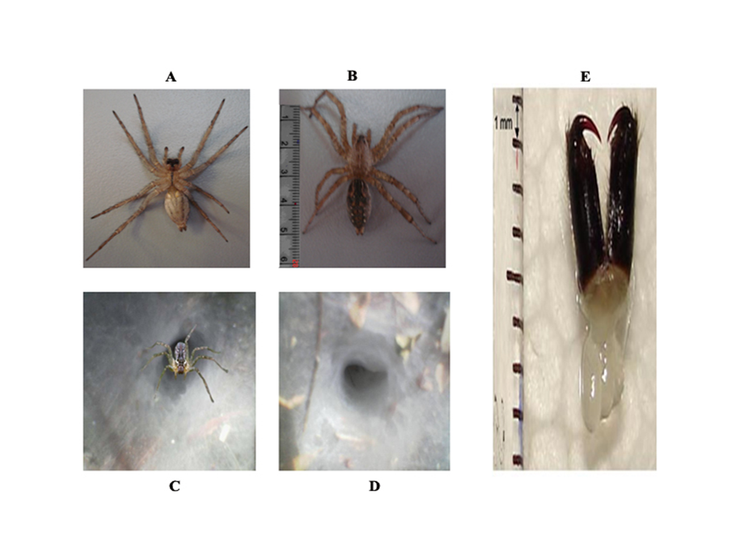
Figure 1: A) H. agelenoides spider ventral view. B) Dorsal view. C) Spider on funnel shapedweb. D) Web. E) The dissected venom gland with the chelicerae.
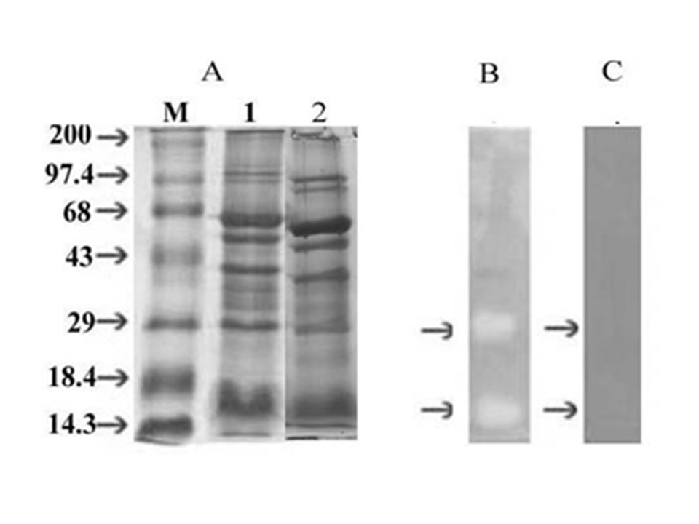
Figure 2: (A) SDS-PAGE banding pattern of Hippasa agelenoides spider venom gland extract: Lane 1 and 2; Venom gland extract (80 μg) under reduced condtion and non-reduced conditions, (B) SDS-PAGE zymogram, (C) Inhibition of proteolytic activity by PMSF. Lane M; Molecular mass markers (M) in kDa from top to bottom: myosin-H-chain (200), phosphorylase b (97.8), BSA (68), ovalbumin (43), carbonic anhydrase (29), β-lactalbumin (18.4) and lysozyme (14.3).

Proteolytic activity of venom gland extract
The venom gland extract showed proteolytic activity on casein in colorimetric assay. The specific activity was found to be 0.63 ± 0.09 units/min/mg of protein at 37ºC. The proteolytic activity was further confirmed by the activity staining on the casein zymogram. The venom gland extract revealed two translucent activity bands in the region of molecular weights range approximates to 16 kDa and 29 kDa. Fig 2B shows the proteolytic zymogram activity staining of the venom gland extract on SDS-PAGE containing casein as substrate. The proteolytic activity of the venom gland extract was sensitive to PMSF (Fig 2C) as there was complete inhibition of the activity while, the activity was insensitive to EDTA, EGTA, 1, 10, phenanthroline and indole 3-acetic acid (IAA) (Table 1)

Table 1: Effect of inhibitors on the proteolytic activity
Inhibitor ( 5 mM each) | % Activity/residual activity
None | 100 ± 0.04
EDTA | 98.2 ± 0.02
EGTA | 97.3 ± 0.04
1, 10, PHENANTHROLINE | 98.7 ± 0.03
IAA | 93.4 ± 0.03
PMSF | 1.9 ± 0.06

Table 1: H. agelenoides spider venom gland extract (50 µg) was pre-incubated independently with the inhibitors for 30 min and the activity was measured after incubation at 37⁰ C for 2 h 30 min. Values are average of three independent determinations.

Toxicity studies
The venom gland extract was not lethal up to the tested dose of 15 mg/kg body weight of mice. However, the mice exhibited acute neurotoxic symptoms such as respiratory distress, flaccid paralysis about an hour after injection but without any cases of mortality. The mice were sacrificed after 24 h. The postmortem examination revealed no visible damage to vital organs such as heart, kidneys, spleen, and liver. The venom gland extract was non-toxic to EAT cells, as there was no death of cells and the cells appeared translucent. While, the positive control H. partita spider venom gland extract was toxic to EAT cells as the dead cells took up trypan blue stain. Further, the venom gland extract induced the myotoxicity in experimental mice; the mice showed elevated levels of cytoplasmic marker enzymes such as serum CK and LDH activities against saline injected control mice serum samples (Fig 3). The Fig 4 shows the light microscopic observation of longitudinal sections of H.agelenoides spider venom gland extract treated mice muscle tissue sections. The sections revealed the extensive destruction of myocytes and the effect was increased with the increased time of treatment of 1 h, 2 h and 4 h (Fig 8B, 8C and 8D) respectively. In contrast, the saline injected control muscle sections revealed normal histology where the myocytes were intact with the regular striated spacing of the intact myofibrils (Fig 4A). The serine protease inhibitor PMSF did not inhibit the myotoxic property of H. agelenoides spider venom gland extract (Fig 4E).

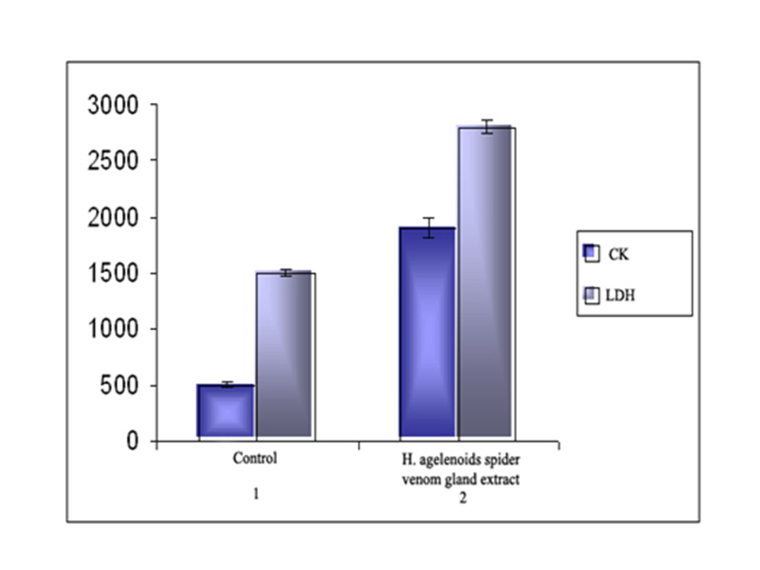
Figure 3: Serum CK and LDH activities: The venom gland extract was injected into thigh muscle at a concentration of 10 mg/kg body weight into group of mice. Blood was drawn after 3 h. CK and LDH activities were determined. 1: Control, 2: H. agelenoides venom gland extract injected mice serum CK and LDH activities.
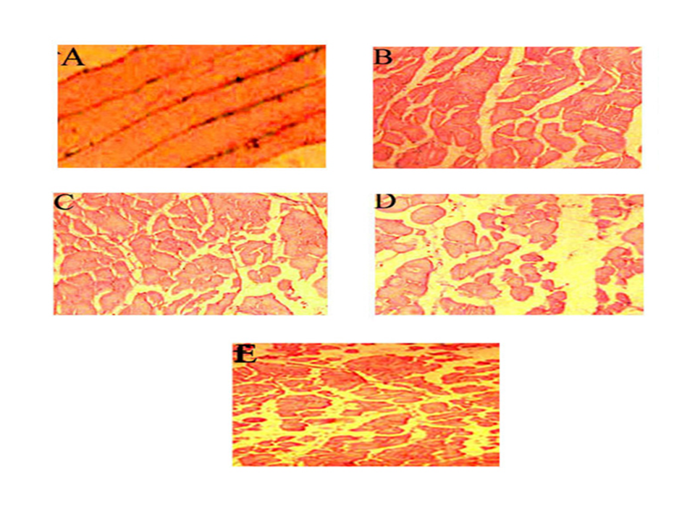
Figure 4: Light micrograph of longitudinal section of mouse skeletal muscle: (A) Section from control mice injected with saline (B), (C) and (D) are 1 h, 2 h and 4 h after the injection of H.agelenoides spider venom gland extract (10 mg/kg body weight). (E) Section pre-treated with PMSF.

of The H.agelenoides spider venom gland extract did not cause the hemorrhage in experimental mice but caused skin tissue destruction at the site of injection. The histopathology of transverse section of mice skin tissue showed the extensive degradation of hypodermis with a conspicuous disappearance of ECM in a dose dependent manner with out causing much noticeable damage to the epidermis and dermis layers (Fig 5B, 5C and 5D). In contrast, the PMSF pre-treated venom gland extract did not cause any visible damage to the skin and the skin sections showed normal histology including the intact hypodermis (Fig 5E), and the histology was similar to the saline injected control section (Fig 5A). The Fig 5F shows the high power view of the blood vessel in the dermis of the skin in which the intact wall morphology was observed. However, the positive control Partitagin, a Hemorrhagic metalloprotease purified from H. partita spider venom gland extract (20 µg) treated mice skin section showed extensive damage of ECM dermis and as well as hemorrhage as supported by the damaged endothelium of blood vessel (Fig 5G).

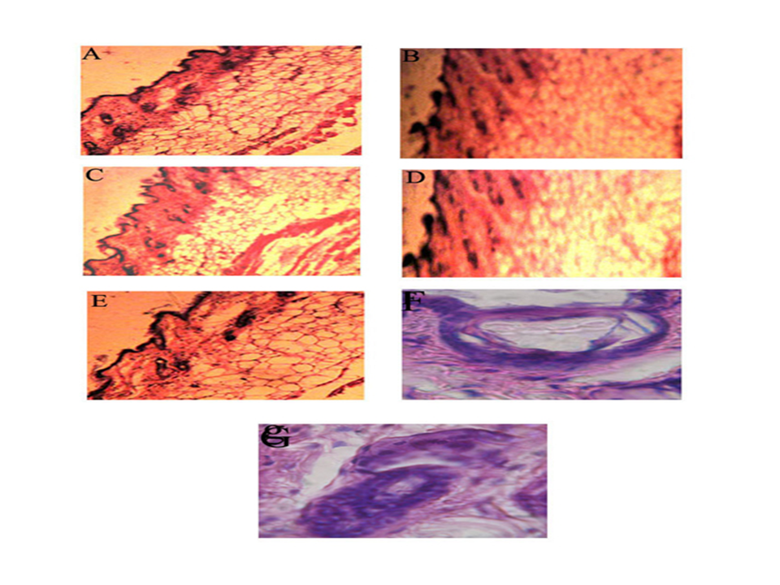

Figure5: Light micrograph of transverse section of mouse skin: Light micrograph of transverse section of mouse skin showing dose dependent effect following intra-dermal injection of H.agelenoides spider venom gland extract for 5 h, (A) Control section injected with saline, (B) (C) and (D) are sections treated respectively with 25, 50 and 75 μg of venom gland extract. (E) Section pre-treated with PMSF (F) A high power view of dermis section showing the intact blood vessel wall. (G) A high power view of dermis section showing the extensive destruction of blood vessel wall injected with Partitagin (positive control).

Degradation of ECM components
H. agelenoides spider venom gland extract selectively degraded both collagen type-I and fibronectin. It readily and preferably degraded β and γ chains of collagen type-I without affecting α1 and α2 chains throughout the incubation period of 10 h (Fig. 6A). Similarly, the venom gland extract selectively degraded the B band of fibronectin without affecting the A band throughout the incubation period of 10 h (Fig. 6B). In both the cases, the activity was confirmed by the progressive decreased intensity of the susceptible bands and appearance of new low molecular weight bands as degradation products in SDS-PAGE under reduced condition. The PMSF inhibited the degradation of collagen type-I and fibronectin. The venom gland extract did not degrade collagen type-IV (Fig. 6C).

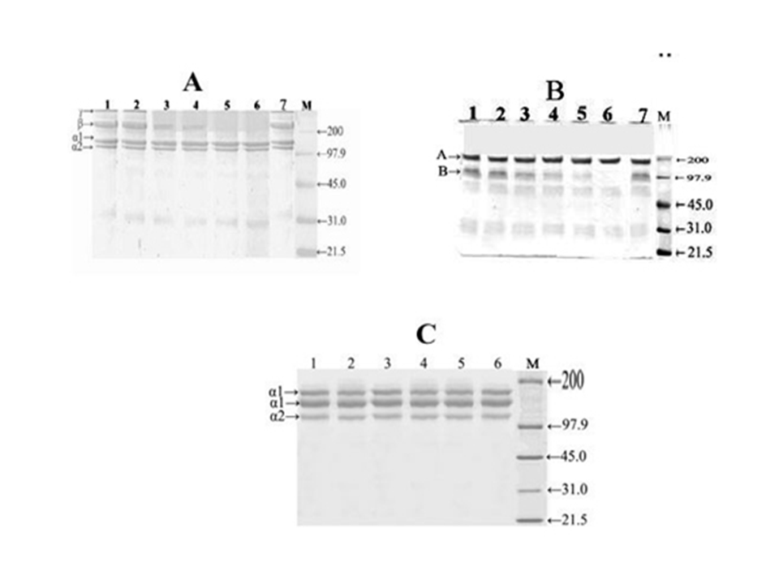
Fig. 6. Degradation of Extracellular matrix components: (A) collagen type-I, (B) fibronectin and (C) Collagen type-IV. Respective ECM components were incubated independently with various concentrations (0-30 μg) of H. agelenoides venom gland extract at 37º C for 5 h and analyzed on SDS-PAGE (7.5 %) under reduced condition. In respective cases the lanes indicates the following, (1) ECM molecule alone and ECM molecule treated with (2) 5 μg, (3) 10 μg, (4) 15 μg, (5) 20 μg (6) and 30 μg of venom gland extract. Fig A lane 7 and B lane 7 venom gland extract pre-treated with PMSF. Lane M represents the molecular weight markers in kDa from top to bottom: myosin H chain (200), phosphorylase b (97.8), BSA (68.0), ovalbumin (45.0), carbonic anhydrase (31.0) and trypsin inhibitor (21.5).

Edema forming activity
The venom gland extract induced the weak edema in the footpads of experimental mice dose dependently (Fig 7) with the minimum edema dose (MED) of 13 ± 0.2 μg of protein. The PMSF pre-treated H. agelenoides spider venom gland extract did not inhibit the edema forming activity.

Plasma.recalcification.time
Figure 8 represents the effect of H. agelenoides spider venom gland extract on recalcification time of citrated human plasma. The venom gland extract reduced the recalcification time of plasma dose dependently from control 250 ± 1.5 sec to 48 ± 1.2 sec. The PMSF pre-treated venom gland extract did not interfere in plasma recalcification time.

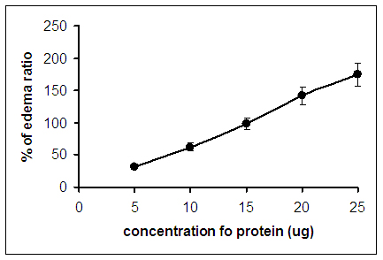
Fig.7. Edema inducing activity: Different concentration of venom gland extract (0-25 μg) was injected to right foot pads of mice in a total volume of 20μl saline. After 1 h mice were sacrificed and legs were cut at the ankle joint weighed the edema ratio was calculated as described in method section.

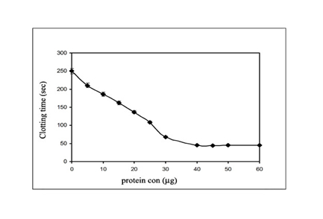
Fig. 8. Plasma recalcification time of human citrated plasma: venom gland extract (0 to 60 μg) was pre incubated with 0.2 ml of citrated human plasma in the presence of 20 μl 10 mM Tris-HCl buffer pH 7.4 for 1 min at 37⁰ C. A 20 μl of 0.25 M CaCl₂ was added to the pre-incubated mixture and clotting time was recorded. Values represent ± SD of three independent experiments.

Fibrinogenolytic activity
The venom gland extract hydrolyzed the human fibrinogen. It readily and preferentially hydrolyzed the Aα-chain and later the Bβ-chain, while the γ-chain remained resistant to proteolytic activity irrespective of dose and incubation time up to 24 h. The Fig. 9A represents the dose and Fig 9B represents the time dependent hydrolysis of fibrinogen. In both the cases the activity was confirmed by the progressive decreased intensity of the susceptible bands and appearance of new low molecular weight bands as degradation products in SDS-PAGE under reduced condition. The PMSF inhibited the fibrinogenolytic activity, while EDTA, EGTA, 1, 10, phenanthroline and indole 3-acetic acid (IAA) did not inhibit the activity (Fig 9C).

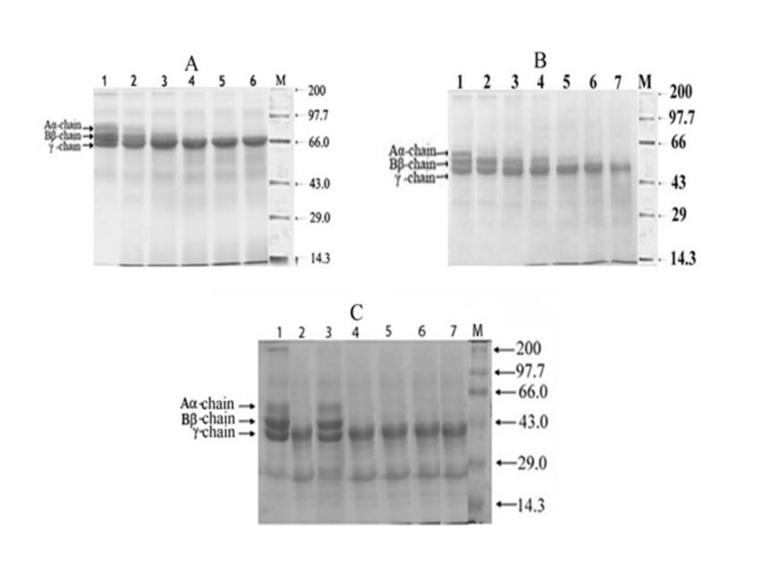
Figure9: Fibrinogenolytic activity: Fibrinogen (50 μg) incubated for 5 h at 37º C and then separated on 10 % SDS-PAGE under reduced condition. (A) Dose dependent effect: Fibrinogen alone 50 μg (1) and fibrinogen treated with 5 μg (2), 10 μg (3), 15 μg (4), 20 μg (5) and 30 μg (6) of venom gland extract for 5 h. (B) Time dependent effect: 0 h (1), 2 h (2), 4 h (3), 8 h (4), 12 h (5), 16 h (6) and 24 h (7). (C) Inhibition of fibrinogenolytic activity: Venom gland extract (10 μg) was pre-incubated with and with out protease inhibitors for 30 min at 37º C. Further reaction was initiated by adding 50 μg of fibrinogen and incubated for 5 h. (a) Fibrinogen alone (1), a + (b) 10 μg of venom gland extract (2), a + b + 5 mM, PMSF (3), a + b + 5 mM, EGTA (4), a + b + 5 mM, EDTA (5), a + b + 5 mM, 1, 10, phenanthroline (6), a + b + 5 mM, IAA (7). M represents the molecular weight marker in kDa from top to bottom: myosin-H-chain (200), phosphorylase b (97.8), BSA (68), ovalbumin (43) carbonic anhydrase (29), β-lactalbumin (18.4) and lysozyme (14.3).

Fibrinolytic activity
H. agelenoides spider venom gland extract hydrolyzed all the sub units (α-polymer α-chain, β-chain and γ-γ dimers) of partially cross-linked fibrin clot as shown in SDS-PAGE under reduced condition (Fig 10A). The degradation of fibrin was further confirmed by the semi-quantitative fibrin agarose plate method in which, the venom gland extract caused clear zones of hydrolysis of fibrin clot dose dependently with 2 ± 0.6, 4 ± 0.8 and 6 ± 0.5 mm diameters respectively for 10, 20 and 30 μg when incubated for 12 h. However, the possitve control urokinase (2.5 units) caused the clear zone of 12 ± 0.4 mm diameter (Fig 10B). The PMSF completely inhibited the fibrinolytic activity of the venom gland extract.

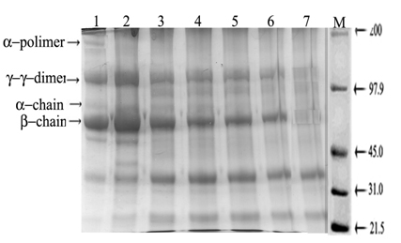

Figure10A: Fibrinolytic activity by SDS-PAGE: Washed plasma clot was incubated with venom gland extract for 5 h and then separated on SDS-PAGE. Plasma clot alone (1) and plasma clot treated with 5 μg (2), 10 μg (3), 15 μg (4), 20 μg (5), 25 μg (6) and 30 μg (7) of venom gland extract. M represents the molecular weight markers in kDa from top to bottom: myosin H chain (200), phosphorylase b (97.8), BSA (68), ovalbumin (45), carbonic anhydrase (31) and trypsin inhibitor (21.5).
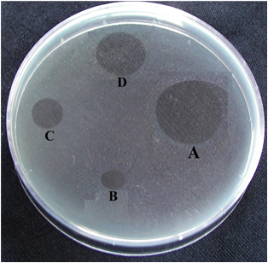

Fig.10B. Fibrinolytic activity by plate method: Fibrin agarose plate was prepared and various concentration of venom gland extract (10, 20 and 30 µg) and 2.5 units of Urokinase (positive control) were independently placed on the surface and incubated over night at room temperature. Then 0.01 % TCA was added over the surface and the diameter of the translucent clear zones due to lysis of fibrin clot (plaque) were measured in mm. Urokinase, 2.5 units (A), venom gland extract 10 µg (B), 20 µg (C) and 30 µg (D).

Platelet function
H. agelenoides spider venom gland extract inhibited the agonist collagen induced platelet aggregation of platelet rich plasma. The Fig 11A shows the dose dependent inhibition of collagen induced aggregation of platelet rich plasma. The inhibition was attained to an extent of about 24% in presence of 30 μg of venom gland extract. The Fig 11B indicates the aggregation trace with the inset showing the differences in the lag period, the time taken for the initiation of aggregation. The PMSF did not abolish the platelet aggregation inhibition property of the venom gland extract in PRP.
Further, the venom gland extract also inhibited the agonist collagen induced platelet aggregation of washed human platelets suspension. The Fig 12A shows the dose dependent inhibition of collagen induced platelet aggregation. The inhibition was attained to an extent of about 58% in presence of 30 μg of venom gland extract. The Fig 12B shows the aggregation trace with the inset showing the difference in the lag period. In contrast, The PMSF completely abolished the platelet aggregation inhibition property of the venom gland extract.

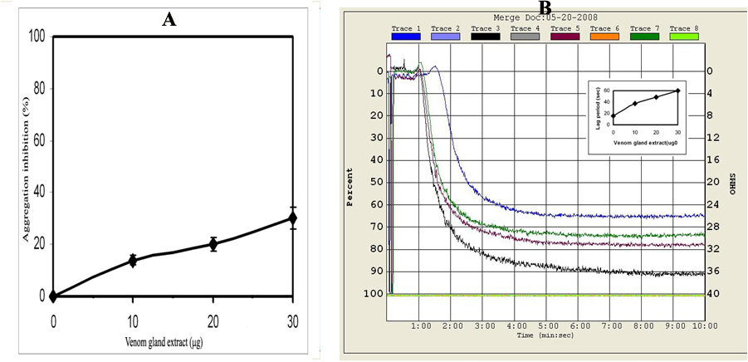
Figure 11: Aggregation of platelet rich plasma: Effect of H.agelenoides spider venom gland extract on collagen induced aggregation of human platelet rich plasma. Inset showing the delay in lag period in sec. (A) Dose dependent effect (B) Aggregation trace. The values represent ± SD of three independent experiments.

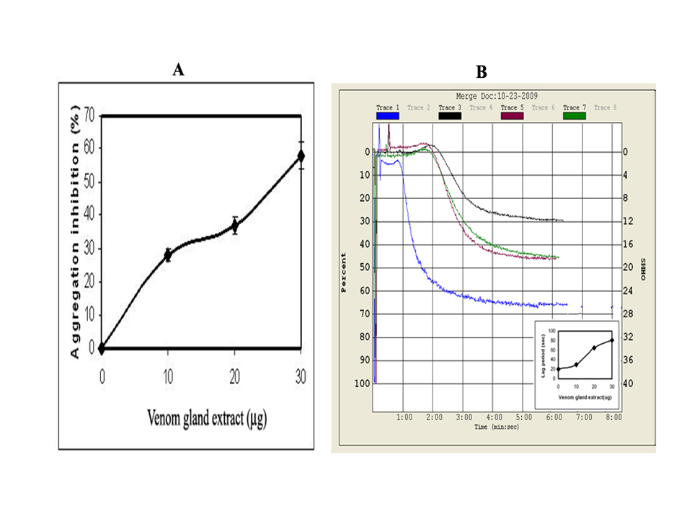

Figure 12: Aggregation of washed human platelets: Effect of H. agelenoides spider venom gland extract on collagen induced aggregation of washed human platelets (A) Dose dependent effect (B) Aggregation trace. Inset showing the delay in lag period in sec. The values represent ± SD of three independent experiments.

DISCUSSION
The present study describes the biochemical and pharmacological examination of H. agelenoides spider venom gland extract for the proteolytic activity and along with other pharmacological properties. The venom gland extract showed similar pattern of protein bands in the molecular weight range from 200 kDa to 14 kDa in SDS-PAGE under both reduced and non-reduced conditions. The venom gland extract showed proteolytic activity in colorimetric assay. The proteolytic activity was further confirmed by activity staining on casein zymogram, the venom gland extract revealed two translucent activity bands in the region of molecular weight range approximates to 16 kDa and 29 kDa, suggesting the possible existence of two isoforms of proteases. The proteolytic activity of the venom gland extract in both calorimetric assay and in zymogram was inhibited by PMSF, while EDTA, EGTA, 1, 10, phenanthrolene did not inhibit the activity. This suggested that both the isoforms present are serine protease family. Kaiser (1956) [24] was the first to report the proteolytic activity from Loxosceles raptoria and Ctenidae nigriventer spider venoms. Spider venoms were found to contain both metallo- and serine proteolytic activities. Metalloproteolytic activity was assayed in several spider venoms such as Loxosceles intermedia, L. deserta, L. gaucho, L. laeta, L. recluse, L. deserta, L. gaucho, L. laeta and L. recluse and Hippasa partita [25, 26, 27, 28]. However, the serine proteolytic activity (two isoforms of high molecular weight 85- and 95-Da) was showed for the first time in the venom of L. intermedia spider in gelatin zymography [29].
The venom gland extract did not cause lethality and cytotoxicity but caused myotoxicity by causing extensive destruction of myocytes. The destruction of myocytes was supported by the elevated levels of cytoplasmic marker enzymes such as lactate dehydrogenase and creatine kinase activities. The serine protease inhibitor PMSF did not inhibit the myotoxic property of the venom gland extract, suggesting the absence of serine proteolytic activity in causing the myotoxicity in experimental mice. The whole venom of H. partita and H. lycosina were found to cause myotoxicity and cytotoxcity [3]. While, ‘Partitagin’ a non-myotoxic, metalloprotease from H. partita spider venom was found to destroy the integrity of muscle tissue by not degrading the myocytes and the myofibrils but by degrading the ECM of the muscle tissue [3]. However, the myotoxicity may generally be attributed to phospholipase A₂ and non enzymatic myotoxic peptides of venoms [30]. The venom gland extract was devoid of hemorrhagic property but involved in non-hemorrhagic local tissue destruction in experimental mice by specifically degrading the ECM of hypodermis without affecting dermis, epidermis, blood vessels and capillaries. However, the positive control Partitagin, a hemorrhagic metalloprotease purified from H. partita spider venom gland extract damaged the basement membrane surrounding the blood vessels and capillaries and caused hemorrhage in experimental mice. The venom components that damage basement membrane surrounding the blood vessels are generally known to cause the hemorrhage. PMSF completely abolished the dermo-necrotic activity of H.agelenoides spider venom gland extract and thus suggesting the role of serine proteolytic activity in dermo-necrosis of experimental mice. ‘Partitagin’ a hemorrhagic metalloprotease from Hippasa partita spider venom was found to degrade the basement membrane of blood vessels in the skin [28]. The whole venom of L. intermedia and the purified enzymes such as sphingomyelinase D and phospholipase D from Loxosceles reclusa were found to cause dermonecrosis [31, 32].
The degradation of ECM proteins by the venom gland extract was further confirmed by in-vitro studies, using ECM proteins such as, collagen type-I, fibronectin and collagen type-IV. It selectively degraded both collagen type-I and fibronectin but did not degrade collagen type-IV and also gelatin the property generally associated
with non-hemorrhagic venom/components. PMSF inhibited the degradation of collagen type-I and fibronectin, suggesting the involvement of serine proteolytic activity. Collagen type-I is a structural protein and is abundant in skin, myofibrils, tendons and organic part of bone that provides mechanical support while, fibronectin is an adhesive glycoprotein and act as a cementing agent and bridges adjacent cells in a tissue and as well as cells to components of the ECM through its characteristic RGD sequence. It is known that the degradation of ECM components results in tissue destruction, which ultimately leads to edema, hemorrhage, dermo- and myonecrosis. Spider venom components was found to degrade components of ECM, the whole venom of L. intermedia and the metalloproteases purified from L. intermedia venom degraded gelatin, entactin and protein core of heparan sulphate proteoglycan and damaged dermis of blood vessels [33, 29, 26, 27]. Partitagin’ a zinc dependent hemorrhagic metalloprotease from H. partita spider venom gland extract specifically degraded collagen type-IV and fibronectin but not collagen type-I [28].
The venom gland extract induced mild edema in the foot pads of mice. PMSF did not inhibit the edema inducing activity of venom gland extract suggesting serine proteolytic activity was not responsible for edema formation. Generally the edema formation is attributed to the action of phospholipase A₂ of the venom with an eventual release of arachidonate which then serve as substrate for the formation of eicosanoids, the principal agents which cause vasodilation, increased vascular permeability and recruitment of inflammatory cells through chemotaxis resulting in the formation of edema. However, proteolytic activity of the venom in most cases is also associated with the formation of edema in which the generation of chemotactic/vasodilating proteolytic peptide fragments that cause edema formation may not be ignored. The venoms of H. partita and H. lycosina spiders were found to cause edema in the foot pads of experimental mice [3].
The venom gland was further evaluated for interference in hemostasis. It reduced the recalcification time of citrated human plasma suggesting its procoagulant effect on coagulation process. The PMSF completely abolished the procoagulant activity of the venom gland extract suggesting the involvement of serine proteolytic activity. The venom of L. intermedia was found to prolong the coagulation time [29]. Thus spider venoms and their purified toxins interfered in plasma coagulation process either as pro- or anti-coagulants. In contrast, several proteases from snake venoms strongly interfered in plasma clotting process [35, 36, 37, 38, and 39].
The venom gland extract hydrolyzed the human fibrinogen and partially cross linked fibrin clot, it readily and preferentially hydrolyzed the Aα-chain and later the Bβ-chain but without affecting the γ-chain of human fibrinogen. However, it hydrolyzed all the sub units (α-polymer α-chain, β-chain and γ-γ dimers) of partially cross-linked fibrin clot. PMSF abolished the fibrin (ogen) olytic activity, while EDTA, EGTA, 1, 10, Phenonthroline the inhibitors of metalloprotease and IAA the inhibitor of cystein protease did not inhibit the activity suggesting the involvement of serine proteolytic activity of the venom gland extract. The venoms from L. deserta, L. gaucho, L. laeta and L. recluse spiders were found to degrade human fibrinogen in zymography experiments. While, L. intermedia, H. partita and H. lycosina spider venoms were shown to degrade Aα or Bβ or both the chains but not the γ-chain [40, 3]. An astacin-like metalloprotease from L. intermedia venom that specifically degrade Aα- and Bβ-chains but not the γ-chain was cloned and expressed in the recent past [41].
Interestingly, the H. agelenoides spider venom gland extract was also interfered in platelet function. It inhibited the agonist collagen induced platelet aggregation of platelet rich plasma and washed human platelets suspension. The PMSF did not inhibit the interference of venom gland extract in the platelet function of human platelet rich plasma. While it completely inhibited the platelet function of washed human platelets suspension. This suggested the role of only the serine protease activity of venom gland extract on the washed human platelets. Several spider venom components such as, sphingomyelinase-D and phospholipase-D were found to interfere in platelet function [42, 41, 32]. However, there are several toxins; both enzymatic and non-enzymatic were isolated and studied extensively for their role in platelet function activation/inhibition from various snake venoms [43, 44, and 45]

CONCLUSION
This study for the first time provides the systematic study on the biochemical and pharmacological examination of H.agelenoides spider venom gland extract for the proteolytic activity along with other pharmacological properties. The serine proteolytic activity was found to cause non-hemorrhagic dermo-necrosis and also interfered in hemostasis.

ACKNOWLEDGEMENT
Authors thank VGST, Banaglore and UGC New Delhi for financial support.

REFERENCES:
- Konaté K, Yomalan k, Sytar O, Zerbo P, Brestic M and Van Damme P, Gagniuc P and Barro N. Free Radicals Scavenging Capacity, Antidiabetic and Antihypertensive Activities of Flavonoid-Rich Fractions from Leaves of Trichilia emetica and Opilia amentacea in an Animal Model of Type 2 Diabetes Mellitus . Evid Based Complement Alternat Med. 2014; p13, vol 2014.

- Komane B M, Olivier E I and Viljoen A M. Trichilia emetica (Meliaceae) – A review of traditional uses, biological activities and phytochemistry. Phytochem. Lett. 2011; p1-9, vol1.

- Jackson H and Parks T N. Spider toxins: Recent applications in neurobiology. Ann. Rev. Neurosci. 1989: p 405-414, vol 12.
- Rash L D and Hodgson W C. (2002) Pharmacology and biochemistry of spider venoms. Toxicon. 2002: p 225-254, vol 40.
- Nagaraju S, Mahadeshwara swamy Y H, Girish K S, and Kemparaju K. Venom from spiders of the genus Hippasa: Biochemical and pharmacological studies. Comp Biochem Physiol. 2006: p 1-9, vol 144.
- Torda T A, Loong E and Greaves I. Severe lung edema and fatal consumption coagulopathy after funnel-web spider bite. Med. J. Aust. 1980: p 442-444, vol 2.
- Bucaretchi F, de Deus Reinaldo C R, Hyslop S, Madureira P R, de Capitani EM and Vieira RJ. Accidents caused by Phoneutria (armed spider). EAPCCT XIX International Congress. J. Toxicol. Clin. Toxicol 1999: p 413, vol 37.
- Habermehl G. Gift- Tiere und ihre Waffen: Araneae (spinnen), Springer, Heidelberg, 1984: p29-40.
- Platnick N I. The world spider catalog, version 6.0. American Museum of Natural History. 2005.
- Siliwal M, Sanjay Molur and Biswas B K. Indian spiders (Arachnida: Araneae): Updated checklist 2005. Zoos’ print journal. 2005 : p 1999-2049, vol 20(10).
- Tikader B K. Hand book of Indian spiders, Zoological survey of India, Calcutta. 1985.
- Tikader B K, and Malhotra M S. Lycosidae (wolf spiders). Fauna India (Araneae), 1980: p 248-447, vol.
- da Silveira, R B, Pigozzo R B, Chaim O M, Appel H, Dreyfuss J L, Toma L, Mangili O C, Gremski W, Dietrich C D, Nadu H B and Viega S S. Molecular cloning and functional characterization of two isoforms of dermonecrotic toxin from Loxosceles intermedia (Brown spider) venom gland. Biochimie,2006: p12411253, vol 88.
- Lowry O H, Rosebrough N J, Farr A L and Randall R J. Protein measurement with the Folin-phenol reagent. Journal of Biological Chemistry,1951: p 265-275, vol 193.
- Laemmli U K. Cleavage of structural proteins during the assembly of the head of bacteriophage T4. Nature, 1970: p 680-685, vol 227.
- Satake M, Murata Y and Suzuki T. Studies on snake venoms XIII Chromatographic separation and properties of three proteinases from Agkistrodon halys blomhoffii venom. J of Biochemistry, 1963: p 483-497, vol 53.
- Chwetzoff S, Tsunasawa S, Sakiyama F and Menez A. Nigexine, a phospholipase A₂ from cobra venom with cytotoxic properties not related to esterase activity. Purification, amino acid sequence and biological properties. J. Biol. Chem. 1989: p13289-13297, vol 264.
- Gutierrez J M, Arce V, Brenes F and Chaves F. Changes in myofibrillar components after skeletal muscle necrosis induced by a myotoxin isolated from the venom of the snake Bothrops aspe. Journal of Experiments in Molecular Pathology,1990: p 25-37. vol 52.
- Kondo H, Kondo S, Itezawa H, Murata R and Ohasaka A. A study on the quantitative method from determination of hemorrhagic activity of Habu snake venom. Jpn. J. Med. Sci. Biol, 1969: p 43-51, vol 13.
- Vishwanath B S, Kini R M and Gowda TV. Characterization of three edematic inducing phospholipase A2 enzymes from habu (Trimeresurus flavoviridis) venom and their interaction with the alkaloid aristolochic acid. Toxicon, 1987: p 501-515, vol 25.
- Quick A J. The prothrombin in hemophilia and obstructive jaundice. J Biol Chem, 1935: p73-85. vol 107.
- Ouyang C and Teng CM. Fibrinogenolytic enzymes of Trimeresurus mucrosquamatus venom. Biochimica Biophysica Acta, 1976: p 298-308, vol 420.
- Rajesh R, Raghavendra Gowda C D, Nataraju A, Dhananjaya B L and Vishwanath B S. Procoagulant activity of Calotropis gigantea latex associated with fibrin(ogen)olytic activity. Toxicon, 2005: p 84-92, vol 46.
- Ardlie N G and Han P. Enzymatic basis for platelet aggregation and release: the significance of the "platelet atmosphere" and the relationship between platelet function and blood coagulation. J. Haematol,1974: p 331-356, vol
- Born G V R. Aggregation of blood platelets by adenosine diphosphate and its reversal. Nature, 1962: p 27-29, vol 194.
- Kaiser E. Enzymatic activity of spider venoms. In: Buckley, E. E., Porges, N., (Eds.).Venoms. American Association for the Advancement of Science, Washington, DC, 1956: p 91-93.F
- Young A R and Pincus S J. Comparison of enzymatic activity from three species of necrotizing arachnids in Australia: Loxosceles rufescens, Badumma insignis and Lampona cylindrata. Toxicon,2001: p 391-400, vol 39.
- da Silvera R B, Filho J F S, Mangili O C, Veiga S S, Gremski W, Nader H B and Dietrich C P. Identification of proteases in extract of venom glands from brown spiders. Toxicon, 2002: p 815-822, vol 40.
- Zanetti V C, da Silveira R B, Dreyfuss J L, Haoach J, Mangili O C, Veiga S S, and Gremski W. Morphological and biochemical evidence of blood vessel damage and fibrinogenolysis triggered by brown spider venom. Blood coagulation and fibrinolysis,2002:p135-148, vol 13.
- Nagaraju S, Girish K S, Fox J W and Kemparaju K. ‘Partitagin’ a hemorrhagic metalloprotease from Hippasa partita spider venom: Role in tissue necrosis. Biochimie,2007: p1322-1331, vol 89,
- Veiga S S, da Sliveria R R, Dreyfuss J L, Haoach J, Pereira A M, Mangili O C and Gremski W. Identification of high molecular weight serine proteases in Loxosceles intermedia (Brown spider) venom. Toxicon,2000: p 825-839, vol 38.
- Bhat M K and Gowda T V. Purification and characterization of a myotoxic phospholipase A2 from Indian cobra (Naja naja naja) venom. Toxicon. 1989: p861-873, vol 27.
- Veiga, Waldemiro Gremski, Helena B, Nader Carl P, von Dietrich. Identification of proteases in the extract of venom glands from brown spiders. Toxicon, 2002: p 815-822, vol 40.
- da Silveira R B, Pigozzo R B, Chaim O M, Appel, Dreyfuss M H J L, Toma L, Mangili O C and Gremski W, Dietrich C D, Nadu H B and Viega S S. Molecular cloning and functional characterization of two isoforms of dermonecrotic toxin from Loxosceles intermedia (Brown spider) venom gland. Biochimie,2006: p 1241-1253, vol 88.
- Feitosa L, Gremski W, Veiga S S, Elias M C Q B, Graner E, Mangili O C and Brentani R R. Detection and characterization of metalloproteinases with gelatinolytic, fibrinectinolytic and fibrinogenolytic activities in brown spiders (Loxosceles intermedia) venom. Toxicon, 1998: 1039-1051, vol 36.
- Zanetti V C, da Silveria R B, Dreyfuss J L, Haoach J, Mangili O C, Veiga S S and Gremski W. Morphological and biochemical evidence of blood vessel damage and fibrinogenolysis triggered by brown spider venom. Blood Coagul. Fibrinolysis,2002:135-148, vol 13.
- Markland F S. Snake venoms and the haemostatic system. Toxicon, 1998:p 749-1800, vol 36.
- Jagadeesha D K, Shashidhara murthy R, Girish K S and Kemparaju K. A non-toxic anticoagulant metalloprotease: purification and characterization from Indian cobra (Naja naja naja) venom. Toxicon,2002: p 667-675, vol 40.
- Manjunatha Kini R. Serine Proteases Affecting Blood Coagulation and Fibrinolysis from Snake Venoms. Pathophysiol Haemos Thromb, 2005: p200-204, vol 34.
- Matsui T, Fujimura Y and Titani K. Snake venom proteases affecting haemostasis and thrombosis. Biochim. Biophys Acta. 2000: p 146_156. vol 1477.
- Marsh N and Williams V. Practical applications of snake venom toxins in haemostasis. Toxicon, 2005: p1171-1181, vol 45.
- Rafael B, da Silveira ,Jose F, dos Santos Filho, Oldemir C, Mangili and Silvio S. Identification of proteases in the extract of venom glands from brown spiders. Toxicon,2002: p815–822, vol 40.
- da Silveira R B, Wille A C M, Chaim O M, Appel M H, Silva D T, Franco C R C, Toma L, Mangili O C, Gremski W C P, Dietrich Nader H B and Veiga S S. Identification, cloning, expression and functional characterization of and astacin-like metallporotese toxin from Loxosceles intermedia (Brown spider) venom. Biochemistry Journal, 2007: p 355-36, vol 406.
- Cunha R B, Barbaro K C, Muramatsu D, Portaro F C V, Fontes W and de Souza M V. Purification and characterization of Loxnecrogin a dermonecrotic toxin from Loxosceles gaucho Brown spider venom. Journal of Protein Chemistry, 2003: p 135-146, vol 22.
- Kini R M and Evans H J. A model to explain the pharmacological effects of snake venom phospholipases A₂. Toxicon. 1989: p613-635, vol 27.
- Kemparaju K, Krishnakanth T P and Veerabasappa Gowda T. Purification and characterization of a platelet aggregation inhibitor acidic phospholipase A₂ from Indian saw-scaled viper (Echis carinatus) venom. Toxicon, 1999: p1659-1671, vol 37.
- Kamiguti A S. Platelets as targets of snake venom metalloproteinases. Toxicon, 2005: p1041-1049. vol 15.

