Biological synthesis of silver nanoparticles from marine alga Colpomenia sinuosa and its in vitro anti-diabetic activity
Vishnu Kiran, M* and Murugesan, S
Unit of Algal Biotechnology and Bio-Nanotechnology, PG and Research Department of Botany, Pachaiyappa’s College, Chennai 600 030. India.
E-mail: dna.vishnu@gmail.com, smurugesan5@gmail.com
*Corresponding author
Published: March 01, 2014 Received: November 25, 2013
AJBBL 2014, Volume 03: Issue 01 Page 01-07 Accepted: January 04, 2014
ABSTRACT
Diabetes is a clinical syndrome characterized by hyperglycemia due to absolute or relative deficiency of insulin. The intestinal digestive enzymes alpha glucosidase and alpha amylase plays a key role in carbohydrate digestion, one main anti-diabetic approach is to reduce the post prandial glucose level in blood by inhibition of α-glucosidase and α-amylase enzymes. The synthesis of silver nanoparticles is an active area of application research in nanotechnology. Biological means by using plants, algae, fungi, bacteria are been employed for the production of low-cost, energy efficient, and non-toxic silver nanoparticles. Silver nanoparticles were prepared from marine alga Colpomenia sinuosa by green synthesis method and the characterization were determined using various techniques like UV – Nano photometer, XRD, FT-IR and SEM. In the present study antidiabetic activity was studied from the biosynthesis of silver nanoparticles from the marine brown alga Colpomenia sinuosa. The assay results of silver nanoparticles showed dose dependent significantly (P<0.005) increase in percentage inhibitory activity against α–amylase and α–glucosidase enzymes.
KEYWORDS: Colpomenia sinuosa, Antidiabetic activity, α-glucosidase, α-amylase, silver nanoparticle

INTRODUCTION
Marine algae, popularly known as seaweeds, are considered very important because they are excellent source of single cell protein (1), hydrocarbons (2), biogas, polysaccharides such as agar-agar, alginic acid, carrageenan (3), antibiotics (4), color pigments (5), important medicines (6). Diabetes mellitus a metabolic alteration characterized by hyperglycemia resulting from defects in insulin secretion, action or both, currently affecting approximately 3% of the world population(7). Prolonged glucose toxicity may lead to complications such as retinal damage, chronic renal failure, cardiovascular and neurodegenerative diseases. Both α-amylase and α-glucosidase enzymes plays a key role in the degradation of starch and oligosaccharides to glucose and if suppressed would in turn delay the glucose absorption in the intestine. Eventually, the postprandial blood sugar is controlled (8). Silver nanoparticles unique properties and applications have been applied in chemical sensing, catalysis, photonics, bio sensing, electronic and pharmaceuticals (9) and biomedicine especially for antibacterial agent (10) and antiviral agents,(11) therefore the properties of silver nanoparticles from marine brown alga Colpomenia sinuosa can be extended to antidiabetic activity. Medical industry has applications of sliver nanoparticles in the form of topical ointments to prevent infection from burns and open wounds (12). In the present study silver nanoparticles biosynthesized from marine brown alga Colpomenia sinuosa were investigated for their antidiabetic activity.

MATERIALS AND METHODS
BIO–SYNTHESIS OF SILVER NANOPARTICLES
Silver nanoparticles formations were carried out by taking 500 mg of dry Colpomenia sinuosa in 250 ml Erlenmeyer flask with 10⁻³ M aqueous (Silver AgNO₃⁻⁾ solution and incubated at room temperature. The _{P}H was checked during the course of reaction and it was found to be 5.09. The 95% of the bio-reduction of AgNO₃⁻ ions occurred within 24h at stirring conditions. The time dependent formation of silver nanoparticles were studied using UV – Vis Nanophotometer, structure from X-ray diffraction (XRD) technique, size and morphology were studied using SEM and Fourier transform infrared (FT-IR) spectroscopy was used to study the cell wall polysaccharide–silver nanoparticles interaction.

ANTI-DIABETIC ACTIVITY
INHIBITION OF α-AMYLASE ENZYME
A starch solution (0.1% w/v) was obtained by stirring 0.1 g of potato starch in 100 ml of 16 mM of sodium acetate buffer. The enzyme solution was prepared by mixing 27.5 mg of alpha amylase in 100 ml of distilled water. The colorimetric reagent is prepared by mixing sodium potassium tartrate solution and 3, 5 di nitro salicylic acid solution 96 mM. Both control and silver nanoparticles were added with starch solution and left to react with α–amylase solution under alkaline conditions at 25⁰C. The reaction was measured over 3 minutes and the experiment was repeated thrice consecutively. The generation of maltose was quantified by the reduction of 3, 5 di nitro salicylic acid to 3-amino-5-nitro salicylic acid. This reaction is detectable at 540 nm (13).
INHIBITION OF α–GLUCOSIDASE ENZYME
The inhibitory activity was determined by incubating a solution of starch substrate (2% w/v maltose or sucrose) 1 ml with 0.2 M tris buffer pH 8.0 and various concentration of silver nanoparticles for 5 min at 37⁰C. The reaction was initiated by adding 1 ml of alpha glucosidase enzyme (IU/ml) to it followed by incubation for 40 min at 35⁰C. Then the reaction was terminated by the addition of 2 ml of 6N HCl. Then the intensity of color was measured at 540 nm (14). The experiment was repeated thrice consecutively.
Calculation of 50% Inhibitory Concentration (IC₅₀)
% of Inhibition = (Enzyme activity of control – Enzyme activity of SNP)
Enzyme activity of control
STATISTICAL ANALYSIS:
Statistical significance was analyzed by one-way analysis of variance (ANOVA) followed by the Duncan post hoc test of significance using SPSS. Version 16.0 .P-(< 0.05) values were considered as statistically significant.
RESULTS AND DISCUSSION
Silver nanoparticles are formed by the reduction of Ag⁺ during exposure to the extract of Colpomenia sinuosa followed by UV-Nano photometer. Pale yellow to brown color formation indicates the presence of silver nanoparticles in solution. (15).The change in color formation arises due to the excitation of surface plasmon vibrations in the silver metal nanoparticles. (16) Fig 1 shows the UV – Nano photometer from the biosynthesized silver nanoparticles obtained from the extract of the marine brown alga Colpomenia sinuosa. It is observed that the silver surface plasmon resonance band occurs at 420 nm, the frequency and width of surface plasmon absorption depends upon the size and shape of the metal nanoparticles as well as on the dielectric constant of the metal itself and the surrounding metal (17,18). It is generally recognized that UV – Nano photometer could be used to examine absorption peak of controlled nanoparticles in aqueous suspensions (19).
The FT-IR spectral measurements were carried out to identify the possible biomolecules form brown alga Colpomenia sinuosa which is responsible for reducing and capping the bio reduced silver nanoparticles. Fig 2 shows the FT-IR spectrum analysis of silver nanoparticles which manifests absorption peaks. The absorption peak at 3435 cm⁻¹ can be assigned as N-H stretching and that at 2923 cm⁻¹ as CH2-C-H (Methyl) stretching, 2853 cm⁻¹ as C-H (Methylene) stretching, 1633 cm⁻¹ as C=C –stretching, 1469 cm⁻¹ as C-C- stretching, 1103-1034 cm⁻¹ as C-O stretching and 875-603 cm⁻¹ as C-H out of plane bending respectively. The FT-IR spectrum provided information about the molecular environment of the organic molecules on the surface of nanoparticle.
Figure1. UV-Vis – Nano photometer of Silver Nanoparticles.

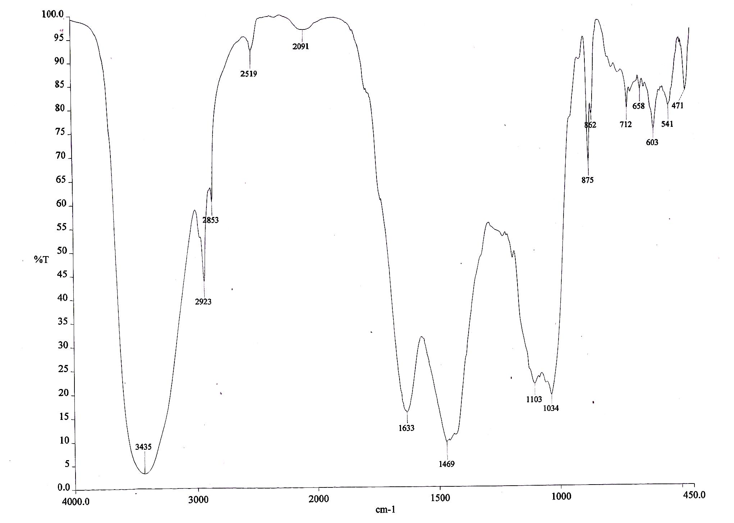 Figure.2. Fourier Transform Infra-Red analysis of Silver Nanoparticle
Fig 3 shows the SEM images recorded from drop coated films of the silver nanoparticles synthesized by treating silver nitrate solution with the extract of the marine brown alga Colpomenia sinuosa. The silver nanoparticles formed were predominately cubical with uniform shape as reported by Chandran et al (20). It is known that shape of the metal nanoparticles considerably change their optical and electronic properties (21). The size of the silver nanoparticles was found to be 54-65 nm.

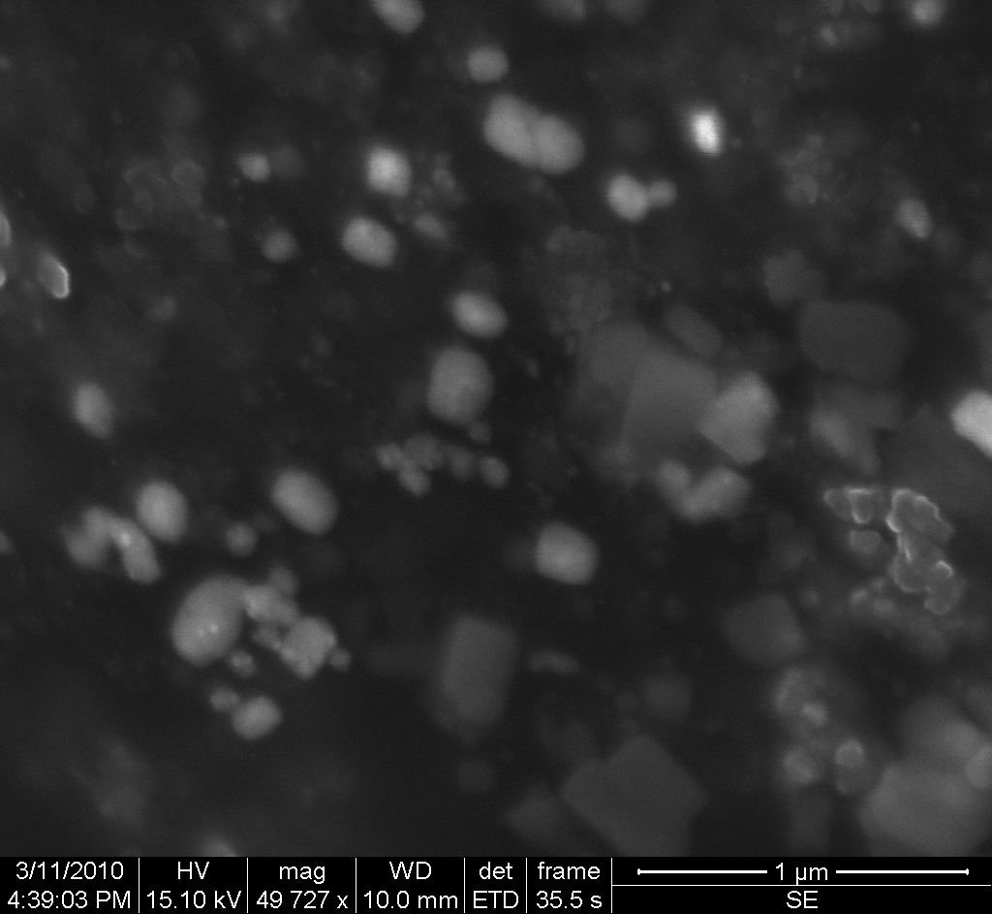 | 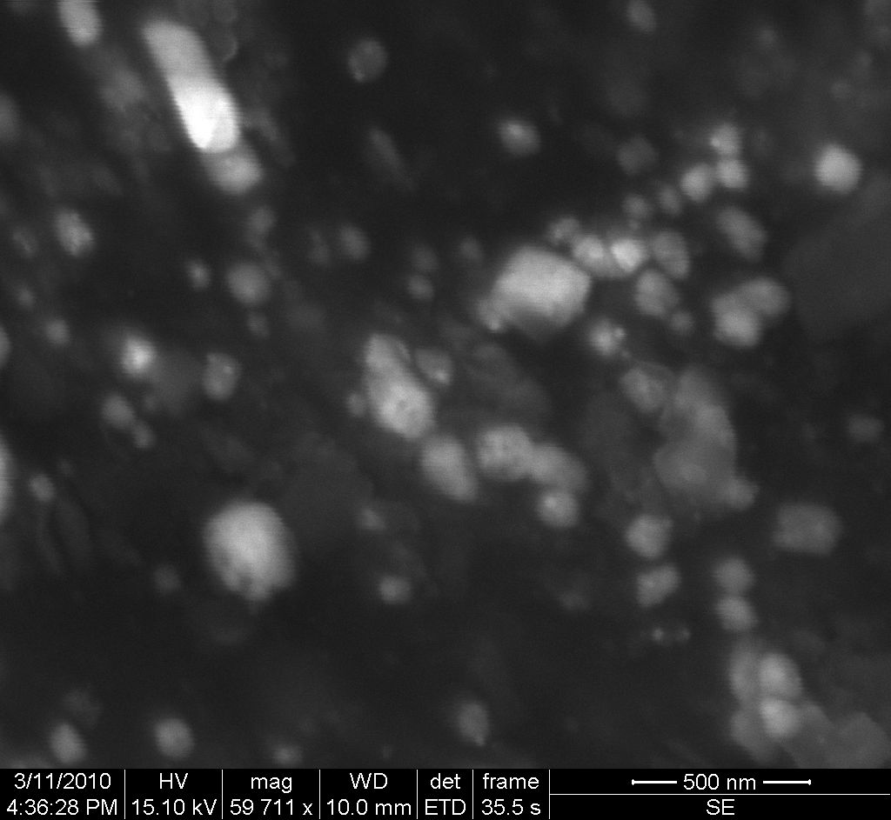
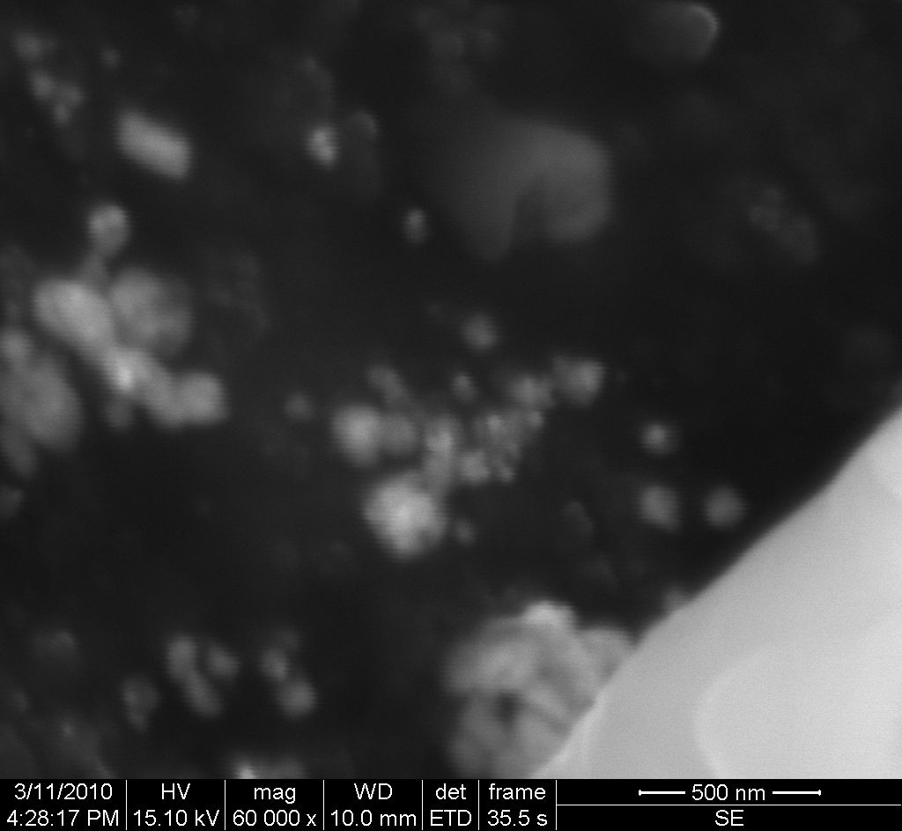 | 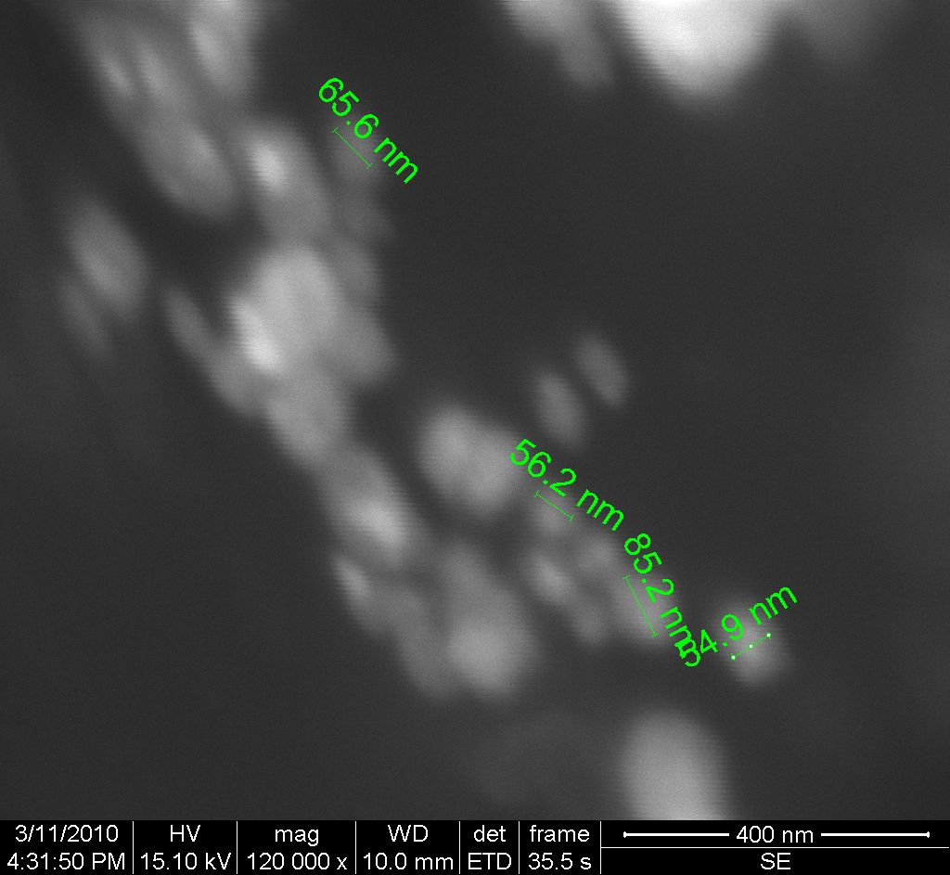
(A)
(B)
(B)
(D)

(C) 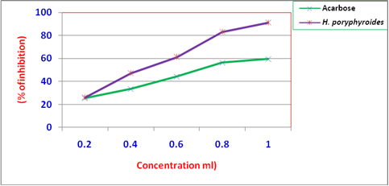

Figure.3. Scanning Electron Micrograph of Silver Nanoparticles
(A) 49727 X Magnification (B) 59711 X Magnification (C) 60000 X Magnification (D) 12000 X Magnification

The X-ray Diffraction patterns of silver nanoparticle were recorded according to the description of Wang (2000). Samples were air dried, powdered and used for XRD analysis. Fig 4 shows the XRD patterns obtained from biosynthesized silver nanoparticles using Colpomenia sinuosa shows characteristics peaks shows characteristics peaks at (2ɵ =1 ), marked with (111). A number of Bragg reflections corresponding to the (111) sets of lattice planes are observed which may be indexed based on the face- centered cubic structure of silver. The XRD pattern thus clearly shows that the silver nanoparticles are crystalline in nature. The XRD pattern of pure silver ions is known to display peaks at 2ɵ =1 (22). The value of pure silver lattice constant has been estimated to be α = 4.081, a value that is consistent with α =4.0862 A0 reported by the JCPDS file no 4-0783.This estimation confirmed the hypothesis of particle monocrystallinity. The sharpening of the peaks clearly indicates that the particles are in nanoregime. The size of the silver nano crystallites as estimated from the FWHM of the (111) peak of silver using the Scherrer formula were reported as 54-85 nm.
ANTIDIABETIC ACTIVITY
Several possible mechanisms of algae can control the blood glucose level (23), the inhibition activity of alpha amylase and alpha glucosidase would delay the degradation of carbohydrate, resulting in the decrease of glucose absorption as a result of postprandial of blood glucose level elevation (24). The silver nanoparticles showed a dose dependent significantly (P<0.005). The
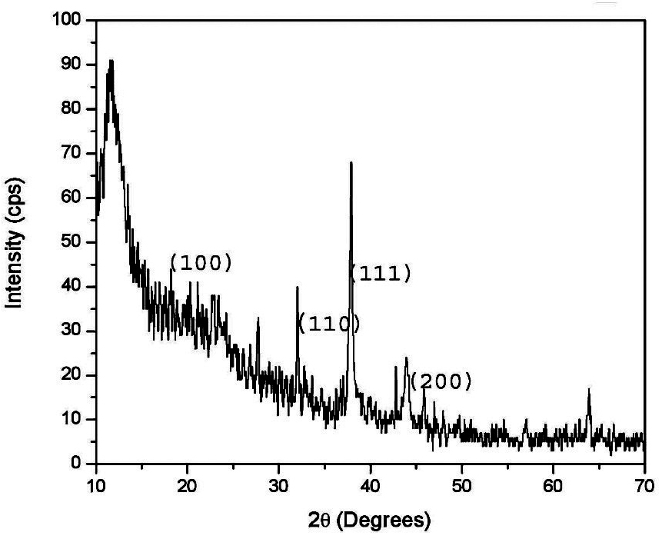
Figure.4. XRD studies of silver nanoparticles
The silver nanoparticles showed a dose dependent significantly (P<0.005). The increase in percentage inhibitory activity against α–amylase enzyme, at a concentration of 0.2 mg/ml 28.70 ± 0.10% inhibition was seen and at 1.0 mg/ml 94.30 ± 0.10% inhibition was observed, similarly dose dependent significantly (P<0.005) increase in percentage inhibitory activity against α-glucosidase enzyme was also observed where in at lower concentration of 0.2 mg/ml 32.40 ± 0.10% of inhibition and at higher concentration of 1.0 mg/ml 90.50 ± 0.10% inhibition were recorded respectively. The Figures 5 and 6 shows the % of inhibition (mg/ml) of α-amylase and α-glucosidase against standard acarbose respectively. The α-amylase and α-glucosidase inhibitor effectiveness of silver nano particle from brown algae Colpomenia sinuosa were compared on the basis of their resulting IC₅₀ values. Inhibited the activity of α-amylase with an IC₅₀ value of 490 ± 0.02 mg/ml and α-glucosidase with an IC₅₀ value of 385 ± 0.02 mg/ml. The IC₅₀ value of standard drug acarbose against α-amylase 630 ± 0.01 mg/ml was α-glucosidase was found to be 695 ± 0.01 mg/ml. (Tables.1,2

Table.1. In vitro Antidiabetic activity of alpha – amylase from Colpomenia sinuosa
S.No | Concentration of | Acarbose | % of inhibition of silver nanoparticles
S.No | Sample (mg/ml) | Acarbose | % of inhibition of silver nanoparticles
1 | 0.2 | 25.39 ± 0.01ª | 28.70 ± 0.10ª
2 | 0.4 | 33.35 ± 0.01^{b} | 49.30 ± 0.10^{b}
3 | 0.6 | 44.15 ± 0.01^{c} | 63.20 ± 0.10^{c}
4 | 0.8 | 56.35 ± 0.01^{d} | 88.50 ± 0.10^{d}
5 | 1 | 59.69 ± 0.10e | 94.30 ± 0.10e
6 | F-Value | 0.00000508 | 0.0000223
6 | P-Value | 0.000 | 0.000
7 | IC₅₀ | 630 ± 0.01 mg/ml | 480 ± 0.10 mg/ml

Fig.5. In vitro Antidiabetic activity of α-amylase Fig.6. In vitro antidiabetic activity of α–glucosidase
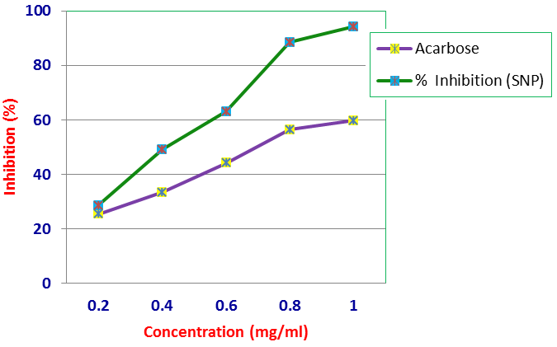 | 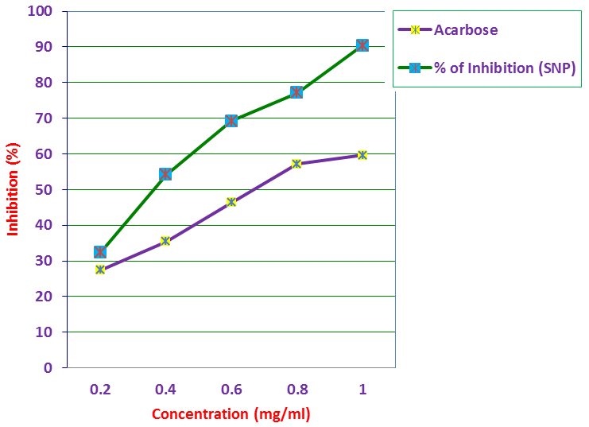
(Figure: 5)
(Figure: 6)
S.No | Concentration of | Acarbose | %of Inhibition of silver nanoparticles
S.No | Sample (mg/ml) | Acarbose | %of Inhibition of silver nanoparticles
1 | 0.2 | 27.34 ± 0.01ª | 32.40 ± 0.10ª
2 | 0.4 | 35.43 ± 0.01^{b} | 54.20 ± 0.10^{b}
3 | 0.6 | 46.33 ± 0.01^{c} | 69.30 ± 0.10^{c}
4 | 0.8 | 57.13 ± 0.01^{d} | 77.20 ± 0.10^{d}
5 | 1 | 59.63 ± 0.01e | 90.50 ± 0.10e
6 | F-Value | 0.00000574 | 0.0000149
6 | P-Value | 0.000 | 0.000
7 | IC₅₀ | 695 ± 0.01 mg/ml | 370 ± 0.10 mg/ml
Table.2. In vitro Antidiabetic activity of alpha –glucosidase from Colpomenia sinuosa

CONCLUSION
The use of marine brown alga for the biosynthesis of silver nano particle is a viable method because of its ecofriendly and low cost effectiveness. The present findings suggest that biosynthesized silver nano particles from Colpomenia sinuosa effectively inhibit both α-amylase and α–glucosidase enzymes in vitro in a dose dependent manner which paves a way for the in vivo studies further. The synthesized silver nano particles proved to exhibit better antidiabetic efficacy against standard acarbose. Therefore, the use of natural products is an important source for their various pharmacological effects and for their nutritive essentials.

REFERENCES

- G Shelef; and C J Soeder. (eds.) 1980 Algal Biomass: Production and Use. Elsevier/North Holland, Amesterdam.
- A Ben – Amtoz; and M Auron. 1980 Glycerol, β- carotene, and dry meal production by commercial cultivation of Dunaliella. In: Algal Biomass: Production and Use (Eds.) G Shelef and C J Soeder, Amesterdam, 603-610.
- E.L McCandless. 1981 Polysaccharides of Seaweeds. In: The Biology of Seaweeds (Eds.) C S Lobban and M J Wynne, Blackwell Scientific Publications, Oxford, 559-588.
- H A Hoppe. 1979 Marina algae and their products and constituents in pharmacy. In: Marine Algae in Pharmaceutical Science (Eds.) H A Hoppe; T Levring and Y Tanaka. Water de Gruyter, Berlin, pp. 25-119.
- L V Venkataraman and E W Becker. 1985 Biotechnology and Utilization of algae. The Indian experience. Dept. Sci. & Tech. and CFTRI, Mysore.
- D Schwimmer and M Schwimmer. 1964 Algae and Medicine. In Algae and Man (Ed.) D F Jackson. Plenum Press, New York, 361-412.
- J P Boyle; A A Honeycutt; K M Narayan; T J Hoerger; L S Geiss; H Chen; T J Thompson. Projection of diabetes burden through 2050: impact of changing demography and disease prevalence in the U.S. [J]. Diabetes Care 2001. 24 (11), 1936-1940.
- H Gin and V Rigalleau. 2000. Post –prandial hyperglycemia and diabetes. Diabetes and Metabolism, 26: 265-272.
- R Sarkar; P Kumbhakar and A.K Mitra. Green synthesis of silver nanoparticles and its optical properties. Digest J. Nanometer.Biostruct., 5: (2010), 491-496.
- M Rai; A Yadav and A Gade. Silver nanoparticles as new generation of antimicrobials. Biotechnol. Adv., 27: (2009), 76-83.
- J L Elechiguerra; J.L Burt; J.R Morones; A Camacho-Bragado; X Gao; H H Lara and M J Yacaman. Interaction of silver nanoparticles with HIV-1. J. Nanobiotechnol., 3: (2005), 6-6
- M Ip; S L Lui; V K M Poon; I Lung and A Burd. Antimicrobial activity of silver dressings: An in vitro comparison. J. Med. Microbial., 55: (2006), 59-6 3.
- C P Malik; and M B Singh. 1980. Plant Enzymology and Histoenzymology,
Kalyani publishers, New Delhi, P. 278.
- S Krishnaveni; B Theymoli; and S Sadasivam. 1984. Food Chem. 15:229.
- M Sastry; V Patil; S R Sainkar. J Phys Chem B. 102, (1998) 1404.
- P Mulvaney. Langmuir. 12 (1996) 788.
- P Mukherjee; S Senapati; D Mandal; Ahmad; M I Khan; R Kumar & M Sastry. Chem. Bio. Chem. 3, (2002) 461.
- J Gonzalo; R Serna; J Sol; D Babonneau & C N Afonso. J. Phys: Condens. Matter 15 (2003) 3001.
- I Sondi & B Salopek- Sondi. J. Colloid Interface Sci., 275, (2004) 177.
- S P Chandran; M Chaudhary; R Pasricha; R Ahmad; M Sastry. Synthesis of nanotriangles and silver nanoparticles using Aloe vera plant extract, Biotechnol.Prog, 22, (2006), 577.
- H Xu; M & Kall. J.Nanosci.Nanotechnol.4, (2002) 254.
- P Gong; H Li; X He; K Wang; J Hu; W Tan; S Zhang and X Yang. Nanotechnology 18, (2007).285604(7pp).
- M O M Tanira. Antidiabetic medicinal plants: a review of the present status and future directions. Int. J. Diabetes 29(1): (1994) 15-22.
- R Rhabaso Lhoret and J.L Chiasson. 2004 α-Glucosidase inhibitors. In: R A Defronzo; E Ferrannani; H Keen; P Zimmet. (Eds.), International Textbook of Diabetes Mellitus, Vol. 1, third ed. John Wiley and Sons Ltd., UK, pp. 901-914.

