Impact of salinity on above ground biomass and stored carbon in a common mangrove Excoecaria agallocha of Indian Sundarbans
Asit Kumar Bhattacharjee*, Sufia Zaman#* Atanu Kumar Raha#, Subhadra Devi Gadi$, and Abhijit Mitra#*
#TECHNO INDIA UNIVERSITY, Salt Lake Campus, Kolkata 700 091. *Department of Marine Science, Calcutta University, 35. B.C. Road, Kolkata 700 019. $Department of Zoology, Carmel College for Women, Nuven, Salcete, Goa 403604
E-mail: sufia_zaman@yahoo.com, Tele Phone: +91 9830 501959
*Corresponding author
Published: July 01, 2013, Received: April 04, 2013
AJBBL 2012, Volume 02: Issue 02 Pages 01-11 Accepted: May 31, 2013
ABSTRACT
The above ground biomass (AGB) and carbon stock of Excoecaria agallocha (a common mangrove plant species) were estimated in western and central Indian Sundarbans for five successive years (2005 – 2010). The two sectors are drastically different with respect to salinity on account of massive siltation that prevents the flow of fresh water of the River Ganga to the central sector of Indian Sundarbans. The biomass and carbon content of the above ground structures (stem, branch and leaf) of the species vary significantly with locality (p<0.01), the values being more in the high saline central sector on account of higher stem biomass. The tolerance of Excoecaria agallocha to high saline environment of lower Gangetic delta is confirmed.

INTRODUCTION
Mangroves are a taxonomically diverse group of salt-tolerant, mainly arboreal, flowering plants that grow primarily in tropical and subtropical regions (Ellison and Stoddart 1991). Salinity plays a crucial role in the growth and survival of mangroves. Based on the physiological studies, Bowman (1917) and Davis (1940) concluded that mangroves are not salt lovers, rather salt tolerant. However, excessive saline conditions retard seed germination, impede growth and development of mangroves. Indian Sundarbans, the famous mangrove chunk of the tropics is gradually losing a few mangroves species (like Heritiera fomes, Nypa fruticans etc.) owing to increase of salinity in the central sector of the deltaic complex around the Matla River. Reports on adverse impact of salinity on growth of mangroves in Indian Sundarbans are available (Mitra et al. 2004). However no study has yet been carried out to investigate the effect of salinity on the carbon content of mangroves from this part of the Indian subcontinent.
The present study aims to establish a baseline data set of stored carbon in the AGB of Excoecaria agallocha, a dominant mangrove species of Indian Sundarbans. The species thrives luxuriantly in a wide range of salinity (4 psu – 28 psu) and hence an attempt was also made to find the AGB and carbon content in above ground structures (stem, branches and leaves) of the species with respect to ambient aquatic salinity.
MATERIALS AND METHODS
STUDY AREA:
The mighty River Ganga emerges from the Himalayas and flows down to the Bay of Bengal covering a distance of 2525 km. At the apex of Bay of Bengal a delta has been formed which is recognized as one of the most diversified and productive ecosystems of the tropics and is referred to as Indian Sundarbans. The deltaic complex has a Biosphere Reserve area of 9630 sq. km and houses 102 islands. The western sector of the deltaic lobe receives the snowmelt water of mighty Himalayan glaciers after being regulated through several barrages on the way. The central sector on the other hand, is fully deprived from such supply due to heavy siltation and clogging of the Bidyadhari channel in the late 15th century (Chaudhuri and Choudhury 1994). Such variation cause sharp difference in salinity between the two sectors (Mitra et al. 2009). Two sampling sites were selected each in the western and central sectors of this lower Gangetic delta (Fig.1). The station in the western part lies at the confluence of the River Hugli (a continuation of Ganga-Bhagirathi system) and Bay of Bengal. The site is locally known as Sagar South (88° 01' 47.28" E Latitude and 21° 31' 4.68" N Longitude). In the central sector, the sampling station was selected at Canning (88° 40' 36.84" E Latitude and 22° 18' 37.44" N Longitude), near to tide fed Matla River. Study was undertaken in both these sectors during low tide period through three seasons viz. premonsoon (March), monsoon (September) and postmonsoon (December) for five consecutive years (2005 – 2010).
In each sector, plot size of 10m × 10m was selected and the average readings were documented from 15 such plots. The mean relative density of Excoecaria agallocha was evaluated for relative abundance of the species.

ABOVE - GROUND STEM BIOMASS ESTIMATION
The stem volume for each tree of the species in every plot was estimated using the Newton’s formula (Husch et al. 1982) as per the expression: V = h/6 (A_{b} + 4A_{m} + A_{t}) where, V is the volume (in m³), h the height measured with laser beam (BOSCH DLE 70 Professional model), and A_{b}, A_{m}, and A_{t} are the areas of the selected tree at base, middle and top respectively. Specific gravity (G) of the wood was estimated taking the stem cores from 5 to 10 cm depth with a motorized corer, which was further converted into stem biomass (B_{S}) as per the expression B_{S} = GV. The stem biomass of individual tree was finally multiplied with the number of trees of the species in 15 selected plots in both western and central Indian Sundarbans.
ABOVE GROUND BRANCH BIOMASS ESTIMATION
The total number of branches irrespective of size was counted on each of the sample trees. These branches were categorized on the basis of basal diameter into three groups, viz. <6 cm, 6–10 cm and >10 cm. Dry weight of two branches from each size group was recorded separately using the equation of Chidumaya (1990). Total branch biomass (dry weight) of individual tree was determined after drying at 80 ± 5⁰C as per the expression: B_{db} = n₁bw₁ + n₂bw₂ + n₃bw₃ = Σ n_{i}bw_{i}
Where, B_{db} is the dry branch biomass per tree, n_{i} the number of branches in the ith branch group, b_{wi} the average weight of branches in the ith group and i = 1, 2, 3, …..n are the branch groups. The branch biomass of individual tree was finally multiplied with the number of trees of the species in all the 15 plots for each station.

ABOVE GROUND LEAF BIOMASS ESTIMATION

Leaves from nine branches (three of each size group) of individual trees were plucked, weighed and oven dried separately to a constant weight at 80 ± 5⁰C. Three trees per plot were considered for estimation. The leaf biomass was then estimated by multiplying the average biomass of the leaves per branch with the number of branches in a single tree and the average number of trees per plot as per the expression: L_{db} = n₁Lw₁N₁ + n₂Lw₂N₂ + ……….n_{i}Lw_{i}N_{i}
Where, L_{db} is the dry leaf biomass of selected mangrove species per plot, n_{1..}….n_{i} are the number of branches of each tree of the species, Lw₁ …….Lw_{i} are the average dry weight of leaves removed from the branches and N_{1………}N_{i} are the number of trees of the species in the plots.

CARBON ESTIMATION

Direct estimation of percent carbon was done by a CHN analyzer. For this, a portion of fresh sample of stem, branch and leaf from thirty trees (two trees/ plot) of the species (covering all the 15 plots) was collected. The vegetative parts were oven dried separately at 70⁰C and ground to pass through a 0.5 mm screen (1.0 mm screen for leaves). The carbon content (in %) was finally analyzed on a Vario MACRO elementar CHN analyzer.

SALINITY

The surface water salinity was recorded by means of an optical refractometer (Atago, Japan) in the field and cross-checked in laboratory by employing Mohr- Knudsen method. The correction factor was found out by titrating the silver nitrate solution against standard seawater (IAPO standard seawater service Charlottenlund, Slot Denmark, chlorinity = 19.376‰). Our method was applied to estimate the salinity of standard seawater procured from NIO and a standard deviation of 0.02% was obtained for salinity. The average accuracy for salinity (in connection to our triplicate sampling) is ± 0.28 psu.
STATISTICAL ANALYSIS
Scatterplots, allometric equations and correlations were computed with a sample size of 240 for each sector to observe the interrelationships between AGB, DBH, stem, branch and leaf biomass along with stored carbon in these above ground structures. Analysis of variance (ANOVA) was performed to assess whether biomass and carbon content varied significantly between sites, years and seasons; possibilities less than 0.01 (p < 0.01) were considered statistically significant. All statistical calculations were performed with SPSS 9.0 for Windows.
RESULTS
RELATIVE ABUNDANCE

Nine species of mangroves were documented in the selected plots in the western sector, but in the central sector only six species were recorded. The mean relative abundance of Excoecaria agallocha was 18.75% and 25.81% in the western and central sectors respectively. In both the sectors, the trees are ~12 years old, but high salinity in the central sector probably stunted the growth of the species.

ABOVE GROUND BIOMASS

The stem, branch, leaf and AGB of the mangrove species increased with age. The increment was however not uniform in both the sectors as revealed from the trend line equations (Fig. 2 - 5). We observed significant variation in the rate of AGB increase between sites (p<0.01). It was 0.63t/ha/month and 0.75 t/ha/month in the western and central sectors respectively. The yearly variation of AGB was also significant (p<0.01), but the seasonal variation was not pronounced. It is interesting to note that AGB of Excoecaria agallocha in the Indian Sundarbans is accounted solely due to stem, which is a basic indicator of growth unlike branches and leaves that contribute substantially to litter fall and less to permanent biomass. The nature of the scatter plots also confirm strong dependency of AGB on stem biomass and DBH unlike branch and leaf biomass that exhibit no relationships with AGB of the species (Fig. 6 -11).

CARBON CONTENT

The seasonal variations of stored carbon in the above ground structures of the species for five successive years are shown in Fig. 12 to 15. In both the sectors carbon content was highest in stems, followed by branches and leaves. In stem the carbon content ranged from 0.81 t/ha (in the central sector during September, 2005) to 10.13 t/ha (in the central sector during March, 2010), which are 40.5% and 42.0% of the biomass respectively. The sequestration rates of carbon in the stem of the western and central sectors are significantly different (p<0.01) with values of 0.10 t/ha/month and 0.17 t/ha/month respectively. In branch the range of stored carbon was 0.22 t/ha (39.2% of the branch biomass in the central sector during September, 2005) to 6.40 t/ha (42.2% of the branch biomass in the western sector during March, 2010). The branch sequestered 0.10 t/ha/month and 0.09 t/ha/month in the western and central sectors respectively. In leaf minimum carbon content (0.22 t/ha which is equivalent to 43.1% of leaf biomass) was observed in the central sector in September, 2005 and the maximum value (4.74 t/ha which is equivalent to 46.4% of leaf biomass) was recorded in the western sector in March, 2010. The sequestration rates are 0.08 t/ha/month and 0.06 t/ha/month in the western and central sectors respectively.

ANOVA results confirmed significant differences in stored carbon of the stem between the sites (p < 0.01), but no differences were observed for branches and leaves. The carbon content in the above ground structures exhibit significant positive correlations with stem biomass and its DBH, but not with branch and leaf biomass.

SALINITY

The surface water salinity values ranged from 8.66 psu (at Sagar south in the western sector during 2010 monsoon) to 26.59 psu (at Canning in the central sector during 2008 premonsoon). The salinity values varied as per the order premonsoon > postmonsoon > monsoon and the seasonal variation is significant (p < 0.01). The salinity values were significantly higher (p<0.01) in the central sector compared to the western sector irrespective of seasons and year (Table 1).

Table 1. Seasonal variation of surface water salinity (in psu) in the selected stations during 2005 -2010
Season | 2005 |  | 2006 |  | 2007 |  | 2008 |  | 2009 |  | 2010
 | A | B | A | B | A | B | A | B | A | B | A | B
Pre monsoon | - |  | 26.10 | 26.50 | 25.12 | 26.00 | 29.11 | 26.59 | 24.04 | 26.08 | 23.58 | 25.95
Monsoon | 9.16 | 10.44 | 9.02 | 9.65 | 9.30 | 9.98 | 8.76 | 9.90 | 9.08 | 10.02 | 8.66 | 10.13
Post monsoon | 22.32 | 23.10 | 21.67 | 23.15 | 21.80 | 23.88 | 20.73 | 24.06 | 20.04 | 24.32 | 20.12 | 25.02
A - Sagar south (Western sector) and B – Canning (Central sector)
Table 2. Data on AGB in few mixed mangrove forests
Region | Location | Condition or age | AGB (t/ha) | Reference
Sri Lanka | 8° 15' N Latitude and 79° 50'E Longitude | Fringe forest | 172.0 | Amarasinghe and Balasubramaniam (1992)
Sri Lanka | 8° 15' N Latitude and 79° 50'E Longitude | Riverine forest | 57.0 | Amarasinghe and Balasubramaniam (1992)
Thailand (Trat Eastern) | 12° 12' N Latitude and 102° 33'E Longitude | Secondary forest | 142.2 | Poungpam (2003)
Western Indian Sundarbans (Sagar South) | 88° 01' 47.28" N Latitude and 21° 31' 4.68" E Longitude | ~ 12 years | 15.14 | This study, considering only 1 species (n = 225)
Central Indian Sundarbans (Canning) | 88° 40' 36.84" N Latitude and 22° 18' 37.44" E Longitude | ~ 12 years | 26.52 | This study, considering only 1 species (n = 225)

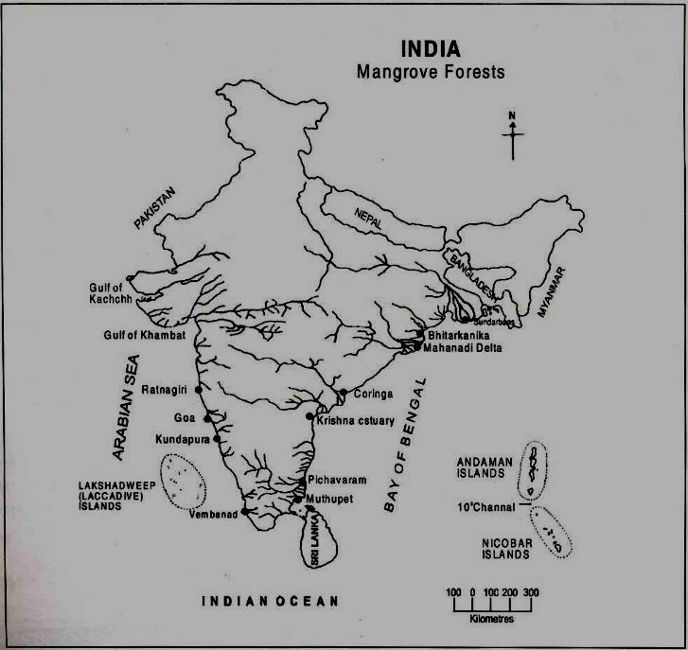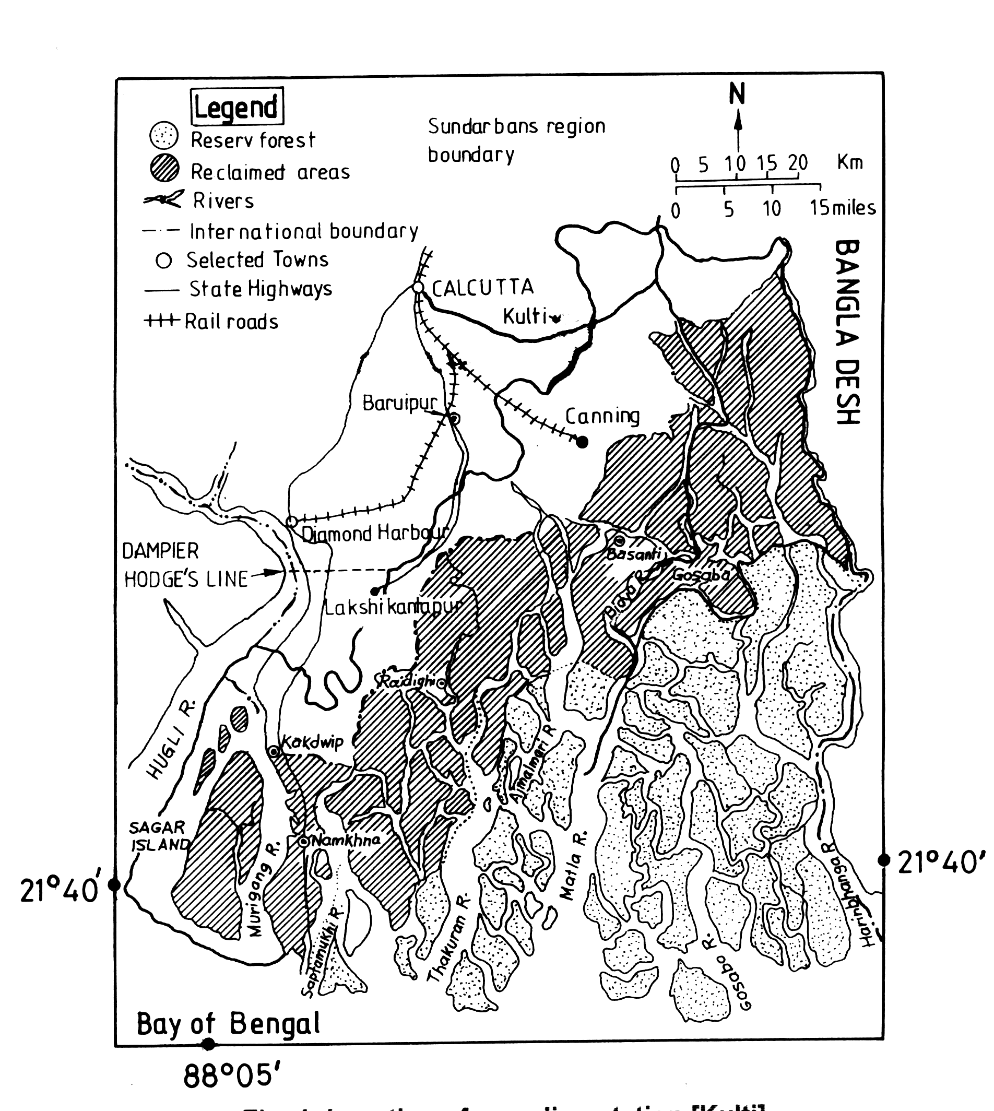
Canning
Sagar South
Fig.1. Location of sampling stations in the western and central sectors of Indian Sundarbans

DISCUSSION
The potential impact of mangrove on coastal zone carbon dynamics has been a topic of intense debate during the past decades. Despite the large number of case studies dealing with various aspects of organic matter cycling in mangrove systems (Kristensen et al. 2008), there is very limited consensus on the carbon sequestering potential of mangroves. It has been opined by several workers that the carbon sequestration in this unique producer community is a function of biomass production capacity, which in turn depends upon interaction between edaphic, climate, and topographic factors of an area (Chaudhuri and Choudhury, 1994; Mitra and Banerjee, 2005). Hence, results obtained at one place may not be applicable to another. We therefore attempted to establish allometric equations for Excoecaria agallocha of Indian Sundarbans relating its DBH, stem biomass, branch biomass, leaf biomass, AGB and stored carbon. The nature of the scatter plots indicate significant positive correlations between AGB, stem biomass, DBH and stored carbon in both the sectors. The AGB and stored carbon do not exhibit any dependency on branch and leaf biomass of the species. This indicates the sole contribution of stem biomass and DBH to AGB and carbon stored in the above ground structures.

Mangroves, in general, prefer brackish water environment and in extreme saline condition stunted growth is observed (Mitra et al. 2004). The present study, however, presents a different picture and reveals the adaptation of Excoecaria agallocha in the high saline central sector. The relatively higher growth rate of the above ground structures of the species in the central sector (0.75 t/ha/month) compared to the western part (0.63t/ha/month) confirms its tolerance to salinity. A critical analysis of biochemical mechanisms may throw light on the adaptation of Excoecaria agallocha in the high saline environment of central Indian Sundarbans.

The carbon content and sequestration rate of above ground structures are also higher in the central sector as a direct function of above ground biomass. During our study period the average surface water salinity in the central Indian Sundarbans were relatively higher (26.22 psu during premonsoon, 10.02 psu during monsoon and 23.70 during postmonsoon) compared to the western part (25.59 psu during premonsoon, 9.00 psu during monsoon and 21.31 during postmonsoon). This could not retard the carbon sequestration of the species (by the total AGB) as evidenced from the stored carbon value and sequestration rate in the central sector (0.32 t/ha/month) compared to the western sector (0.28 t/ha/month). The results of our study have been compared with the AGB of few mixed mangrove forests (Table 2) to evaluate the potential of Indian Sundarbans mangrove as carbon sink. The values of the present study are less when compared with other regions, but efficient adaptation of the species in high saline zone has multiplied the importance of the species as the present geographical locale is vulnerable to climate change induced salinity rise owing to its location below the mean sea level and experiencing a sea level rise of 3.14 mm/yr as compared to global average of 2.5 mm/yr.

CONCLUSION
Indian Sundarbans is ecologically dynamic with contrasting salinity in western and central sectors. The western sector is hyposaline as the area receives the freshwater of River Ganga. The central sector has no head-on discharge and therefore the environment is hypersaline in nature. The comparatively more biomass and carbon content in the Excoecaria agallocha sampled from central Indian Sundarbans suggests the adaptive efficiency of the species to high saline condition. Considering the present state of sea level rise in the deltaic complex of Indian Sundarbans it can be concluded that Excoecaria agallocha can cope and survive better in the matrix of rising salinity.
ACKNOWLEDGEMENT:
The financial assistance from the TECHNO INDIA UNIVERSITY, Salt Lake Campus, Kolkata is gratefully acknowledged. The authors are also grateful to the Forest Department, Govt. of West Bengal for assisting the research team in collecting data and providing all infrastructural facilities to reach the remote islands.

REFERENCES

- Bowman (1917) Mangrove regeneration and management. In: AKF Hoque 1995. Mimeograph.
- Chidumaya, E.N., 1990. Above ground woody biomass structure and productivity in a Zambezian woodland. For. Ecol. Manage. 36, 33-46.
- Chaudhuri, A.B., Choudhury, A., 1994. Mangroves of the Sundarbans. India, IUCN- The World Conservation Union, 1.
- Davis JH (1940) The Ecology and Geological Role of Mangroves in Florida. Pap Tortugas Lab 32: 303-412.
- Ellison JC and Stoddart DR (1991) Mangrove ecosystem collapse during predicted sea-level rise: Holocene analogues and implications. Journal of Coastal Research 7: 151-165.
- Husch, B., Miller, C.J. Beers, T.W., 1982. Forest mensuration, Ronald Press, New York.
- Kristensen, E., Bouillon, S., Dittmar, T., Marchand, C., 2008. Organic matter dynamics in mangrove ecosystems. Aqua. Bot. J Aqua. Bot. 2007 15.05 (in press).
- Mitra, A., Banerjee, K., 2005. In: Living Resources of the Sea: Focus Indian Sundarbans, Published by WWF India. (Ed: Col S.R. Banerjee ), Canning Field Office, 24 Parganas (S), W.B. 96 pp.
- Mitra, A., Banerjee, K., Bhattacharyya, D.P., 2004. In The Other Face of Mangroves. Published by Department of Environment, Govt. of West Bengal, India.
- Mitra, A., Banerjee, K., Sengupta, K., Gangopadhyay, A., 2009. Pulse of climate change in Indian Sundarbans: A myth or reality? Natl. Acad. Sci. Lett. 32, 1-2.

