A Fake Medicated Navapashana Herbal Statue – A
Forensic Case Study

A.Visalakshi, Dr.Kamalakshi Krishnamurthi*, B.Maria Selvi Rosaline, L.C.Amutha , Dr.K.Nandagopal
Forensic Sciences Department, Chennai 600 004- Tamilnadu, India
Address: Dr. Kamalakshi Krishnamurthy, Deputy Director-DNA Division, Forensic Sciences Department, Chennai 600 004- Tamilnadu, India

E-mail: kamalkissan2011@gmail.com
*Corresponding author
Published: 30 November 2012 Received: 12 December 2012
AJBBL 2012, 2: 1-10 Accepted: 01 November 2012
ABSTRACT
The medicated Navapashana Statue is very difficult to obtain and to make. It is commonly known as “Herbal Statue” and it is made of Navapashana, just like scientific preparations containing the essence of 473 Herbs, 9 kinds of Salts, 9 kinds of Pashana medicines, the milk from 9 kinds of other ancillary materials. Sridhar’s mix all the above ingredients in suitable proportions to make the disease curing Navapashana Statue. The Forensic Examination of Herbal Statue has been successfully employed by Forensic Science Laboratory, Chennai 600 004 to differentiate the Fake Herbal Statue from the original. This paper attempts to explain a case study of Herbal Navapashana Statue in detail with various analytical procedures.

INTRODUCTION
Diabetic retinopathy (DR) is a vascular disorder affecting the microvasculature of the retina (1). Patients with diabetes mellitus are at an increased risk to develop microangiopathy which is clinically manifested as diabetic retinopathy, nephropathy and neuropathy (2). Arteriosclerotic retinopathy involves vessel walls by medial layer hypertrophy, hyalinization in the intima and hyperplasia in the endothelial layer (3).
The retinal arteriole shares similar anatomic and physiological characteristics with cerebral and coronary microcirculation. Therefore retinal microvascular disease may also reflect presence of systemic microvascular disease (4 & 5). The pathogenesis of diabetic retinopathy is not completely understood but established risk factors include poor glycemic control, hypertension, increasing age and duration of diabetes (6).
Oxidative stress on the blood vessel wall and the expression of inflammatory cytokines and cell adhesion molecules are all involved in the progression of diabetic retinopathy (7). Further identification of risk factors and determinants for retinopathy is important to improve the understanding of the disease mechanism and to facilitate new treatments and preventive strategies (8). Several clinical studies have suggested that dyslipidemia is associated with the initiation and progression of diabetic retinopathy (9). Capillary occlusion is a frequent finding in diabetic retinopathy. High serum Lp(a) levels may play a role in occlusion of retinal capillaries leading to proliferative diabetic retinopathy. (10).
Lipoprotein (a) [Lp (a)] is present only in humans, old world non-human primates and the European hedgehog (11). The composition of the lipid moiety of Lp(a) is similar to that of Low Density Lipoprotein-Cholesterol (LDL-C). (12). Like LDL each particle of Lp(a) has one molecule of apolipoprotein-B 100 (13). Lp(a) contains a unique carbohydrate rich protein, apolipoprotein a (apo-a) covalently bound to apo-B 100 through a disulfide bond connecting their C-terminal regions (14-17). Serum Lp(a) concentrations are highly heritable. (18-19). There is analogy between apo-a and plasminogen genes (20). The size of apo- a gene is highly variable resulting in the protein molecular weight ranging from 300 to 800 Kda. (21-22).
Lp(a) due to its structural similarity with plasminogen, impairs the binding of plasminogen to fibrin leading to inhibition of fibrinolysis, resulting in atherogenesis and thrombogenesis. (23). Relationship of Lp(a) and macrovascular complications has been evaluated by most studies(24,25). The aim of this study is to analyse the levels of Lp(a) in diabetic patients who have developed diabetic retinopathy, which is a microvascular complication.
MATERIALS AND METHODS
This was a cross sectional study involving 40 Type II diabetic patients of both gender. 15 diabetic patients without diabetic retinopathy served as the control group and 25 patients with diabetic retinopathy formed the study group. All patients were diagnosed to have type II diabetes mellitus according to the guidelines proposed by American Diabetes Association (26). The study was approved by the Institutional ethical committee and informed consent was obtained from all the participants. After 12 hrs of fasting, plasma glucose and serum lipid profile were measured by Beckman Coulter autoanalyser using enzymatic kits. Serum Lp(a) level was measured by immunoturbidometric method by Beckman Coulter autoanalyser. Fundoscopic examination was performed through dilated pupils by an experienced ophthalmologist. The fundus findings were graded as normal retina (NR), non proliferative diabetic retinopathy (NPDR) and proliferative retinopathy (PR).
STATISTICAL ANALYSIS:
Variables were compared between control and study groups by using the students unpaired‘t’ test. All probability values presented are two tailed and probability values <0.05 were considered to be statistically significant. The association of Lp(a) with LDL-C and HDL-C was performed by Pearson’s correlation co efficient.

RESULTS
Among the 25 patients belonging to the study group, 21 patients had NPDR and 4 patients had PDR. Patients with DR had significantly elevated levels of Lp(a). Patients with DR also had a longer duration of the disease along with statistically significant plasma glucose levels. 3 patients of the control group and 10 patients of the study group were on lipid lowering medications. Clinical and laboratory characteristics of the control and study groups are presented in Table I.
Figure I shows the level of Lp(a) in both the groups. Figures 2 and 3 show the correlation between Lp (a) with HDL-C and Lp(a) with LDL-C in the study group. Lp(a) and LDL-C were positively correlated(r=0.354) whereas Lp(a) and HDL-C showed a negative correlation(r= - 0.147) in the diabetic retinopathy group.

Table I: Clinical and laboratory characteristics of the control and study groups
Parameters | Control group | Study group
No of cases(n) | 15 | 25
Age (Years) | 55±1.2 | 58±2.9(NS)
Duration of diabetes (years) | 6±2.4 | 10±1.8(S)
Fasting plasma glucose( mg/dl) | 133±5.4 | 172±3.6(S)
Lipoprotein (a)(mg/dl) | 17.64±3.4 | 44.76±6.3(S)
Cholesterol (mg/dl) | 212.4±8.3 | 167.6±7.9 (S)
Triglycerides (mg/dl) | 153.7±16.9 | 124.7±13 (NS)
High Density Lipoprotein -C(mg/dl) | 40.6±2.4 | 40.6±1.9 (NS)
Low density Lipoprotein-C(mg/dl) | 140.9±7.3 | 102.9±6.9 (S)
All the values are expressed as Mean ± SEM. NS- Non significant.
S – Significant; SEM = Standard error of mean.
Figure: I Lp(a) levels in control and study (DR) Groups
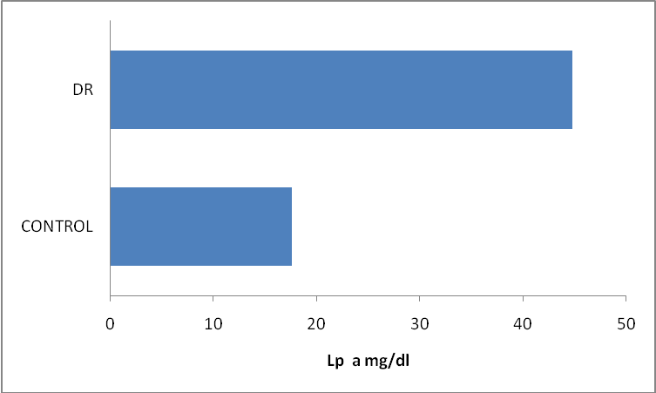
Lp (a) - Lipoprotein (a); DR – Diabetic retinopathy

Figure II: Correlation between Lp (a) and HDL-C in study group (Diabetic retinopathy patients)
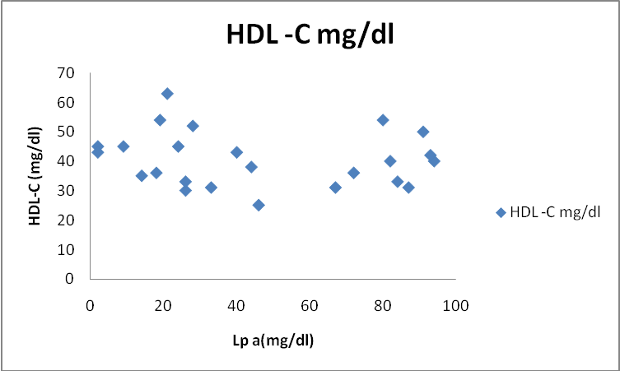
HDL-C - High Density Lipoprotein- Cholesterol; Lp (a) - Lipoprotein (a)
Figure III: Correlation between Lp (a) and LDL-C in study group (Diabetic retinopathy patients)
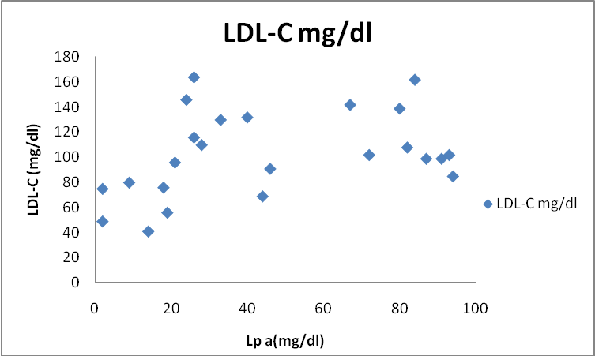
LDL-C - Low Density Lipoproteins- Cholesterol; Lp (a) - Lipoprotein (a)

DISCUSSION
Poor glycemic control, longer duration of diabetes, smoking and elevated total cholesterol are important etiological factors in retinal arteriosclerosis. But there is limited information about the role of Lp(a) in diabetic retinopathy. As Lp(a) has antifibrinolytic effects, it may contribute to occlusion of small retinal vessels (27, 28). Konno et al in 1996 (29) showed that retinal blood flow progressively decreases from the very early stage of diabetic retinopathy, reflecting increasing resistance to flow through the retinal vascular network.
In this study diabetic patients with DR are found to have elevated values of Lp(a). Similar findings have been reported by Chul –Hee et al (1998) in a study involving 412 Korean type II diabetic patients (10). Rupali Chopra et al (2007) have shown the presence of high levels of Lp (a) in DR (30). But conflicting results have been reported about the serum Lp(a) concentrations in patients with DR. Ergun et al (2004)could not find any association between serum Lp(a) levels and diabetic retinopathy in type II diabetic patients(31).
The size of apo (a) gene is highly variable. There is a considerable variation in Lp(a) levels across individuals (11). Lp(a) levels are particularly affected by apo (a) synthetic rate which is subject to strong genetic regulation. Because of this strong genetic impact Lp(a) levels are affected only to a minor extent by age, sex and environmental factors (32).
Foody et al in 2000 found that thiols such as homocysteine can dissociate apo-a from Lp(a) leading to exposure of an additional lysine binding site on apo-a that can increase the affinity of apo-a to plasmin-modified fibrin(33). Amir et al (2008) has suggested that Lp(a) as well as homocysteine could play a role in the development of retinal arteriosclerosis (34). Sotirios et al in 2005 has shown that pro-inflammatory oxidised phospholipids are present on Lp(a) which may mediate the atherogenicity of Lp(a) (35).
There is controversy regarding the role of lipids in the pathogenesis of DR. (36-38). Lipid associations with DR have been investigated in multiple population – based studies and clinical trials but findings remain inconsistent with no single lipid measure consistently found to be associated with DR (36-42). Multi –Ethnic Study of Atherosclerosis (MESA) has shown no associations of serum lipids with DR (42). But Total cholesterol was an independent risk factor for DR in the Chennai Urban Rural Epidemiology Study (CURES) (41).
HDL has antioxidant, antithrombotic, and anti inflammatory properties (43).High Lp(a )levels are associated with retinal arteriosclerosis(44).In the study we have observed a negative correlation between Lp(a) and HDL levels. Tedeschi-Reiner (45) has shown an inverse association, although a weak one, between the serum concentration of HDL cholesterol and the stage of the retinal artery atherosclerosis. Molitch et al. (46) have demonstrated that HDL cholesterol levels were significantly lower in patients with diabetic retinopathy than in those who did not have any changes at fundus of the eye. Wierusz-Wysocka et al (47) have stated that higher levels of HDL cholesterol are associated with decreased risk of diabetic retinopathy.
Modifications of lipoproteins by glycation and oxidation and variations in the size distributions of lipoprotein particles within the major lipoprotein classes are not reflected in conventional lipid profiles (48). Timothy J. Lyons et al (37) in 2004 demonstrated that severe retinopathy was associated with a shift in LDL particle size. These associations cannot be detected from conventional lipid profiles which do not discern subclass distributions. This may explain the findings of lipid profile of this study group.
Several studies have shown that the duration of diabetes is significantly associated with DR in both type I and type II diabetes (49-51). In the present study patients with DR had a longer duration of the disease. The Wisconsin Epidemiologic Study of Diabetic Retinopathy (WESDR) has reported that higher prevalence of DR was associated with longer duration of diabetes (52). In the CURES Eye study 41.8% of patients had DR after 15 years of diabetes and severity of DR increased with longer duration of diabetes. In addition it has been demonstrated that for every five year increase in duration of diabetes, the risk for DR increased by 1.89 times (53).
The major limitation of the study is the small size of the study groups. Only large scale prospective studies will help to improve our understanding of the role of lipids and Lp (a) in Diabetic Retinopathy.
CONCLUSION
The results of this study have shown increased levels of Lp(a) in diabetic retinopathy. These findings suggest that Lp (a) levels which are genetically determined may also be involved in the pathogenesis of diabetic retinopathy along with hyperglycemia and longer duration of diabetes.
ACKNOWLEDGEMENT:
The authors thank K. Ramachandran, S. Swapna and B. Sudha Gandhi for their assistance during the study. Conflict of interest: none

REFERENCES

- Aiello LP, Gardner TW, King GL, Blankenship G, Cavallerano JD, Ferris FL 3rd, et al. Diabetic retinopathy. Diabetes Care 1998; p143-56:Vol21.

- American Diabetes Association. Implication of the United Kingdom Prospective Diabetes study. Diabetes Care 2003; p28-32: Vol26 (1).

- Teikari JM, Laatikainen L, Rapola JM, Virtamo J, Haukka J, Liesto K, Taylor P, Heinonen OP. Retinal vascular changes following supplementation with alpha-tocopherol or beta-carotene. Acta Ophthalmol Scand 1998; p68-73:Vol76.

- Wong TY, Klein R, Klein BE, Tielseh JM, Hubbard L, Nieto FJ. Retinal microvascular abnormalities and their relationship with hypertension, cardiovascular disease, and mortality. Surv Ophthalmol 2001; p59-80: Vol 46

- Hu R, Zhang XX, Wang WQ, Lau CP, Tse HF. Smoking, Homocysteine and degree of arteriolar retinopathy. Athersclerosis 2005; p95-100: Vol 183.

- KM, Erdreich LJ, Stober JA. A detailed study of risk factors for retinopathy and nephropathy in diabetes. Diabetes. 1980; p501-508: Vol 29.

- Sato H, Kawasaki R, Yamashita T, et al. Oxidative stress and cell damage in proliferative diabetic retinopathy. Jpn J Clin Ophthalmol 2004; p211-216: Vol 58.

- Timothy J. Lyons. Alicia J. Jenkins, Deyi Zheng, Daniel T. Lackland, Daniel McGee, W .Timothy Garvey, Richard L. Klein, and the DCCT/EDIC Research Group. Diabetic Retinpathy and Serum Lipoprotein Subclasses in the DCCT/EDIC Cohort. Investive Ophthalmology & Visual Science. 2004; p910-918: Vol 45.

- Mingyuan Wu, Ying Chen, Kenneth Wilson, Alin Chirindel, Michael A, Ibnat, Yongxin Yu, Michael E. Boulton, Luke I. Szweda, Jian-Xing Ma, and Timothy J. Lyons. Intraretinal Leakage and Oxidation of LDL in Diabetic Retinopathy. Investigative Ophthalmology & Visual Science, 2008; p2679-2685: Vol 49

- Chul-Hee Kim, MD , Hyung-Joo Park, MD , Joong-Yeol Park, MD , Sung-Kwan Hong, MD , Young-Hee Yoon, MD , Ki-Up Lee, MD . High Serum Lipoprotein (a) Levels in Korean Type 2 Diabetic Patients With Proliferative Diabetic Retinopathy. Diabetes Care, 1998; p2149-2151: Vol 21.

- Berglund L, Rajasekhar Ramakrishnan. Lipoprotein (a) – An Elusive Cardiovascular Risk Factor. Arteriosclerosis, Thrombosis, and Vascular Biology. 2004;p2219-2226: Vol 24.

- Rainwater DL, Ludwig MJ, Haffner SM, VandeBerg JL. Lipid and lipoprotein factors associated with variation in Lp(a) density. Artioscler Thromb Vasc Biol. 1995; p313-319: Vol 15.

- Rader DJ, Rosas S. Management of selected lipid abnormalities. Hypertriglyceridemia, low HDL cholesterol, Lipoprotein (a), in thyroid and renal diseases, and post-transplantation. Med Clin North Am. 2000; p43-61: Vol 84.

- Gabel B, Yao Z, McLeod RS, Young SG, Koschinsky ML. Carboxyl-terminal -truncation of apolipoprotein B-100 inhibits lipoprotein(a) particle formation. FEBS lett. 1994; p77-81: Vol 350.

- McCormick SPA, Linton MF, Hobbs HH, Taylor S, Curtiss LK, Young SG. Expression of human apolipoprotein B90 in transgenic mice: demonstration that apolipoprotein B90 lacks the structural requirements to form lipoprotein (a). J Biol Chem. 1994; p24284-24289: Vol 269.

- Brunner C, Kraft HG, Utermann G, Muller HJ. Cys 4057 of apolipoprotein(a) is essential for lipoprotein(a) assembly. Proc Natl Acad Sci U S A. 1993; p11643-11647: Vol 90.

- Koschinsky ML, Cote GP, Gabel B, Van der Hoek YY. Identification of the cysteine residue in apolipoprotein(a) that mediates extracellular coupling with apolipoprotein B-100. J Biol Chem. 1993; p19819-19825: Vol 268.

- Mihalich A, Magnaghi P, Sessa L, Trubia M, Acquati F, Taramelli R. Genomic structure and organisation of kringles type 3 to 10 of the apolipoprotein(a) gene in 6q26-27. Gene 1997; p1-8: Vol 196.

- Boerwinkle E, Leffert CC, Lin J, Lackner C, Chiesta G, Hobbs HH. Apolipoprotein(a) gene accounts for greater than 90% of the variation in plasma lipoprotein(a) concentrations. J Clin Invest 1992; p52-60: Vol 92.

- McLean JW, Tomlinson JE, Kuang W-J, Eaton DL, Chen EY, Fless GM, Scanu AM, Lawn RM. Complementary DNA sequence of human apolipoprotein(a) is homologous to plasminogen. Nature. 1987; p132-137: Vol 330.

- Hobbs HH, White AL, Lipoprotein (a): Intrigues and insights. Curr Opin Lipidol. 1990; p225-236: Vol 10.

- Gavish D, Azrolan N, Breslow J, Plasma Lp(a) concentration is inversely correlated with the ratio of kringle IV/Kringle V encoding in the apo(a) gene. J Clin Invest. 1989; p2021-2027: Vol 84.

- Luthra K, Misra A, Srivastava LM. Lipoprotein (a): Biology and role in atherosclerotic vascular disease. Current Science 1999; p1553-60: Vol 76.

- Nordestgaard BG, Chapman MJ, Ray K, Borén J, Andreotti F, et al .Lipoprotein(a) as a cardiovascular risk factor: current status. Eur Heart J. 2010;p2844-53: Vol 31(23).

- Erqou S, Kaptoge S, Perry PL, Di AE, Thompson A, White IR, Marcovina SM, Collins R, Thompson SG, Danesh J. Lipoprotein(a) concentration and the risk of coronary heart disease, stroke, and nonvascular mortality. JAMA 2009; p412–423: Vol 302.

- American Diabetes Association: clinical practice recommendations 2000: Clinical practice recommendations 2000. Diabetes Care. 2000; p345-5: Vol 23.

- Scott J: Thrombogenesis is linked to atherogenesis at last? Nature 1989; p22-23: Vol 341.

- Hajjar KA, Gavish D, Breslow JL, Nachman RL: Lipoprotein (a) modulation of endothelial cell surface fibrinolysis and its potential role in atherosclerosis. Nature 1989; p303-305: Vol 339

- Konno S, Feke GT, Yoshida A, Fujjo N, Goger DG, Buzney SM : Retinal blood flow changes in type I diabetes : a long-term, follow-up study. Invest Ophthalmol Vis Sci 1996;p1140-148: Vol 37.

- Rupali Chopra, Jaison G Saramma , John Mary, Abraham Rebecca. Lipoprotein(a) as a risk factor for Diabetic Retinopathy in patients with type 2 diabetes mellitus. Indian J Ophthalmol 2007; p195-8: Vol 55.

- U G O Ergun , S Oztuzun, G Seydaoglu. Lipoprotein (a) Levels in type 2 Diabetic patients with Diabetic Retinopathy. Med J Malaysia. 2004; p406-410: Vol 59(3).

- Utermann G. The Mysteries of lipoprotein (a). Science (Washington DC). 1989; p904 – 910: Vol 246.

- Foody JM, Milberg JA, Robinson K. Pearce GL, Jacobsen DW, Spreacher DL. Homocysteine and lipoprotein (a) interact to increase CAD risk in young men and women. Arterioscler Thromb Vasc Biol 2000;p493-9: Vol 20.

- Amir Ghorbaniharghjo, Alireza Javadzadeh, Hassan Argani, Nariman Nezami, Nadereh Rashtchizadeh, Mandana Rafeey, Mohammad Rohbaninoubar, Babak Rahimi- Ardabili. Lipoprotein(a), Homocysteine, and Retinal Arteriosclerosis. Molecular Vision 2008; p1692-1697: Vol 14.

- Sotirios Tsimikas, Emmanouil S. Brilakis , Elizabeth R. Miller BS, Joseph P. McConnell, Ryan J, Lennon MS, Kenneth S. Korman,Joseph L. Witztum, and Peter B. Berger. Oxidised Phospholipids, Lp(a) lipoprotein, and Coronary Artery Disease. N Engl J Med 2005 ; p46-57: Vol 353.

- Klein BE, Moss SE, Klein R, Surawicz TS. The Wisconsin Epidemiologic Study of Diabetic Retinopathy. XIII. Relationship of serum cholesterol to retinopathy and hard exudate. Ophthalmology 1991;p1261–1265 : Vol 98.

- Lyons TJ, Jenkins AJ, Zheng D, et al. Diabetic retinopathy and serum lipoprotein subclasses in the DCCT/EDIC cohort. Invest Ophthalmol Vis Sci 2004;p910–918: Vol 45.

- Miljanovic B, Glynn RJ, Nathan DM, Manson JE, Schaumberg DA. A prospective study of serum lipids and risk of diabetic macular edema in type 1 diabetes. Diabetes 2004; p2883–2892: Vol 53.

- Wong TY, Klein R, Islam FM, et al. Diabetic retinopathy in a multi-ethnic cohort in the United States. Am J Ophthalmol 2006;p446–45: Vol 141.

- Raman R, Rani PK, Kulothungan V, Rachepalle SR, Kumaramanickavel G, Sharma T. Influence of serum lipids on clinically significant versus nonclinically significant macular edema: SN-DREAMS Report number 13. Ophthalmology 2010; p766–772: Vol 117.

- Rema M, Srivastava BK, Anitha B, Deepa R, Mohan V. Association of serum lipids with diabetic retinopathy in urban South Indians—the Chennai Urban Rural Epidemiology Study (CURES) Eye Study—2. Diabet Med 2006; p1029–1036: Vol 23.

- Wong TY, Cheung N, Tay WT, et al. Prevalence and risk factors for diabetic retinopathy: the Singapore Malay Eye Study. Ophthalmology 2008; p1869–1875: Vol 115.

- O’Connell BJ, Genest J. High-density lipoproteins and endothelial function. Circulation 2001; p1978–1983: Vol 104.

- Wong TY, Klein R, Klein BE, Tielsch JM, Hubbard L, Nieto FJ.Retinal microvascular abnormalities and their relationship with hypertension, cardiovascular disease, and mortality. Surv Ophthalmol. 2001;p59-80: Vol 46(1)

- Tedeschi-Reiner E, Reiner Z, Sonicki Z. Atherosclerosis of retinal arteries in men: role of serum lipoproteins and apoproteins. Croat Med J. 2004; p333-7: Vol 45(3).

- Molitch ME, Rupp D, Carnethon M: Higher levels of HDL cholesterol are associated with a decreased likelihood of albuminuria in patients with long-standing type 1 diabetes. Diabetes Care. 2006:p78–82; Vol29.

- Wierusz-Wysocka B, Zozulinska DA, Araszkiewicz A, Pisarczyk-Wiza D. Higher Levels of HDL Cholesterol Are Associated With a Decreased Likelihood of Albuminuria in Patients With Long-Standing Type 1 Diabetes Diabetes Care .2006;p1176-1177 Vol 29(5).

- Lyons TJ, Jenkins AJ. Glycation, oxidation, and lipoxidation in the development of the complications of diabetes: a carbonyl stress hypothesis. Diabetes Rev. 1997;p365–391: Vol 5.

- Liu DP, Molyneaux L, Chua E, Wang YZ, Wu CR, Jing H, Hu LN, Liu YJ, Xu ZR, Yue DK. Retinopathy in a Chinese population with type 2 diabetes: factors affecting the presence of this complication at diagnosis of diabetes. Diabetes Res Clin Pract. 2002 ;p125-31: Vol 56(2).

- Lovestam-Adrian M, Agardh CD, Torffvit O, Agardh E.Diabetic retinopathy, visual acuity, and medical risk indicators: a continuous 10-year follow-up study in Type 1 diabetic patients under routine care. J Diabetes Complications. 2001; p287-94: Vol 15(6).

- Stratton IM, Kohner EM, Aldington SJ, Turner RC, Holman RR, Manley SE, Matthews DR.UKPDS 50: risk factors for incidence and progression of retinopathy in Type II diabetes over 6 years from diagnosis. Diabetologia. 2001; p156-63: Vol 44(2).

- Klein R, Davis MD, Moss SE, Klein BE, DeMets DL. The Wisconsin Epidemiologic Study of Diabetic Retinopathy. A comparison of retinopathy in younger and older onset diabetic persons. Adv Exp Med Biol 1985; p321-35: Vol 189.

- Rema M, Premkumar S, Anitha B, Deepa R, Pradeepa R, Mohan V. Prevalence of diabetic retinopathy in urban India: The Chennai Urban Rural Epidemiology Study (CURES) Eye Study, I. Invest Ophthalmol Vis Sci 2005; p2328-33: Vol 46.

