A Fake Medicated Navapashana Herbal Statue – A
Forensic Case Study

A.Visalakshi, Dr.Kamalakshi Krishnamurthi*, B.Maria Selvi Rosaline, L.C.Amutha , Dr.K.Nandagopal
Forensic Sciences Department, Chennai 600 004- Tamilnadu, India
Address: Dr. Kamalakshi Krishnamurthy, Deputy Director-DNA Division, Forensic Sciences Department, Chennai 600 004- Tamilnadu, India

E-mail: kamalkissan2011@gmail.com
*Corresponding author
Published: 30 November 2012 Received: 12 December 2012
AJBBL 2012, 2: 1-10 Accepted: 01 November 2012
ABSTRACT
The medicated Navapashana Statue is very difficult to obtain and to make. It is commonly known as “Herbal Statue” and it is made of Navapashana, just like scientific preparations containing the essence of 473 Herbs, 9 kinds of Salts, 9 kinds of Pashana medicines, the milk from 9 kinds of other ancillary materials. Sridhar’s mix all the above ingredients in suitable proportions to make the disease curing Navapashana Statue. The Forensic Examination of Herbal Statue has been successfully employed by Forensic Science Laboratory, Chennai 600 004 to differentiate the Fake Herbal Statue from the original. This paper attempts to explain a case study of Herbal Navapashana Statue in detail with various analytical procedures.

INTRODUCTION
Siddhars dealt with 11 metals, 64 Pashanam (mercurial and non-mercurial’s), 120 Uparasams (salts and their minerals) and animal products in preparing medicines. The common preparations are Bhasma (Calcined metals and minerals), Churna (powders),Kashaya(decoctions),Lehya(confections),Ghirta(ghee preparations) and Taila(oil preparations). The preparation in which the Siddhars specialized are Churna (metallic preparations) which become alkaline, Mezhugu(waxy preparations), Kattu(preparations which are impervious to water and flame). For a medicine to be effective, the inorganic substances have to be brought into their atomic form. The Siddhars developed the knowledge of bringing inorganic substances into atomic and ionic form which can be easily absorbed in the system, when ground with herbal juices and put in the fire with a calculated number of cow dung cakes.
Mercury plays a very important place in Siddha medicine. Five forms of Mercury are normally available. Pashanam drugs do not dissolve but give off vapours when put into fire. The chemical constituents of Navapashanam are Veeram(Mercuric Chloride), Rasam(Mercury) Pooram(Arsenic-Camphor), Lingam(Calcinated powder of Cinnabar-Red Sulphide of Mercury), Rasakarpooram(Calomel-Hg₂Cl₂), Gandhakam(Sulphur), Manochillai (Arsenic disulphide), Karmugil(Oxide of Iron) and Thaalagam(Yellow Arsenic-Yellow Sulphide of Arsenic). The only Navapashana Herbal Statue is available at Palani, Tamil Nadu as Dhandayuthapani Murugan Statue which is a medicated Statue and the prasathams from the Herbal Statue is used to cure various diseases.
A case of Medicated Herbal Statue was received at Chemistry Division of Forensic Science Department, Chennai 600 004 for examination to find out its nature and genuinity of the Statue. A study was undertaken to find out the level of metallic constituents like Mercury, Arsenic, Lead, Tin, Copper, Iron, Zinc & non-metal like Sulphur in the Case Sample to find out whether the Statue is original or fake.
MATERIALS AND METHODS
About 2grams of the reference standard Herbal Powder was taken and about 10ml of concentrated Nitric Acid (AR Grade) was added and digested over hot water bath maintained at 80ºC for 2hours and cooled. Then the digested material was filtered through a previously weighed Whatman No.1 Filter paper and the filtrate was made up to known volume (100ml/250ml in a calibrated standard flask). The acid insoluble residue was dried in an air oven at 110ºC for an hour. The filter paper along with the residue is kept in a dessicator and weighed. The difference in weight gives the percentage of acid insoluble residue which normally includes Sulphur and Tin as hydrated Stannic Oxide (SnO₂ H₂O). Similarly, the scrapings from different parts of the Case sample were taken and subjected to the same procedure, as explained above.
Preliminary qualitative tests were carried out with the filtrate of Standard and Case Sample for the detection of Hg, As, Pb, Cu, Fe & Zn. Quantitation was carried out with the filtrate of Standard and Case sample by volumetry and gravimetry methods, depending upon the quantity of each element, it was further confirmed by Instrumental methods. Based on the results from conventional methods, suitable dilutions were made and subjected to Atomic Absorption Spectrometry.

STATISTICAL ANALYSIS:
Variables were compared between control and study groups by using the students unpaired‘t’ test. All probability values presented are two tailed and probability values <0.05 were considered to be statistically significant. The association of Lp(a) with LDL-C and HDL-C was performed by Pearson’s correlation co efficient.

RESULTS
Among the 25 patients belonging to the study group, 21 patients had NPDR and 4 patients had PDR. Patients with DR had significantly elevated levels of Lp(a). Patients with DR also had a longer duration of the disease along with statistically significant plasma glucose levels. 3 patients of the control group and 10 patients of the study group were on lipid lowering medications. Clinical and laboratory characteristics of the control and study groups are presented in Table I.
Figure I shows the level of Lp(a) in both the groups. Figures 2 and 3 show the correlation between Lp (a) with HDL-C and Lp(a) with LDL-C in the study group. Lp(a) and LDL-C were positively correlated(r=0.354) whereas Lp(a) and HDL-C showed a negative correlation(r= - 0.147) in the diabetic retinopathy group.

Table I: Clinical and laboratory characteristics of the control and study groups
Parameters | Control group | Study group
No of cases(n) | 15 | 25
Age (Years) | 55±1.2 | 58±2.9(NS)
Duration of diabetes (years) | 6±2.4 | 10±1.8(S)
Fasting plasma glucose( mg/dl) | 133±5.4 | 172±3.6(S)
Lipoprotein (a)(mg/dl) | 17.64±3.4 | 44.76±6.3(S)
Cholesterol (mg/dl) | 212.4±8.3 | 167.6±7.9 (S)
Triglycerides (mg/dl) | 153.7±16.9 | 124.7±13 (NS)
High Density Lipoprotein -C(mg/dl) | 40.6±2.4 | 40.6±1.9 (NS)
Low density Lipoprotein-C(mg/dl) | 140.9±7.3 | 102.9±6.9 (S)
All the values are expressed as Mean ± SEM. NS- Non significant.
S – Significant; SEM = Standard error of mean.
Figure: I Lp(a) levels in control and study (DR) Groups
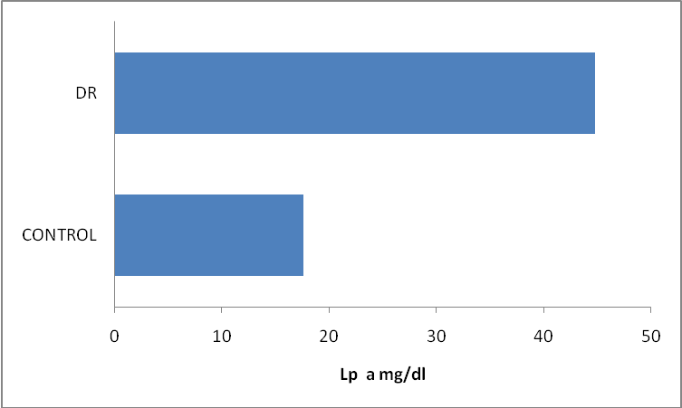
Lp (a) - Lipoprotein (a); DR – Diabetic retinopathy

Figure II: Correlation between Lp (a) and HDL-C in study group (Diabetic retinopathy patients)
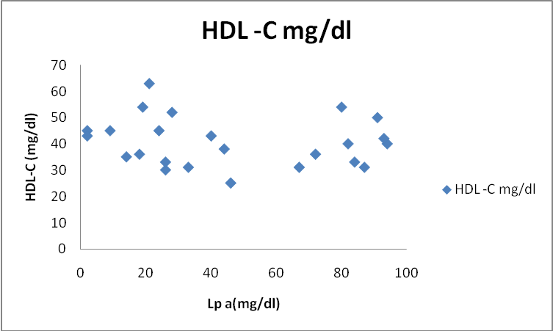
HDL-C - High Density Lipoprotein- Cholesterol; Lp (a) - Lipoprotein (a)
Figure III: Correlation between Lp (a) and LDL-C in study group (Diabetic retinopathy patients)
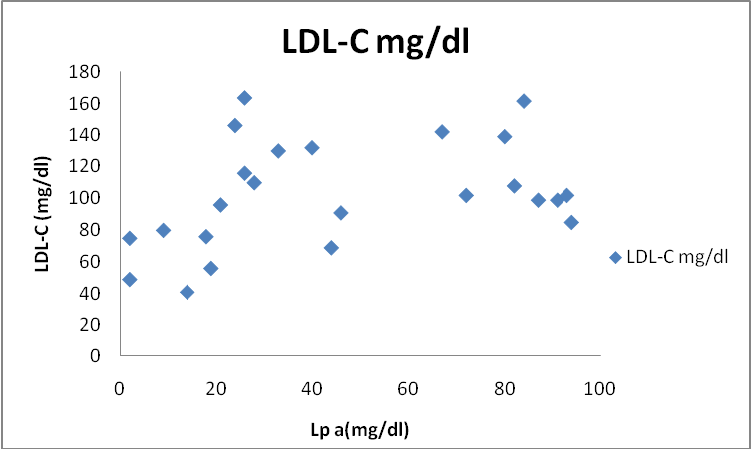
LDL-C - Low Density Lipoproteins- Cholesterol; Lp (a) - Lipoprotein (a)

DISCUSSION
Poor glycemic control, longer duration of diabetes, smoking and elevated total cholesterol are important etiological factors in retinal arteriosclerosis. But there is limited information about the role of Lp(a) in diabetic retinopathy. As Lp(a) has antifibrinolytic effects, it may contribute to occlusion of small retinal vessels (27, 28). Konno et al in 1996 (29) showed that retinal blood flow progressively decreases from the very early stage of diabetic retinopathy, reflecting increasing resistance to flow through the retinal vascular network.
In this study diabetic patients with DR are found to have elevated values of Lp(a). Similar findings have been reported by Chul –Hee et al (1998) in a study involving 412 Korean type II diabetic patients (10). Rupali Chopra et al (2007) have shown the presence of high levels of Lp (a) in DR (30). But conflicting results have been reported about the serum Lp(a) concentrations in patients with DR. Ergun et al (2004)could not find any association between serum Lp(a) levels and diabetic retinopathy in type II diabetic patients(31).
The size of apo (a) gene is highly variable. There is a considerable variation in Lp(a) levels across individuals (11). Lp(a) levels are particularly affected by apo (a) synthetic rate which is subject to strong genetic regulation. Because of this strong genetic impact Lp(a) levels are affected only to a minor extent by age, sex and environmental factors (32).
Foody et al in 2000 found that thiols such as homocysteine can dissociate apo-a from Lp(a) leading to exposure of an additional lysine binding site on apo-a that can increase the affinity of apo-a to plasmin-modified fibrin(33). Amir et al (2008) has suggested that Lp(a) as well as homocysteine could play a role in the development of retinal arteriosclerosis (34). Sotirios et al in 2005 has shown that pro-inflammatory oxidised phospholipids are present on Lp(a) which may mediate the atherogenicity of Lp(a) (35).
There is controversy regarding the role of lipids in the pathogenesis of DR. (36-38). Lipid associations with DR have been investigated in multiple population – based studies and clinical trials but findings remain inconsistent with no single lipid measure consistently found to be associated with DR (36-42). Multi –Ethnic Study of Atherosclerosis (MESA) has shown no associations of serum lipids with DR (42). But Total cholesterol was an independent risk factor for DR in the Chennai Urban Rural Epidemiology Study (CURES) (41).
HDL has antioxidant, antithrombotic, and anti inflammatory properties (43).High Lp(a )levels are associated with retinal arteriosclerosis(44).In the study we have observed a negative correlation between Lp(a) and HDL levels. Tedeschi-Reiner (45) has shown an inverse association, although a weak one, between the serum concentration of HDL cholesterol and the stage of the retinal artery atherosclerosis. Molitch et al. (46) have demonstrated that HDL cholesterol levels were significantly lower in patients with diabetic retinopathy than in those who did not have any changes at fundus of the eye. Wierusz-Wysocka et al (47) have stated that higher levels of HDL cholesterol are associated with decreased risk of diabetic retinopathy.
Modifications of lipoproteins by glycation and oxidation and variations in the size distributions of lipoprotein particles within the major lipoprotein classes are not reflected in conventional lipid profiles (48). Timothy J. Lyons et al (37) in 2004 demonstrated that severe retinopathy was associated with a shift in LDL particle size. These associations cannot be detected from conventional lipid profiles which do not discern subclass distributions. This may explain the findings of lipid profile of this study group.
Several studies have shown that the duration of diabetes is significantly associated with DR in both type I and type II diabetes (49-51). In the present study patients with DR had a longer duration of the disease. The Wisconsin Epidemiologic Study of Diabetic Retinopathy (WESDR) has reported that higher prevalence of DR was associated with longer duration of diabetes (52). In the CURES Eye study 41.8% of patients had DR after 15 years of diabetes and severity of DR increased with longer duration of diabetes. In addition it has been demonstrated that for every five year increase in duration of diabetes, the risk for DR increased by 1.89 times (53).
The major limitation of the study is the small size of the study groups. Only large scale prospective studies will help to improve our understanding of the role of lipids and Lp (a) in Diabetic Retinopathy.
CONCLUSION
The results of this study have shown increased levels of Lp(a) in diabetic retinopathy. These findings suggest that Lp (a) levels which are genetically determined may also be involved in the pathogenesis of diabetic retinopathy along with hyperglycemia and longer duration of diabetes.
ACKNOWLEDGEMENT:
The authors would like to thant Tr.Siddhar Jeyaraman for providing Standard Sample of Navapashana Herbal powder and his valuable guidance. Authors are grateful to Tr.E.D.Thamarai Selvan, FSD,Chennai 600 004 for his literature Support. We thank Mrs.Jamuna Sivasankaran and Mrs. Manjula Devi of Instruments Division of FSD, Chennai 600 004 for their excellent technical co-operation. We are grateful to Tr.KuttalamPillai, Photo Section, FSD, Chennai 600 004 for his valuable photography. We sincerely thank one and all the volunteers who have supported in achieving this study.
Conflict of interest: none

REFERENCES

- Arthur.I.Vogel,”Quantitative Inorganic Analysis”’ 3rd edition 1961.

- Siddhar.M.M.Jeyaraman, “Medicated Nava Pasana Herbal Statue” 1st edition 2001.

- Indian Medical Practioners co-operative Pharmacy and Society, Chennai, “Formulary of Siddha Medicines” 5th edition 2000.

- Lyle E.Cracker, James.e.Simon, “Herbs, Spices and Medicinal Plants” Vol. I to IV-2002.

