From: 26.07.2012
Dr. Meerashivashekar, Ph.,D,
Associate professor,
SRM Medical College Hospital and Research centre,
Kattankulathur-603203.

To:
The editor,
American journal of Biopharmacology Biochemistry and Lifesciences.

Sub: Submission of article for publication.

Respected Sir,
I herewith submit for your kind perusal the article titled "BIOCHEMICAL MARKERS OF BONE TURNOVER IN POST MENOPAUSAL MOTHERS AND PREMENOPAUSAL DAUGHTERS" for publication in your esteemed journal. I state that there is no conflict of interest and the above manuscript has not been published anywhere or is under consideration for publication in any other journal. I request you to kindly give your expert opinion and positive feedback in this regard.

Dr. Meera Shivashekar Ph.,D,
Department of Biochemistry
SRM Medical College Hospital & Research Centre
SRM Nagar, Kattankulathur – 603 203
Phone No / Email address: 9444073797 / vpsrmmedical@yahoo.co.in

BIOCHEMICAL MARKERS OF BONE TURNOVER IN POST MENOPAUSAL MOTHERS AND PREMENOPAUSAL DAUGHTERS
*Dr. Meerashivashekar¹, Ms. Samiya Begum¹, Ms. Kaviarasi¹, Dr. Ebenezer William¹, Dr. Dhanapal².
Department of Biochemistry¹ and Department of Orthopaedics². SRM Medical college, Hospital and Research centre, Potheri, Tamil Nadu, India.
Key words: BMD, BMI, Postmenopausal, Premenopausal and Osteoporosis.

Author for corespondence:
*Dr. Meerashivashekar, Ph.D
Associate professor,
SRM Medical College Hospital and Research centre,
Kattankulathur-603203.
E-mail; vpsrmmedical@yahoo.co.in
Mobile No: 9444073937

ABSTRACT
To study the biochemical markers of bone turnover in postmenopausal mothers and their premenopausal daughters. The study was conducted in 50 postmenopausal mothers of age 45-65years who attended orthopaedics O.P in SRM medical College Hospital and Research Centre and their daughters aged about 25-45 years. The biochemical markers of bone turnover namely serum calcium, phosphorus and alkaline phosphatase were measured by using standard kits. The data was analysed and difference in the above parameters was compared using software SPSS windows. In postmenopausal mothers the level of serum calcium, phosphorous were decreased (p<0.001) compared to premenopausal daughters. In contrast the serum levels of alkaline phosphatase was significantly increased (p<0.001) in postmenopausal mothers when compared to premenopausal daughters. The bone mineral density was found to correlate significantly with the above risk markers. The finding indicates that the biochemical markers of bone turnover provides valuable information for the diagnosis and monitoring of osteoporosis which reflects the rate of bone resorption and also for the prediction of future fracture risk especially in the premenopausal daughters.

INTRODUCTION:

Osteoporosis stands second next to cardiovascular diseases as a global health problem and expert groups expect an estimated increase in number of patients to 30 million by 2013. In India osteoporosis is a very common problem in postmenopausal women. Studies regarding the bone turnover and prevalence of osteoporosis in premenopausal women with regard to biochemical markers is limited. Osteoporosis is a major health problem affecting one in three women. A strong genetic influence on bone mass inevitably implies a parent offspring relation that enables identification of women at future risk for osteoporosis before the onset of bone loss (1). Osteoporosis is characterized by low bone mass with architectural deterioration of bone tissue leading to enhanced bone fragility and increases the susceptibility to fracture (2). The rate of bone loss from all skeletal sites accelerates during the first post menopausal years and subsequently declines. Post menopausal bone loss is associated with increase in bone turnover (3). The recent development of specific and sensitive biochemical markers, reflecting the overall rate of bone formation and bone resorption has improved the non invasive assessment of bone turnover abnormalities. Most of the interest has been devoted in use of these biochemical markers in post menopausal women. Biochemical markers of bone turnover have been shown to provide valuable information for the diagnosis and the monitoring of metabolic bone disease not only in postmenopausal women but also in premenopausal women (4). Bone mineral density a key determinant of osteoporotic fracture in adult women is reflection of the peak bone mass attained in young adult and the bone mass loss during the premenopausal and postmenopausal years(5). The aim of the study was to determine the biochemical markers of bone turn over and to determine the rate of bone loss on bone mineral density.
MATERIALS AND METHODS:
The study group consisted of 50 postmenopausal mothers in the age group of 45-65 years suffering from osteoporosis attending the department of Orthopaedics in SRM Medical Hospital and Research Centre, Kattankulathur and 50 premenopausal daughters in the age group of 25-45 years.
After an overnight fast, blood sample were collected in plain tube from each participant. Serum was separated and analyzed for biochemical markers namely calcium, phosphorus and alkaline phosphatase using Beckman coulter AU 400 autoanalyzer.

BMD was measured with single energy X-ray absorption meter (DTX-100 osteometer meditech Inc). All scans were revived and if necessary reanalysed. Subjects who did not have valid bone densitometry measurement were excluded from the data analysis that involved BMD. Menopausal status was defined based on each woman self report of the frequency of menstrual bleeds per year. Women were considered postmenopausal if they reported the absence of menstrual bleed in the previous 12 months. The institutional ethical committee approved the study and informed consent was obtained from each participant in the study. The data was analysed and the difference in the mean of the various parameters were compared using student t-tests. Statistical analyses were performed using software SPSS window.
RESULTS:
Table I shows the physical characteristics of the post menopausal mothers and their premenopausal daughters. BMI was significantly high in postmenopausal mothers compared to premenopausal daughters. The levels of total calcium and phosphorus are significantly lower in postmenopausal mothers compared to premenopausal daughters but the levels of serum alkaline phosphatase are significantly increased (p<0.001) in post menopausal mothers compared to premenopausal daughters. A significant positive correlation is observed in premenopausal daughters with respect to BMD and serum calcium, phosphorous and a negative correlation is observed in case of serum alkaline phosphatase.

TABLE: I Comparison of markers of bone turnover and BMD in premenopausal
daughters and post menopausal mothers (values expressed as mean±SD)

Parameters Premenopausal daughters Postmenopausal mothers
(n=50) (n=50)
Age 35±7 36±8***
(years)
BMI 25±4.5 29±5***
(kg/m²)
Serum Calcium 8.8±0.8 8.2±0.6***
(mg/dl)
Phosphorus 2.9±0.59 2.5±0.3Ns
(mg/dl)
Alkaline Phosphatase 237±89.4 264±72.2***
(mg/dl)
BMD -2.34±0.86 -2.9±0.5***

Data expressed as mg/dl, mean±SD, Ns p<0.05(not significant), ***p<0.001(highly significant).

FIGURE: I
Comparison of BMD between postmenopausal mothers and premenopausal daughters.
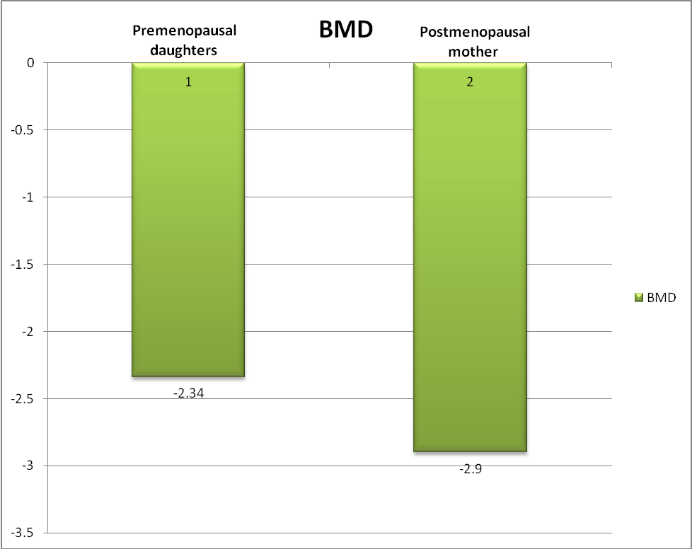
BMD - Bone Mineral Density

DISSCUSION:

The result of the present study shows that the mean weight of postmenopausal mothers were higher than the premenopausal daughters which leads to increased BMI. Most of the women in our study were both professionals and non-professionals and were doing only routine household work. This correlates with other reports that the lack of physical activity is an important risk factor for osteoporosis (6). Age related changes in bone with increased level of biochemical markers correlated with low BMD in both groups. After menopause most women experience rapid bone loss and the levels of bone turnover markers decreased. The standard value of BMD between -1 to 2.5 is considered as osteopenia as and more than 2.5 as osteoporosis (7). In our study we observed that T- score is less in post menopausal mothers compared to premenopausal daughters leading to the state of osteoporosis. Another study has stated that about 50% of post menopausal women were osteopenic and rest are osteoporotic. They also observed that aging increased the risk of osteoporosis (8).

A consistent decrease in BMD with increasing serum bone turnover marker levels was reported in men and women of ethnic groups (9). We observed that the levels of serum calcium rises rapidly and reaches maximum in 2 to 5 years after menopause. The effectiveness of increase in bone mineral density depends heavily on adequate availability dietary calcium(10). Serum alkaline phosphatase level is decreased in premenopausal daughter compared to postmenopausal mother. Alkaline phosphatase is most commonly used markers of bone formation. It is an ubiquitous enzyme and plays an important role in osteoid formation and mineralisation. Women who reached menopause stage have elevated serum alkaline phoshpatase levels. Thus serum alkaline phosphatase can be one of biochemical markers of bone turnover which indicates increased bone activity that can lead to bone loss in future. A significant positive correlation is observed in the premenopausal daughters with respect to BMD, serum calcium, phosphorous and negative correlation in the case of serum alkaline phosphatase.
Our observations suggest that a biochemical marker of bone turnover provides valuable information for the diagnosis and monitoring of osteoporosis which reflects the rate of bone resorption and bone formation. Thus BMD provides static structure of the bone, whereas the biochemical markers provide dynamic measure of bone remodelling and thus are useful in predicting the course of change in bone mass. Our study throws light in the prediction of future fracture risk especially in premenopausal daughters.
CONCLUSION:
The findings indicate that the biochemical markers of bone turnover provide valuable information for the diagnosis and monitoring of osteoporosis which reflects the rate of bone resorption and also for the prediction of future fracture risk especially in premenopausal daughters.
BIBLIOGRAPHY:
1. Sowers MF, Kshirsagar A, Crutchfield. M etal. Body composition, age and femoral bone mass of young adult women. An Epidermol 1991; 245-254: 1.
2. Melton. LJ III, Khosla S, Arkinson EJ, O’Fallon WM & Rigg BL. Relationship of bone turnover to bone density and fracture. Journal of bone and mineral research. 1997;1083-1091: 12.
3. Baran D. Sorenson A, Grimes. J, etal. Dietary modification with dairy products for preventing vertebral bone loss in premenopausal women: A three year prospective study J. Clinl Endocrinol Metab. 1989;264-70: 70.
4. Delmas PD. Biochemical markers of bone turnover for the clinical investigation of osteoporosis. Osteoporosis Int 1993;181-86.
5. Recker RR, Lappe. JM, Davies M etal. Change in bone mass immediately before menopause. J. Bone Miner Res. 2000; 1965-73: 15.
6. Hansen MA. Assesment of age and risk factors on bone density and bone turnover in healthy premenopausal women. Osteoporos Int. 1994; 123-128: 4.
7. Slemenda C, Longcope C, Peacock M etal. Sex steroids, bone mass, boneloss; a prospective study of bone loss in pre, peri and post menopausal women. J Clin Invest. 1996; 14-21: 97.
8. Garton M, Martin J, New. S, etal. Bone mass and metabolism in women aged 45-55. Clinical endocrinology. 1996; 563-70: 44.
9. Kulak CAM, Bilezilian JP. Osteoporosis preventive stratergies. Int J Fertil; 1998; 56-64: 43.
10. Prior JC, Vigna YM, Barr SI etal Ovulatory premenopausal women lose cancellous spinal bone; a five year prospective study Bone. 1996 ; 261-7: 18.

